Social media copy

Bowel cancer

All social media graphics can be downloaded from this website: https://staffsstokeics.org.uk/bowel-cancer/

For more information
If you have any questions about this toolkit or require more information, please email: ssotics.comms@staffsstoke.icb.nhs.uk

Symptom awareness GIF | Alt Text copy | Social media post copy
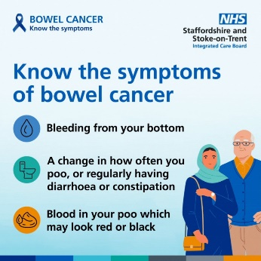  download from resource centre | Know the symptoms of bowel cancer  - Bleeding from your bottom  - A change in how often you poo, or regularly having diarrhoea or constipation  - Blood in your poo which may look red or black | If you have symptoms that last for 3 weeks or more, contact your GP practice. Tests could save your life.  https://staffsstokeics.org.uk/bowel-cancer/

Bowel cancer testing GIF | Alt Text copy | Social media post copy
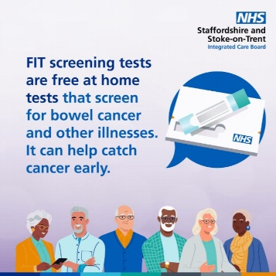  download from resource centre | FIT screening tests are free at home test that screen for bowel cancer and other illnesses. It can help catch cancer early. Don’t ignore your test. | Faecal Immunochemical testing  (FIT) can be posted to you and  taken from the comfort of your own home. Don’t ignore your test, it could save your life.  https://www.nhs.uk/conditions/bowel-cancer-screening/

At-home bowel testing video | Alt Text copy | Social media post copy
https://youtu.be/yyNvW3uQEzM insert YouTube video or download from resource centre | Mark Doran explains the importance and ease of doing your at-home bowel screening test. | Don’t ignore your at-home bowel cancer test. You get one automatically in the post if you are aged 50-74. Testing saves lives.  https://www.nhs.uk/conditions/bowel-cancer-screening/

Early detection video | Alt Text copy | Social media post copy
https://youtu.be/t_lu8RTQkPk insert YouTube Video or download from resource centre | Hear from Jeff, a cancer survivor from Stoke-on-Trent about the importance of doing your at-home bowel screening test. | Doing your at-home bowel cancer test is vital so we can catch cancer early. Hear from Jeff, a cancer survivor from Stoke-on-Trent.  https://www.nhs.uk/conditions/bowel-cancer-screening/

Inherited genes | Alt Text copy | Social media post copy
  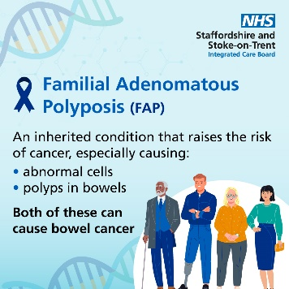  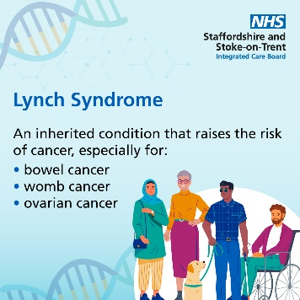  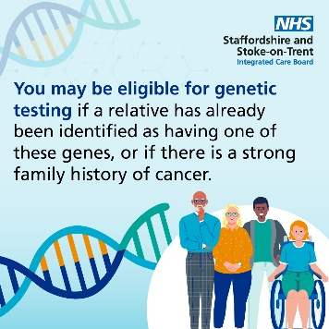  download from resource centre | Some inherited genes and conditions may increase the risk of developing cancer.  Familial Adenomatous Polyposis (FAP)  An inherited condition that raises the risk of cancer, especially causing:  - Abnormal cells  - Polyps in bowels  Both of these can cause bowel cancer  Lynch Syndrome  An inherited condition that raises the risk of cancer, especially for:  - Bowel cancer  - Womb cancer  - Ovarian cancer  You may be eligible for genetic testing if a relative has already been identified as having one of these genes, or if there is a strong family history of cancer. | Learn about which inherited genes and conditions may increase the risk of developing bowel cancer.  https://staffsstokeics.org.uk/brca-fap-lynch-genes/

