Audience and advert | Artwork | Caption copy | Campaign landing page and CTA
Ad set 1: Targeted lung health check  Staffordshire and Stoke-on-Trent wide (blanket approach) ages 50+  Video of patient | 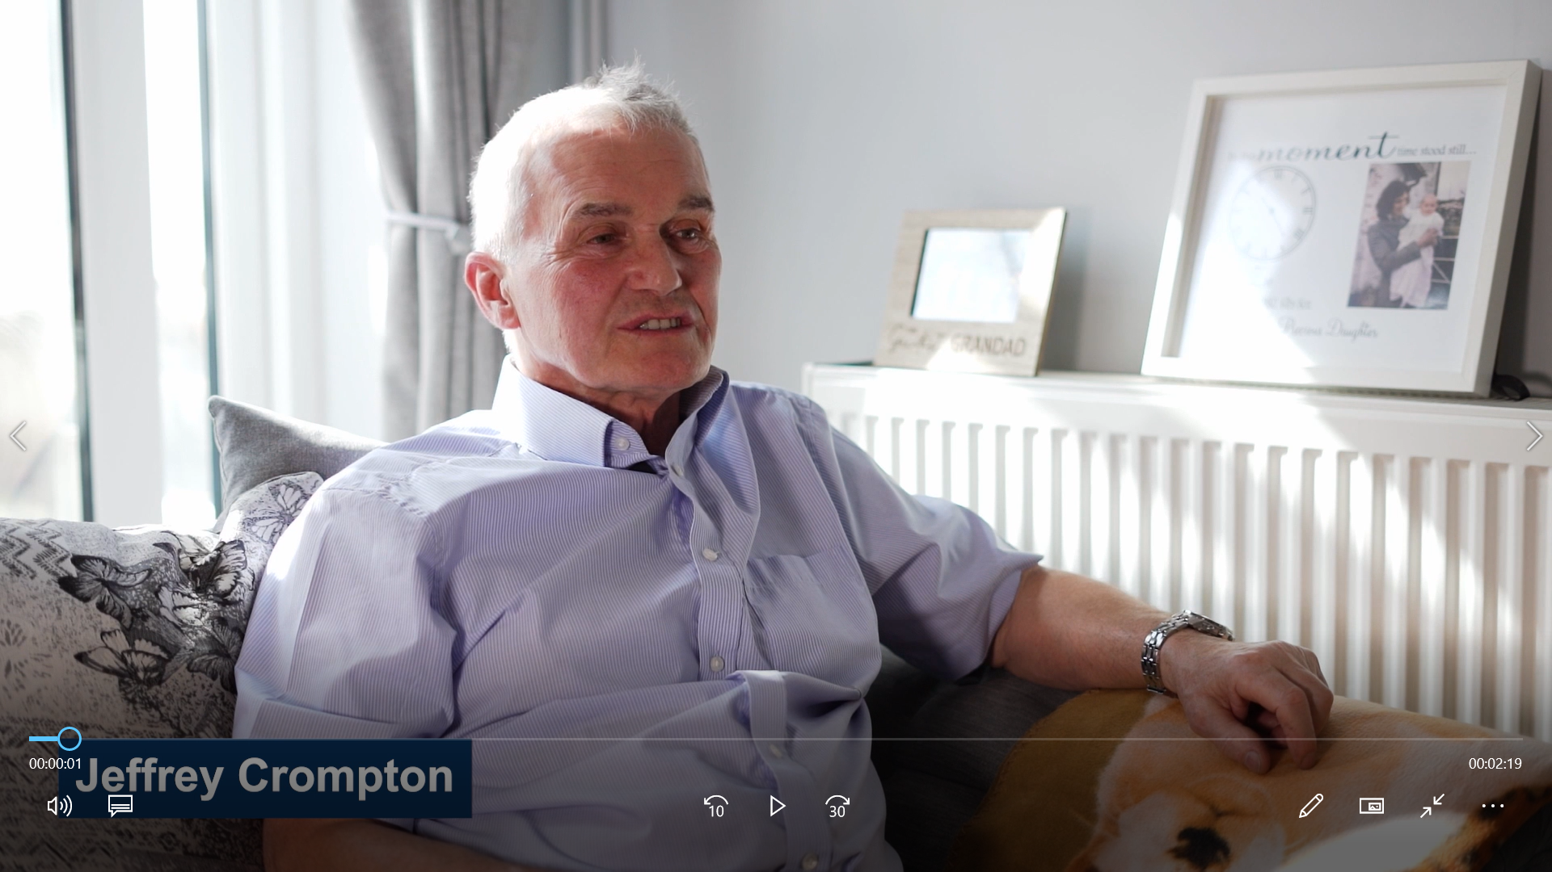 | Jeffrey was diagnosed with lung cancer from his FREE Targeted Lung Health Check. See if you’re eligible and request an appointment here. | https://www.uhnm.nhs.uk/our-services/lung-health-checks/  Learn more  Video link: https://youtu.be/egQ77dHdhg0?si=nzWT8CAOGFN4ptOb
Ad set 2: Targeted lung health check  North Staffordshire ages 50+  Carousel images 1- 5 | 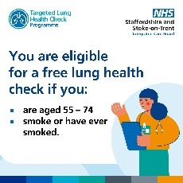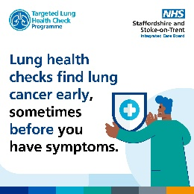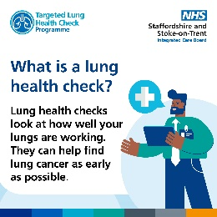  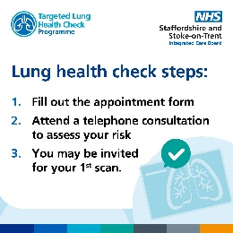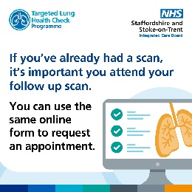 | Get peace of mind. Check if you’re eligible and request an initial telephone consultation by filling out the form. | https://www.uhnm.nhs.uk/our-services/lung-health-checks/  Learn more
Ad set 3: General lung cancer symptom awareness  Adults in SSOT 40+  Carousel images 1-4 | 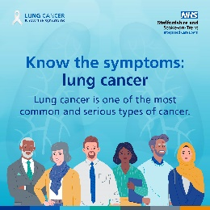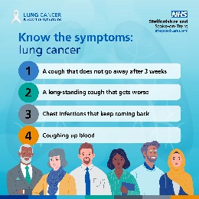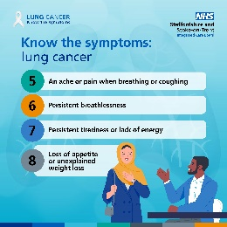  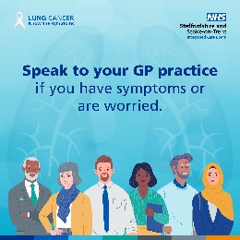 | Learn the symptoms and contact your GP practice if you are worried. | https://www.nhs.uk/conditions/lung-cancer/symptoms/

