Food First Campaign – Post Copy
Post copy | Graphic
If your loved one has lost weight or is malnourished, there are loads of easy ways to make the foods and drinks they already enjoy at home more nutritious. Find out more https://staffsstokeics.org.uk/oral-nutritional-supplements-ons/ | 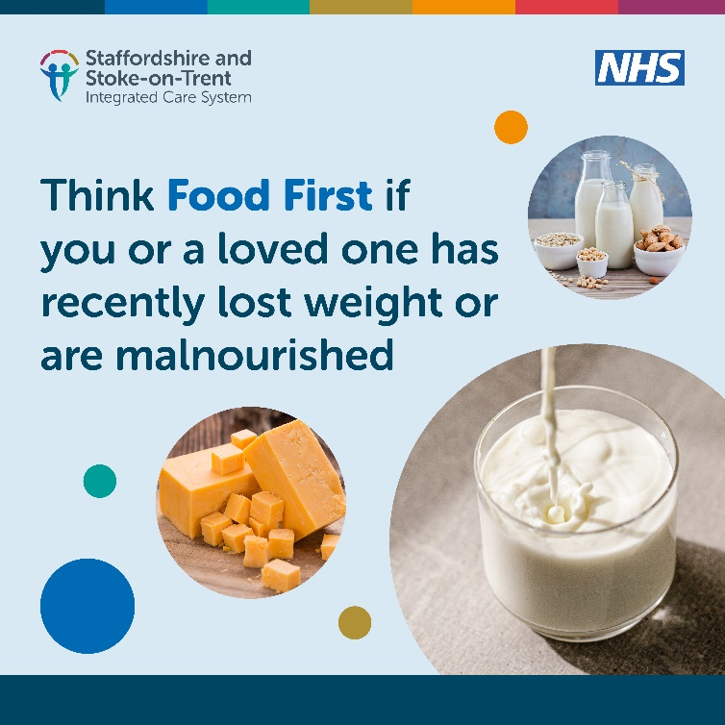
We want patients to enjoy the foods and drinks they love, instead of relying of prescribed supplements that often have no benefits when compared to food. Find out more about how we’re helping patients achieve this by visiting https://staffsstokeics.org.uk/oral-nutritional-supplements-ons/
We want people to enjoy the foods and drinks they already love, instead of taking supplements that often aren’t as nice and no better for you. To help with this, we’ve got hints and tips on how you can make your food and drinks even more nutritious. Visit https://staffsstokeics.org.uk/oral-nutritional-supplements-ons/

