Over the counter medicines and vitamins – social media copy

Graphic | Post copy (each numbered point is a separate ‘post’ and are not linked)
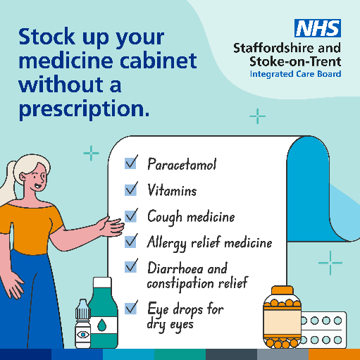 | - Going for your weekly food shop? It’s quick, easy and simple to stock up on medicines and vitamins that are no longer prescribed by GPs at your local pharmacy or supermarket.  - Ordering your food shop online? Even if you can’t get to the shops or pharmacy, it’s quick and easy to order essential medicines and vitamins that are no longer prescribed by GPs with your weekly shop.  - Live in a rural area without a pharmacy close by? Add these products onto your weekly food shop is a quick and easy way to help you stay well.  - If you can’t get out and about, medicines and vitamins that are no longer given on prescriptions can be added to your next online food shop, or ask a loved one to pick them up next time they get your shopping.
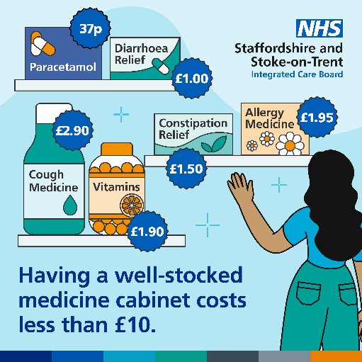 | - Feeling under the weather? A well-stocked medicine cabinet can help ease symptoms quickly and easily without having to wait for appointment you may not need. Stock yours up today – it may cost less than you think!  - A supermarket or pharmacy’s own-brand medicines and vitamins are just as effective and can cost a fraction of the price. Plus, you can get your hands on them quickly and easily. Stock up your medicine cabinet to help keep you well.  - Some medicines and vitamins are no longer given on prescription, but you can get them easily at your local supermarket or pharmacy. Cheaper own-brand medicines are just as effective and you can get them with your weekly shop.
 | - Time for your weekly food shop? Adding healthy foods into your shopping cart where you can is a quick and easy way to help you get essential nutrients and vitamins.

