Stakeholder briefing

Safe Sleep campaign

Campaign introduction
We would like to share news about the Staffordshire and Stoke-on-Trent Integrated Care System (ICS) Safe Sleep campaign.

This campaign is aimed at providing parents and careers with clear, consistent messaging relating to safe sleep with their newborn. There is a lot of misinformation and conflicting information on the internet about safe sleep and the aim with this campaign is to provide one place where parents and carers can go to for advice and support on this important topic. The aim is to increase awareness of Sudden Infant Death Syndrome (SIDS) and ultimately the uptake of measures that support safe sleep amongst carers and parents of babies and young children in Staffordshire and Stoke-on-Trent.

The Safe Sleep campaign equips parents and carers with the information they need to make informed choices for their newborn via leaflets, a webpage and a video. We also encourage them to seek advice and support directly from their Health Visitor.

This toolkit has been developed to help raise awareness of SIDS and advice for the safe sleep of newborns. This toolkit is designed to share the correct information simply and clearly and encourage more people to adopt safe sleep practices.

What this campaign toolkit includes
To help you support the campaign locally, this toolkit includes a range of materials including:
Comms material | Content | Action required
Social media | Social media images and social media posts | Schedule relevant posts on social media channels
Public website | Website/intranet copy | Upload to your website
Flyer | An electronic flyer | To upload to your website for supporting information

How to use the campaign toolkit
Please utilise as many of the enclosed resources as possible to help raise awareness of safe sleep.
Wherever you can, try to use the materials as they have been provided to promote the campaign messages. Avoid making changes unless absolutely necessary. This will help to ensure consistency of branding and messaging throughout the region.
We have also provided a video [Safe sleep for babies] for the public which might be helpful.
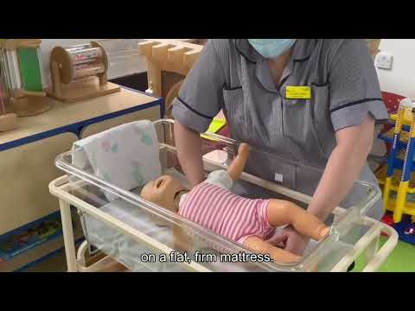

Key messages
- To increase the awareness of SIDS with newborns
- To improve the knowledge of safe sleep practices for parents and carers with newborns
- To encourage contacting their Health Visitor with any questions or support required

For more information
If you have any questions about this toolkit or require more information, please email sue.lloyd@staffsstoke.icb.nhs.uk
Or visit the ICS webpage: www.staffsstokeics.org.uk/safe-sleep

