Staffordshire and Stoke-on-Trent Steady On Your Feet
Communications Toolkit
May 2026

Background - what is Staffordshire and Stoke-on-Trent Steady On Your Feet?

- Steady On Your Feet is a falls prevention solution. Across the UK, it helps NHS and local authority teams deliver earlier intervention, reduce system pressure and support people to stay independent for longer. It brings together a local website, self-assessments, action plans and a full campaign toolkit, all in one package.
- The platform is part of a collaborative falls prevention initiative led by Staffordshire and Stoke-on-Trent Integrated Care Board (ICB), with support from partners across Staffordshire and Stoke-on-Trent Integrated Care System (ICS), including voluntary, community and social enterprise (VCSE) partners.

If you’d like to request any of the bespoke files from the toolkit, please email: ssotics.comms@staffsstoke.icb.nhs.uk or visit Staffordshire and Stoke-on-Trent Integrated Care System’s online Campaign Resource Centre Campaign resource centre - Staffordshire and Stoke-on-Trent, ICS (files will be available on the Centre from 15/05/2026).

News article

New website launches to help Staffordshire and Stoke-on-Trent residents stay steady on their feet

Date: 14 May 2026
Image: by Peter Kindersley via Centre for Ageing Better

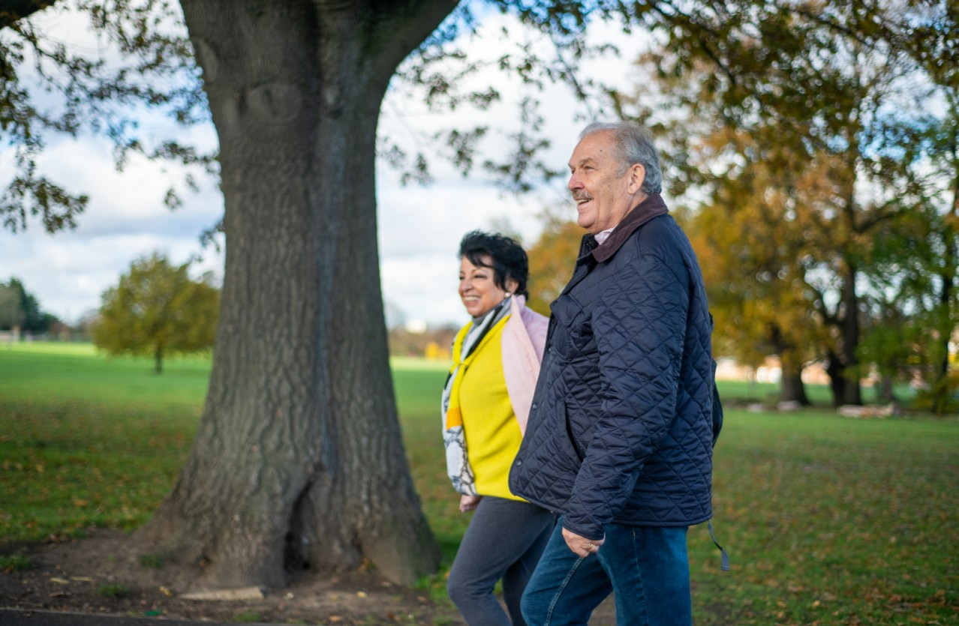

Falls are one of the most common causes of injury in later life, but many can be prevented with the right advice, support and early action. A new online platform has launched in Staffordshire and Stoke-on-Trent to help local people stay steady on their feet and reduce their risk of falling.

The Staffordshire and Stoke-on-Trent Steady On Your Feet website offers free, trusted advice and personalised support for older adults, their families and carers. Whether you want to improve your balance, make your home safer, or learn more about local support, the website is here to help.

The website includes a quick self-assessment tool, personalised action plans, and easy-to-follow advice covering common causes of falls such as poor balance, dizziness, medication or changes in memory. Users can also find information on staying active and improving their home safety, including local links and signposts to support services in their area.

The platform is part of a collaborative falls prevention initiative led by Staffordshire and Stoke-on-Trent Integrated Care Board (ICB), with support from partners across Staffordshire and Stoke-on-Trent Integrated Care System (ICS), including voluntary, community and social enterprise (VCSE) partners.

In Staffordshire and Stoke-on-Trent, 1,443 people aged over 65 contacted 999 because of a fall between 2024 - 2025.

Once a bone has been fractured, only 24% of people return to their previous level of movement and independence. And even if they’re not too badly affected physically, falls can destroy confidence, increase isolation and reduce independence, with around 1 in 10 older people who fall becoming afraid to leave their homes in case they fall again.

Dr Lorna Clarson, Chief Officer Strategy and Improving Outcomes, NHS Shropshire, Telford and Wrekin and NHS Staffordshire and Stoke-on-Trent, said:

“The new Steady On Your Feet website for Staffordshire and Stoke-on-Trent offers a wide variety of information and local signposting links to help people make those small changes which can reduce their risk of falls.”

Developed in partnership with NHS and public health teams across the country, Steady On Your Feet is already supporting residents in other areas. More than 10,000 self-assessments have been completed so far, generating over 7,500 personalised action plans to help users take positive steps towards preventing falls.

"We know how important early action is in preventing falls. This platform makes it easier for individuals and communities to get the advice, support and tools they need, in one trusted place. We’re excited to welcome Staffordshire and Stoke-on-Trent to our growing network of Steady On Your Feet partners,” said Mark Easby, Managing Director, Steady On Your Feet.

The website is free to use and can be completed on your own or with support from a friend, carer or health professional. It’s also designed to work well on phones, tablets and computers.

Watch the Staffordshire and Stoke-on-Trent Steady On Your Feet trailer here https://youtu.be/KRxg-9vMVQc

To find out more and complete your free self-assessment, visit: https://www.steadyonyourfeet.org/staffsstoke

QR code



Video (via YouTube)

https://youtu.be/KRxg-9vMVQc

Social media

Copy to be amended by channel

Falls are one of the most common causes of injury in later life, but many can be prevented with the right advice, support and early action. The Staffordshire and Stoke-on-Trent Steady On Your Feet website is a new online platform to help local people reduce their risk of falling. It offers free, trusted advice and personalised support for older adults, their families and carers. Whether you want to improve your balance, make your home safer, or learn more about local support, the website is here to help. Find out more at https://staffsstoke.steadyonyourfeet.org/

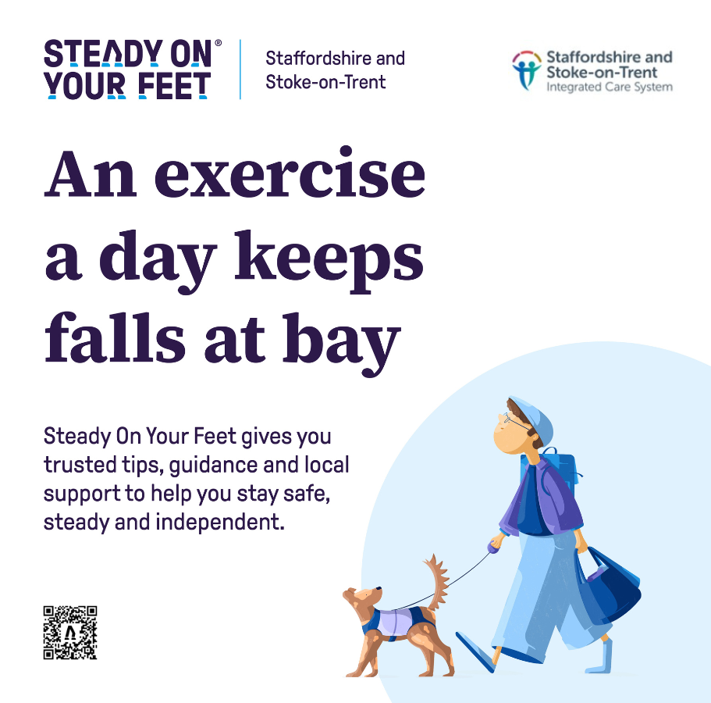

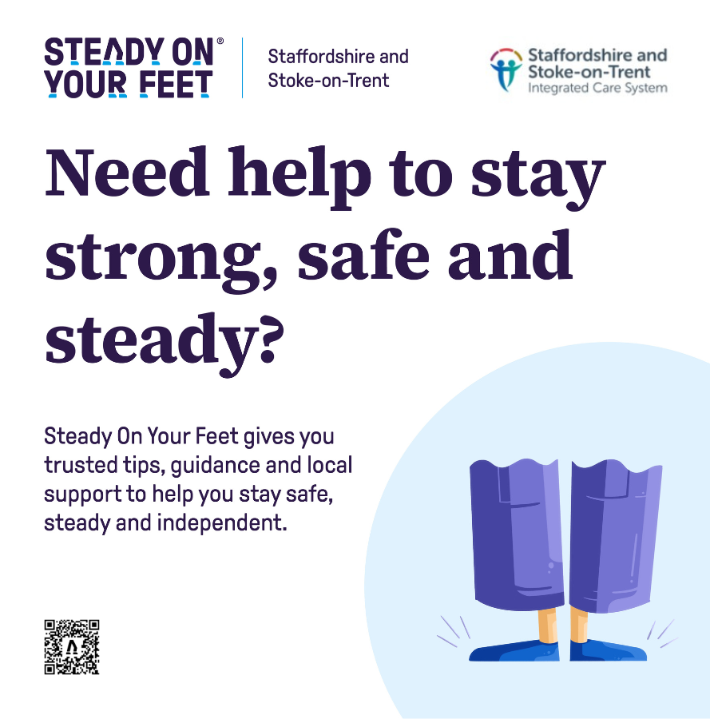

Digital desktops

1024x768

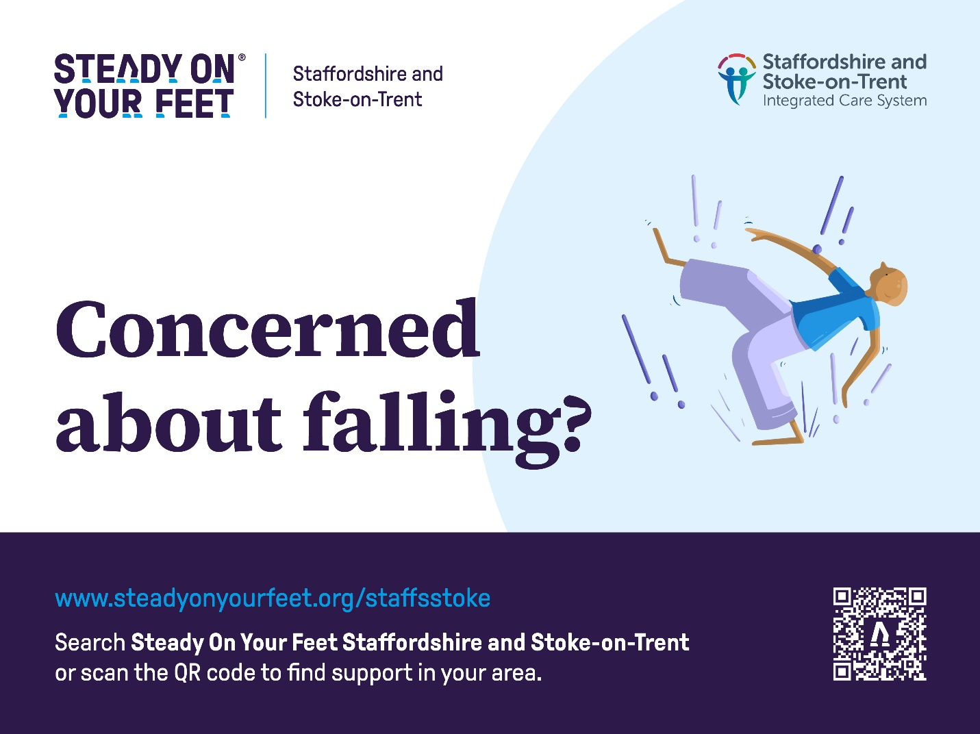

1920x1080

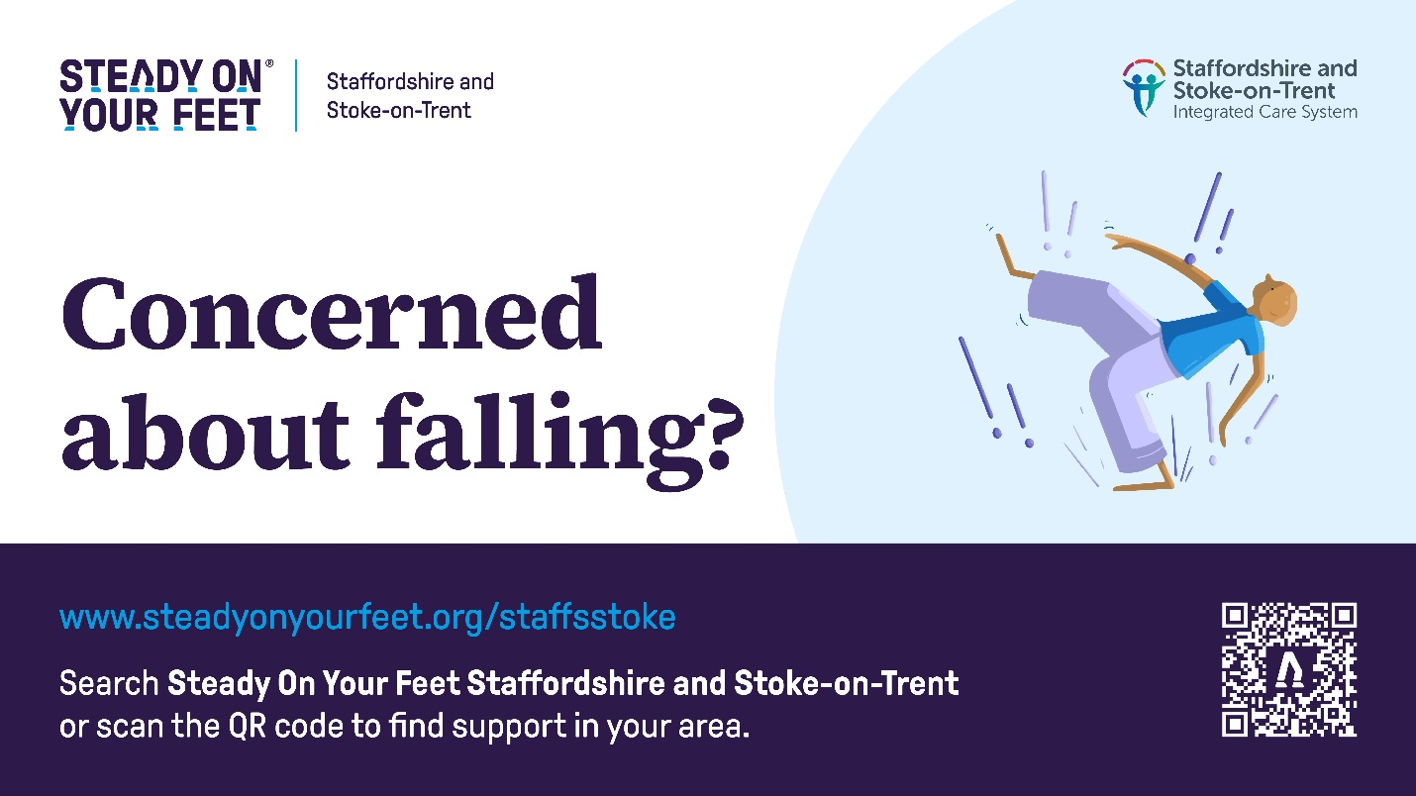

Poster

https://staffsstokeics.org.uk/wp-content/uploads/2026/05/SOYF_StaffsStoke_Posters_A3_SelfPrint_02.pdf

