

Audiology self-referral toolkit
We have created some posters that can be shared digitally or printed and displayed in health and social care settings. You can download these below:
Audiology self-referral poster- print version
Audiology self-referral poster- print version with 3mm bleed
Audiology self-referral poster- digital version

Social media toolkit
The below toolkit includes social media copy and assets, that you can share on your own communication channels.

Channel | Copy | Graphic/ Download link
Twitter/  Instagram/ LinkedIn | If you are having problems with your  hearing, you can now self-refer into NHS audiology (hearing) services. To find out if you’re eligible, visit  - https://staffsstokeics.org.uk/audiology-  self-referral | 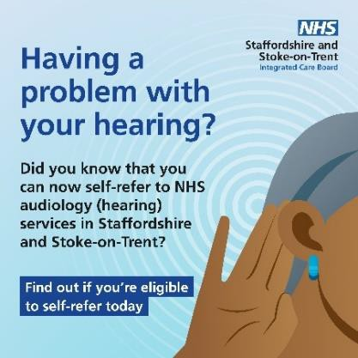  Audiology Self-referral social square asset v1
Twitter/  Instagram/ LinkedIn | If you’re having problems with your  hearing, you might not have to wait for an appointment with your GP to get a referral. Find out if you are eligible to self-refer to NHS hearing services today.  https://staffsstokeics.org.uk/audiology-  self-referral | 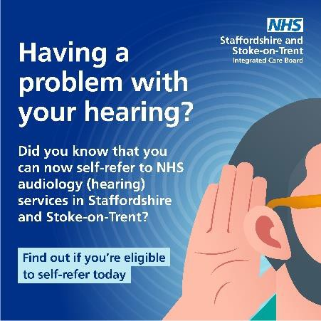  Audiology Self-referral social square asset v2

Twitter/  Instagram/ LinkedIn | Having trouble with your hearing? You can now self-refer into NHS audiology services to get the support you need. Visit  https://staffsstokeics.org.uk/audiology-  self-referral to find out if you’re eligible. | 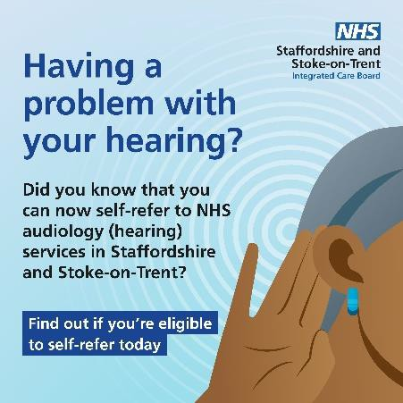  Audiology Self-referral social square asset v1
Twitter/  Instagram/ LinkedIn | Are you having difficulty with your  hearing? Self-refer from the comfort of your own home, without the need for a trip to the doctors. Find out if you’re  eligible by visiting-  https://staffsstokeics.org.uk/audiology-  self-referral | Audiology Self-referral social square asset v2
Facebook | If you are having problems with your  hearing, you can now self-refer into NHS audiology (hearing) services. To find out if you’re eligible, visit  - https://staffsstokeics.org.uk/audiology-  self-referral | 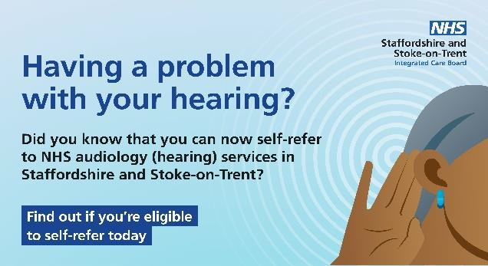  Audiology Self-referral SOCIAL FACEBOOK v1
Facebook | If you’re having problems with your  hearing, you might not have to wait for an appointment with your GP to get a referral. Find out if you are eligible to self-refer to NHS hearing services today.  https://staffsstokeics.org.uk/audiology-  self-referral

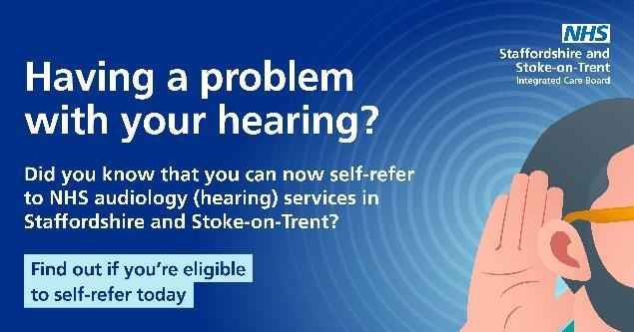

Audiology Self-referral SOCIAL FACEBOOK v2
Facebook | Having trouble with your hearing? You can now self-refer into NHS audiology (hearing) services to get the support you need. Visit  https://staffsstokeics.org.uk/audiology-  self-referral to find out if you’re eligible. | Audiology Self-referral SOCIAL FACEBOOK v1
Facebook | Are you having difficulty with your  hearing? Self-refer from the comfort of your own home, without the need for a trip to the doctors. Find out if you’re  eligible by visiting-  https://staffsstokeics.org.uk/audiology-  self-referral | 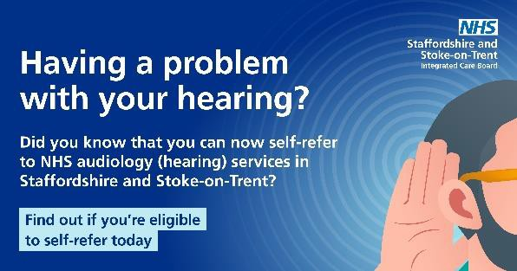  Audiology Self-referral SOCIAL FACEBOOK v2

