Bank Holiday Social Media Toolkit
Post copy | Image
Some local pharmacies may have different opening hours over the bank holiday. To find an open pharmacy near you, visit https://nhs.uk/service-search/pharmacy/find-a-pharmacy. | 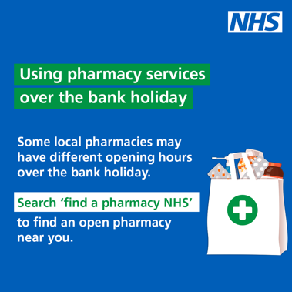
Some GP services will be available over the bank holiday.  If you have a health concern, contact your GP practice or use NHS 111 online or call 111 for urgent medical help.  ➡️ http://111.nhs.uk | 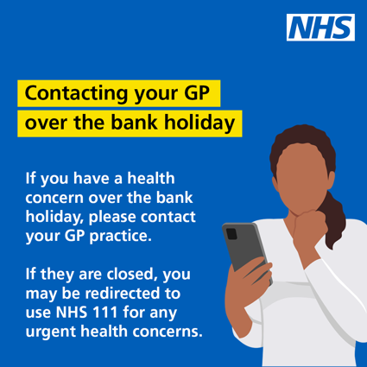
If you need urgent dental treatment over the bank holiday, contact your usual dentist.  If you cannot contact your dentist, use NHS 111 online or call 111 for information about your local out of hours service.  ➡️ http://111.nhs.uk | 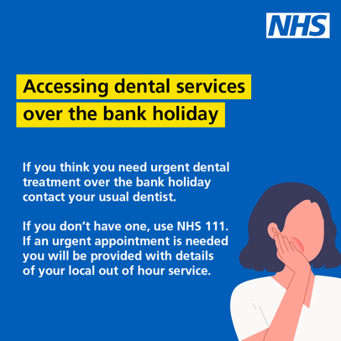
With the bank holiday approaching, make sure you order your repeat prescription in advance.  For more information on how to do this, https://www.nhs.uk/nhs-services/prescriptions/how-to-order-a-repeat-prescription/ | 