Crisis mental health access via NHS 111

Communications toolkit update shared on behalf of the ICB Mental Health, Learning Disability and Autism portfolio
October 2024

Overview
ICBs across England are offering access to age-appropriate urgent mental health support via a new service, NHS 111’s ‘select mental health option’. People of all ages, including children, or concerned family and loved ones, can now call 111, select the mental health option and speak to a trained mental health professional.
We have been working to identify and resolve any new service and technology issues as and when they occur, and to provide shared learning between systems and regions. Following national promotion, to support the roll out of this functionality and with operational team and regional comms group agreement, Staffordshire and Stoke-on-Trent Integrated Care Board (ICB) is now proactively promoting this service to members of the public for the first time. We will actively promote from World Mental Health Day on Thursday 10 October 2024.
To support with the promotion, a communication toolkit has been created. This toolkit has been designed to support the dissemination of local Staffordshire and Stoke-on-Trent communications for NHS 111 ’select mental health option’ and to further support the preparation for winter 2024/25 messaging.
This toolkit includes:
- Information for patients
- Internal message example
- Visuals
- Examples of social media posts
- Message for key stakeholders.
It has been agreed operationally that mental health trust dedicated phone numbers for urgent mental health support will continue alongside NHS 111 ‘select mental health option’ until a date to be agreed by the project operations team. This will be communicated with you as soon as there is an update.
A NHS England ‘Mental health crisis care services – national patient feedback survey’ is also now running until 15 July 2025. This survey is specifically intended for individuals who have accessed crisis care services through the NHS 111 'select mental health option' service. Mental health crisis care services – national patient feedback survey - NHS England - Citizen Space Further promotion information is included in this toolkit messaging.
For more information on NHS 111 ‘select mental health option’ localised communications, please contact: ssotics.comms@staffsstoke.icb.nhs.uk

Information for patients (can also be used as website copy)
Anyone across Staffordshire and Stoke-on-Trent can now get urgent mental health support, 24/7, by calling 111 and selecting the mental health option.
The new service, which has been rolled out across England, means that trained mental health professionals will guide callers through the next steps most appropriate for them, including organising face-to-face community support.
What happens when I call?
The phone will be answered by a trained mental health professional who will be able to listen to your concerns and help you get the support you need. With your permission, they can also access your electronic patient records to better meet your needs and to avoid you repeatedly having to tell us your situation. They can offer advice over the phone, put you in contact with urgent services or refer you to the most appropriate local services for your needs
Who can call?
You can call for yourself, or someone else. NHS 111 is for all ages, including children and young people and those with neurodevelopmental needs.
If you’re deaf or have hearing loss, please use the following link to be connected to local crisis service – NHS 111 – SignVideo.
If you aren't able to make the call yourself, then anyone can call on your behalf - for example a friend, carer, loved one or even your GP. You can also access NHS 111 online via 111.nhs.uk.
The service is available to anyone in England and facing a mental health crisis, which could include:
- Severe changes to your mood
- Withdrawing from people (close family, friends, or work colleagues)
- Not taking care of yourself like you usually would
- Having increased thoughts about your life not being worth living
- Excessive worry
- Feeling out of control or unable to cope
- Feeling anxious about leaving the house
- Hearing voices or seeing things that others can’t
- Thinking about harming yourself.

By calling NHS 111, and selecting the mental health option, we can help to get you the urgent support you need for your mental health.

Other ways to get support:
National organisations:
• SANELine – This is a national out of hours mental health helpline. It offers specialist emotional support, guidance, and information to anyone affected by mental illness, including family, friends and carers. They are open every day from 4pm – 10pm on 0300 304 7000. They can also be contacted via email: support@sane.org.uk however, there is normally a 72-hour turnaround time for replies.
• Samaritans – Available 24 hours a day 365 days a year by calling 116 123 (free from any phone)
• National Suicide Prevention Helpline UK – Available on 0800 689 5652 (6pm – midnight every day)
• CALM – Available on 0800 58 58 58 (5pm – midnight every day). They also have a webchat service
• SHOUT – Available via text, if you message SHOUT to 85258. Shout offers a confidential 24/7 text service if you are in a crisis and need immediate help.
• Papyrus HOPELINE UK – Available to under 35-year-olds, struggling with suicidal feelings or concerns about a young person who might be struggling, on 0800 0119 100 (24 hours, 7 days a week) or text 88247
• Nightline - Students can look on the Nightline website to see if their university or college offers a night-time listening service. Nightline phone operators are all students too.
• Switchboard – Available to people who identify as gay, lesbian, bisexual or transgender, on 0300 330 0630 (10am–10pm every day) or via their webchat service. Phone operators all identify as LGBT+
• Cruse- the UK’s leading bereavement charity; provides a helpline run by trained bereavement volunteers, who offer emotional support to anyone affected by grief. Call 0808 808 1677 (Monday, Wednesday, Thursday and Friday, 9.30am-3pm. Tuesday 1pm – 8pm. Saturday and Sunday Closed. ).
• Childline - a free, private, and confidential service where young people can talk about anything. Calls are free and confidential. Calls are not recorded, and their number won't show up on any phone bills. Call 0800 1111 (24 hours a day, every day)
Local organisations offering urgent support:
• North Staffordshire: 0800 032 8728. Available via text for people with a hearing impairment who are unable to utilise the telephone, on 07739 775202. The team will respond as soon as possible. Please note: this text service is available during the normal service hours and is charged at your network provider’s rate.
• South Staffordshire: 0808 196 3002
• Staffordshire and Stoke-on-Trent NHS Talking Therapies - available to people aged 16 and over, experiencing common mental health problems such as depression, anxiety, and Post Traumatic Stress Disorder (PTSD), and who are registered with a GP practice in Staffordshire and Stoke-on-Trent. Self-referrals can be made online via the web link or calling 0300 303 0923.

In emergency situations where there is an immediate risk to life, you should continue to contact 999 or go to A&E.

NHS 111 ‘select mental health option’ survey
If you have contacted NHS 111 ‘select mental health option’, how was your experience? NHS England would like your feedback. This survey is specifically intended for individuals who have accessed crisis care services through the NHS 111 'select mental health option' service. Its purpose is to gather feedback on your experience and the support you have received.
Responses collected through this survey will be analysed to identify areas where improvements can be made to enhance the quality of care provided.
If you require an alternative format of this survey, please contact england.adultmh@nhs.net.
Access the survey at Mental health crisis care services – national patient feedback survey - NHS England - Citizen Space

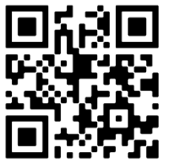

Internal message
Anyone across Staffordshire and Stoke-on-Trent can now get urgent mental health support, 24/7, by calling 111 and selecting the mental health option.
The new service, which has been rolled out across England, means that our system’s trained mental health professionals will guide callers through the next steps most appropriate for them, including organising face-to-face community support.
This service streamlines care for people who need urgent mental health help, while also saving clinician time and easing pressure on existing services urgent and emergency care and primary care services.
Ben Richards, Senior Responsible Officer for the NHS Staffordshire and Stoke-on-Trent Integrated Care System (ICS) Mental Health programme of work, said: “For someone with urgent mental health support needs, this can be distressing, whether that is for the person themselves, or a loved one who is trying to support them.
“Getting help as quickly as possible is vital so any step which helps get people that help sooner will only help those most in need.
“The new integrated service can give people of all ages specialist mental health support and ensure they can be offered face-to-face support in a safe and therapeutic environment.”
Please spread the word about this to your colleagues and networks, and use the visuals included with this message to promote the new access number for urgent care support.
Our local crisis lines will remain accessible directly via 0800 032 8728 (option 1) for those living in North Staffordshire and Stoke-on-Trent, or via 0808 196 3002 for those living in the rest of Staffordshire.
NHS 111 ‘select mental health option’ survey
A NHS 111 ‘select mental health option’ survey by NHS England is also running until 15 July 2025. This survey is specifically intended for individuals who have accessed crisis care services through the NHS 111 'select mental health option' service. Its purpose is to gather feedback on their experiences and the support received.
Responses collected through this survey will be analysed to identify areas where improvements can be made to enhance the quality of care provided.
Please promote the survey which can be accessed at Mental health crisis care services – national patient feedback survey - NHS England - Citizen Space

If you have any questions about NHS 111 ‘select mental health option’, please email mentalhealthportfolioinbox@staffsstoke.icb.nhs.uk

GP comms
People of all ages (children and adults) living in Staffordshire and Stoke-on-Trent can now access 24-hour urgent mental health support directly via NHS 111.
Specially trained mental health staff will be available to speak to callers, discuss their urgent needs and assess the best way to support them, depending on their symptoms. This may be by offering emotional support or signposting to other services. If people have physically harmed themselves, or if their life is at immediate risk, then they should continue to call 999 or go to A&E.
This development is part of a national project to make it easier for people to contact the mental health support team in their local area, without having to remember or search for a helpline number.
Please note:
- GPs and primary care professionals should continue to refer all non-crisis mental health referrals through the usual routes e.g. for adults, to a local Talking Therapies provider, mental health teams, or Mental Health Practitioners or for children and young people, to the local CAMHS team. You can signpost a patient to the helpline for emotional support and signposting.
- If you assess a patient and feel they are in crisis and need immediate on-going support, please refer them to xxx as before. The helpline team cannot offer ongoing face-to-face support to people and does not carry caseloads.
- If you, as the GP or primary care professional, would like advice from the helpline team about someone who is experiencing a mental health crisis, please call the professionals’ number: 0808 196 3002 . You are welcome to tell a patient to call the helpline team for support but this shouldn’t be the route when follow-up face-to-face support is needed.
- For people who are Deaf or have hearing loss, the following link will enable them to connect to the helpline – NHS 111 – SignVideo.
Our local crisis lines will remain accessible directly via 0800 032 8728 (option 1) for those living in North Staffordshire and Stoke-on-Trent, or via 0808 196 3002 for those living in the rest of Staffordshire.
NHS 111 ‘select mental health option’ survey
A NHS 111 ‘select mental health option’ survey by NHS England is also running until 15 July 2025. This survey is specifically intended for individuals who have accessed crisis care services through the NHS 111 'select mental health option' service. Its purpose is to gather feedback on their experiences and the support received.
Responses collected through this survey will be analysed to identify areas where improvements can be made to enhance the quality of care provided.
Please promote the survey which can be accessed at Mental health crisis care services – national patient feedback survey - NHS England - Citizen Space

If you have any questions about NHS 111 ‘select mental health option’, please email mentalhealthportfolioinbox@staffsstoke.icb.nhs.uk

Visuals
Accompanying this toolkit, you will find visuals to use alongside posts promoting the launch of NHS 111 ‘select mental health option’ on your website, by emails and letters, and on social media.
There are also localised posters that you can use. You can access all these graphics here
Example graphics:
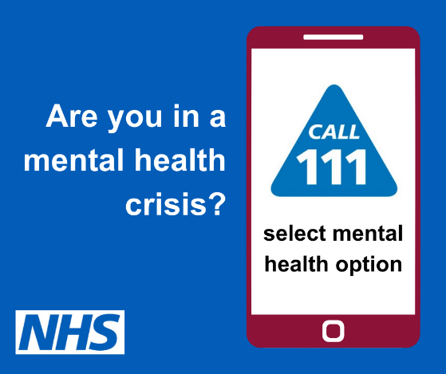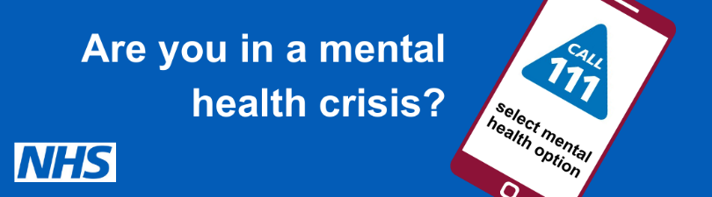

Examples of social media messages
Below are some examples of social media messages you may wish to use on your channels. You can change the area to make this even more localised if you so wish. There are also banners included in the pack of visuals that accompanies this toolkit.
- If you need urgent #mentalhealth support in Staffordshire and Stoke-on-Trent you can now call 111 and select the mental health option to talk to a mental health professional and get help 24/7. More information is available on our website: https://staffsstoke.icb.nhs.uk/our-work/mental-health-2/crisis-mental-health-access-via-nhs-111/
- It’s hard to know who to talk to if you need urgent mental health support. You can now call 111 and select the mental health option to get help 24/7 from a mental health professional in Staffordshire and Stoke-on-Trent. More information is available on our website: https://staffsstoke.icb.nhs.uk/our-work/mental-health-2/crisis-mental-health-access-via-nhs-111/
- If you need urgent mental health support, it can be difficult to know what to do. Your local NHS is Staffordshire and Stoke-on-Trent is here to help – just call 111 and select the mental health option. More information is available on our website: https://staffsstoke.icb.nhs.uk/our-work/mental-health-2/crisis-mental-health-access-via-nhs-111/
- Need urgent support for your mental health? Call 111 and select the mental health option to talk to a mental health professional in Staffordshire and Stoke-on-Trent. More information is available on our website: https://staffsstoke.icb.nhs.uk/our-work/mental-health-2/crisis-mental-health-access-via-nhs-111/
- Your local NHS in Staffordshire and Stoke-on-Trent offers 24/7 urgent mental health support over the phone for all ages. Call 111 and select the mental health option to speak to a mental health professional. More information is available on our website: https://staffsstoke.icb.nhs.uk/our-work/mental-health-2/crisis-mental-health-access-via-nhs-111/

Message for key local stakeholders
Extended 111 service offers urgent mental health support in Staffordshire and Stoke-on-Trent
People living in Staffordshire and Stoke-on-Trent will now be able to access urgent mental health support directly via NHS 111, 24/7.
Our local mental health crisis lines, managed between Midlands Partnership University NHS Foundation Trust (MPFT) and North Staffordshire Combined Healthcare NHS Trust (NSCHT), can now be accessed via NHS 111 ‘select mental health option’.
The extension of the 111 service means people who need urgent mental health support will be able to dial the NHS urgent medical advice number. By calling ‘111’ and selecting the ‘mental health option’, they will be put through to a member of the MPFT or NSCHT local crisis service, depending on where they live in Staffordshire and Stoke-on-Trent.
Specially trained mental health staff will speak to callers, discuss their urgent needs, and assess what the best way to support them is depending on their symptoms.
We think this a really important step forward to improve care for those who are suffering mental health issues. Until now, many people with urgent mental health support needs didn’t know which number to call or who to turn to for help.
If people have physically harmed themselves, or if their life is at risk, then they should continue to call 999 or go to the local Emergency Department (ED). But more often people just want someone to talk to, and advice on what help is available and which services they can access.
Overall, we are aiming to give urgent mental health support parity of esteem by making help more easily accessible and available as well as easing pressure on A&E departments and primary care services.
We count on your support to promote NHS 111 ‘select mental health option’ to your local networks, including the vulnerable people you support on a daily basis.
Our local crisis lines will currently remain accessible directly via 0800 032 8728 (option 1) for those living in North Staffordshire and Stoke-on-Trent, or via 0808 196 3002 for those living in the rest of Staffordshire alongside this new service offer.
NHS 111 ‘select mental health option’ survey
A NHS 111 ‘select mental health option’ survey by NHS England is also running until 15 July 2025. This survey is specifically intended for individuals who have accessed crisis care services through the NHS 111 'select mental health option' service. Its purpose is to gather feedback on their experiences and the support received.
Responses collected through this survey will be analysed to identify areas where improvements can be made to enhance the quality of care provided.
The survey can be accessed at Mental health crisis care services – national patient feedback survey - NHS England - Citizen Space

