RSV social media images for launch

Image | Post copy | Alt text
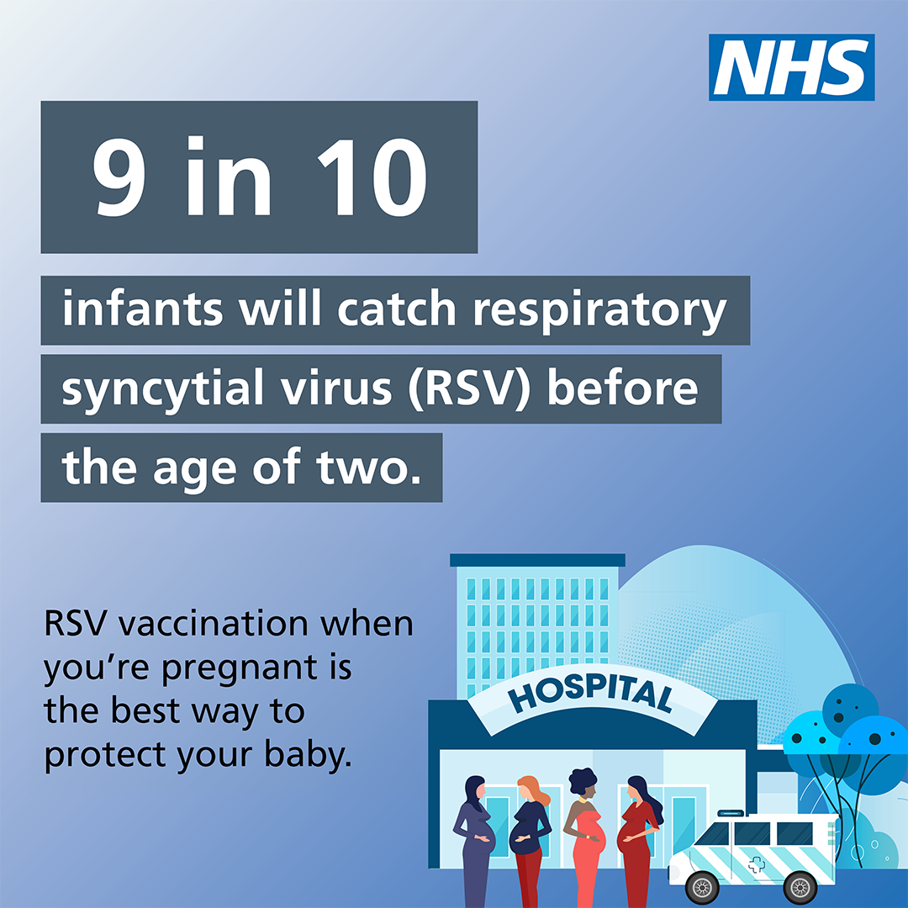 | Respiratory syncytial virus (RSV) can cause lung infections like bronchiolitis, making it difficult for newborn babies to breathe and causing 20,000 infants to need hospital treatment each year.  Talk to your GP or maternity service to schedule yours from 28 weeks of pregnancy. | An illustration of a hospital with pregnant women stood outside. Text reads: 9 in 10 infants will catch respirator syncytial virus (RSV before the age of two. Speak with your maternity service or GP to get your free vaccine.
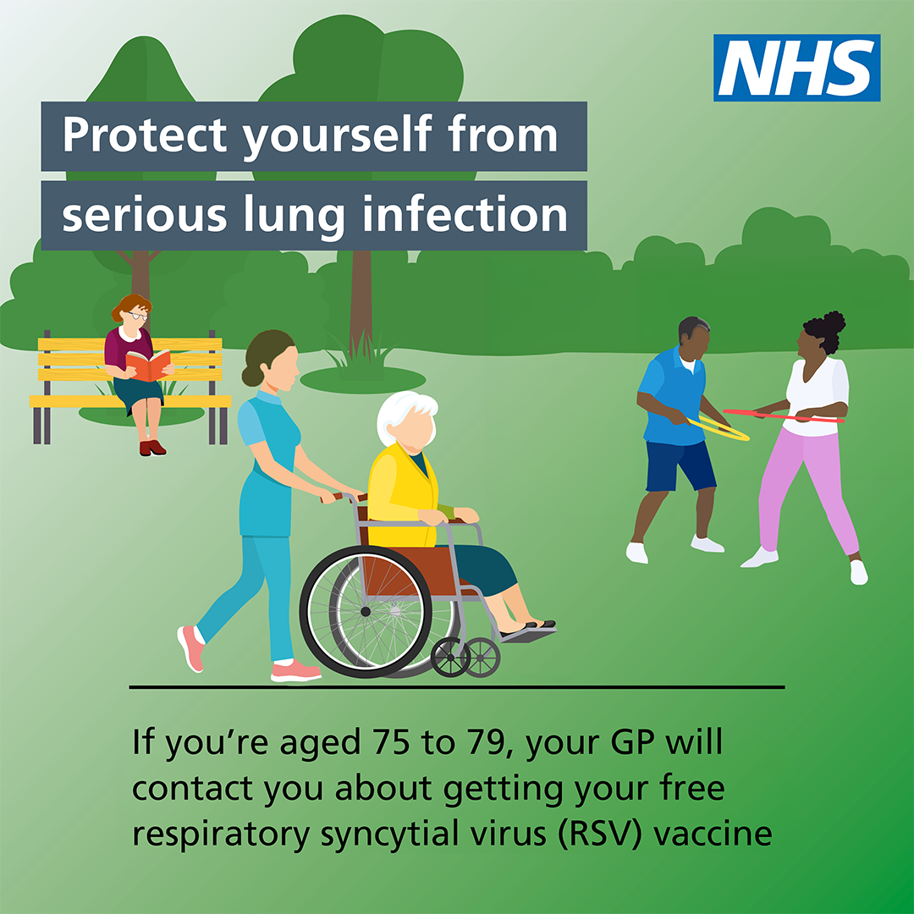 | People aged 75-79 can get a free vaccination to protect themselves from respiratory syncytial virus (RSV), a common lung infection that can lead to serious illnesses like pneumonia.  Read more about RSV vaccination here: https://www.nhs.uk/conditions/respiratory-syncytial-virus-rsv/ | An illustration of older people doing activities in a park. Text reads: Protect yourself from serious lung infection. If you’re aged between 75-79, your GP will contact you about getting your free respiratory syncytial virus (RSV) vaccine.
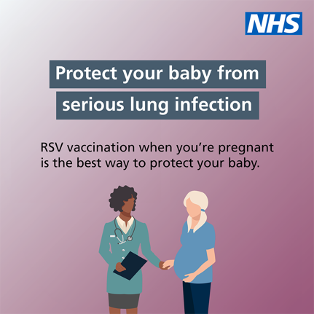 | Pregnant women are eligible for a free respiratory syncytial virus (RSV) vaccine to protect their babies from serious lung infections.  You can get your vaccine from 28 weeks of pregnancy. Talk to your GP or maternity service to schedule yours.  Read more: https://www.nhs.uk/conditions/respiratory-syncytial-virus-rsv/ | An illustration of a pregnant women talking to a health care professional. Text reads: Protect your baby from serious lung infection. If you’re at least 28 weeks pregnant, speak to your maternity service or GP about getting your RSV vaccination.

