Health Passport social media posts
March 23

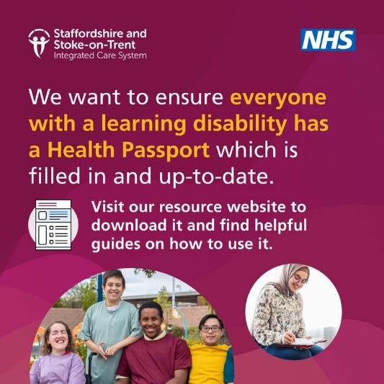 | Visit the website to get your free Health Passport and to find useful guides, videos and more.  https://staffsstokeics.org.uk/health-passport/
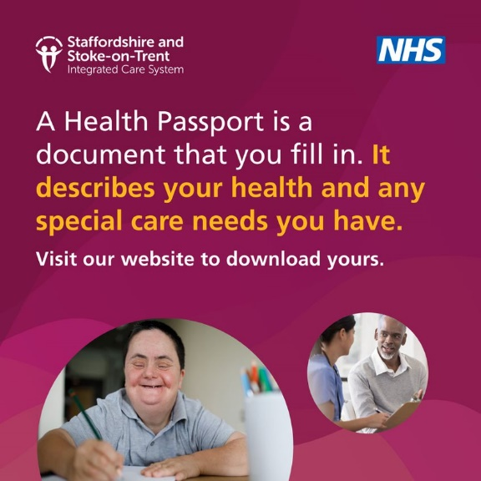 | We want to ensure everyone with a learning disability has access to their own Health Passport. You can get yours here.  https://staffsstokeics.org.uk/health-passport/
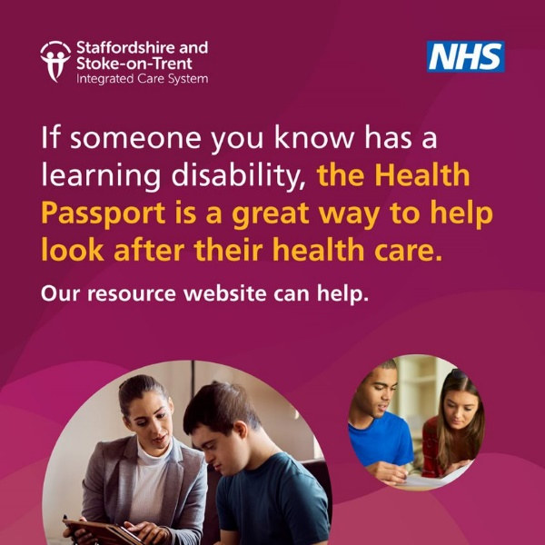 | Do you support or care for a person with a learning disability?  There are a range of Health Passport resources to help you look after the person you care for.  https://staffsstokeics.org.uk/health-passport/

