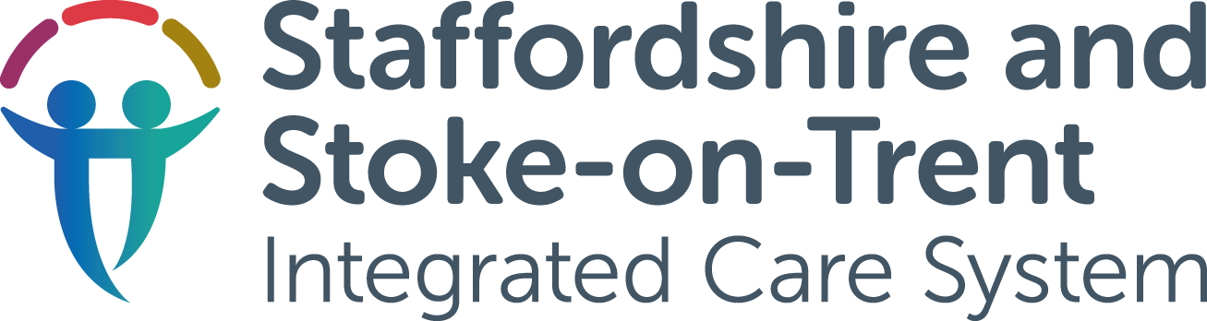

Small Changes
Briefing Sheet
November 2023
A Learning Disability and Autism campaign
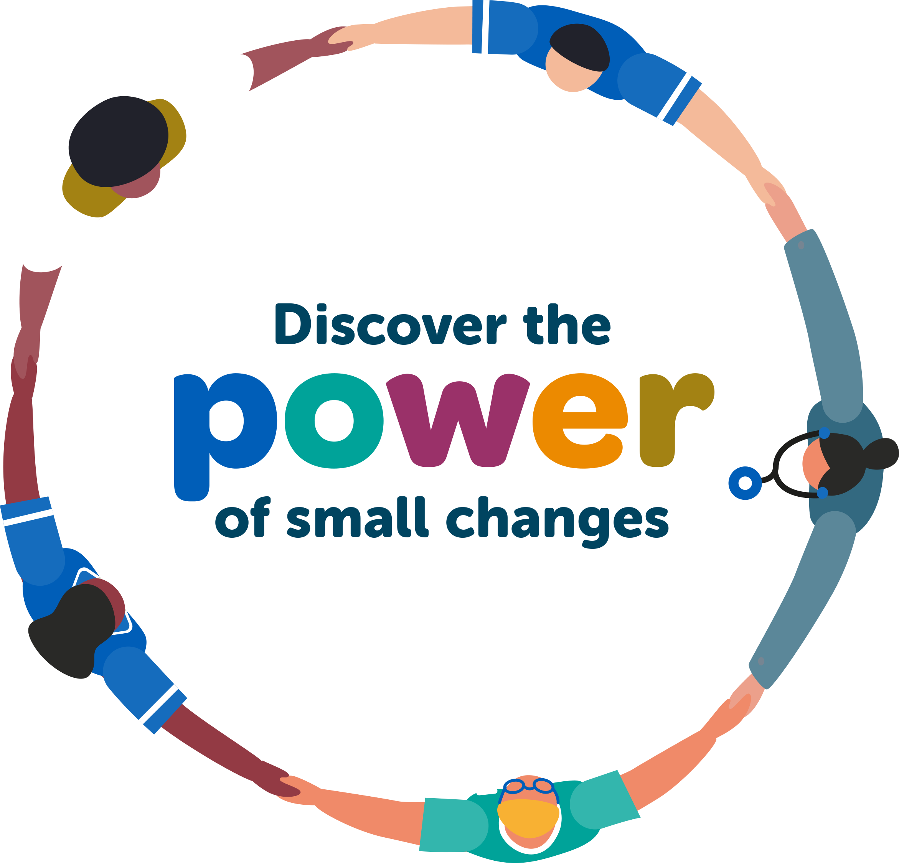
www.staffsstokeics.org.uk/small-changes

About the campaign
Everyone with a learning disability, autism, or both, deserves to live longer, healthier and more independent lives. In Staffordshire and Stoke-on-Trent, people with a learning disability and/or autism want to feel listened to, supported, and understood, without judgement, when using health, care and community services. Across the region there are some excellent examples of where this already happens, but there are also some small changes that could be made to support people having a more positive experience and better outcomes for all.
We have designed this campaign to support people to make small changes that will ultimately make a positive difference to the experience of those with a learning disability and/or autism. We are also aware that some of the small changes that are being suggested could make a positive difference to other people in the community – not just those with a diagnosis.
To start the campaign, we are looking at the small changes that we can make in the NHS. This might be adjusting appointments, communication styles or the environments people visit. However, the long-term ambition is to extend the campaign into social care, other public sector services and the wider community where people with a learning disability and/or autism live and work.
On our website we have collated some of the suggested small changes that people have told us could make a real difference, and we are asking people to pledge to make a small change in their own area of work. As the campaign develops, we will continue to add to the resources and are asking partners across Staffordshire and Stoke-on-Trent to get involved.
Learning Disability and Autistic Champions
We are currently looking for ‘local champions’ who are already doing great work with or for the Learning Disability and Autistic community. If you would like to nominate someone, please contact ssotics.comms@staffsstoke.icb.nhs.uk. As people deliver their pledges, they will become Learning Disability and Autistic Champions.

What this campaign toolkit includes
This toolkit has been developed to help you spread awareness of the campaign, and to support you to encourage people to pledge to make a small change.
Comms material | Action required
Pledge cards | Share with staff to encourage people to pledge. All completed pledge cards are to be sent to ssotics.comms@staffsstoke.icb.nhs.uk
Infographic | Share with staff to promote campaign, signpost people to more information and encourage pledges
Email signature | Share with staff to promote campaign and signpost people to more information
Poster | Share with staff to promote campaign, signpost people to more information and encourage pledges
Graphics | Share with staff to promote campaign and encourage pledges
Teams background | Share with staff to promote campaign and encourage pledges
How to use the campaign toolkit
Please utilise as many of the enclosed resources as possible to help raise awareness of the campaign and to get people to pledge to make a small change. To begin with, this campaign will mostly be focused on internal channels so please add the assets to your local intranets and share within your internal staff bulletins.

For more information
If you have any questions about this toolkit or require more information, please email ssotics.comms@staffsstoke.icb.nhs.uk

