Staffordshire and Stoke On Trent Integrated Care Board
System Intelligence
Quarter 4
January – March 2024

- Introduction
Each week the System Intelligence received via the Datix IQ Cloud system is reviewed by a Clinical member of the Quality Team, who will determine what actions are taken e.g., escalate to Quality Lead to highlight at Clinical Quality Review Meetings (CQRMs), inform Provider directly or a Quality Assurance Visit could be undertaken.

Where there is no patient consent, we are unable to share with the Provider for a review and response, the intelligence will therefore be logged for themes and trends. Themes and trends are frequently reviewed and escalated as required.

2.0 During Quarter 4 the top 5 themes have been identified below:

Identified Theme | Number reported | Previous quarter | Progress (%)
Clinical Treatment Concerns | 34 | 9 | 
Referral process not followed | 20 | 13
Inappropriate onward referral request | 10 | 16
Insufficient information on discharge letter | 9 | 0
Delay in clinical care | 9 | 2
Overall Total Incidents Reported Q4 | 201 | 168

The Clinical Treatment Concerns include a number reported by The Black Country ICB relating to Care Homes within Staffordshire and Stoke on Trent. This intelligence is forwarded to the Local Authority and the Quality Lead within the ICB for their awareness and action as required.

3.0 The chart below indicates the top 5 themes by Providers:

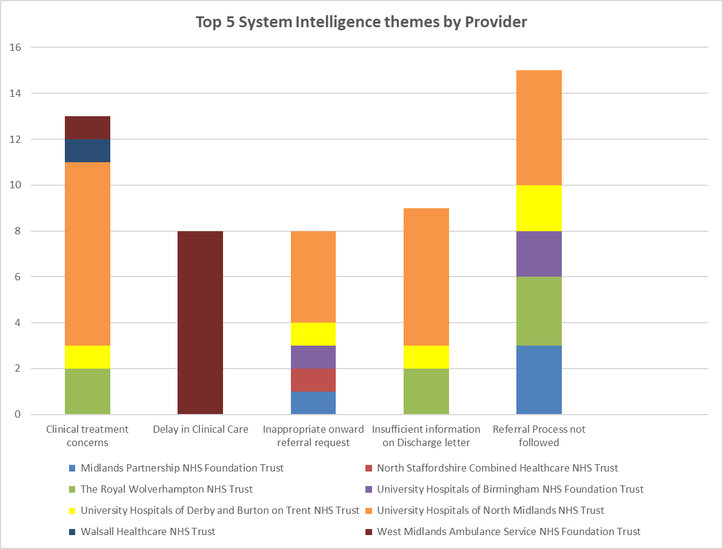

4.0. Examples of Quality Improvements and learning undertaken:

Clinical treatment concerns

CONCERN AND/OR ISSUE​ | Action Taken |  | Update from action​
Patient attended A&E on 18/1/24. After their consultation with patient, he was advised to attend GP surgery for dressings and review of B/P by A&E staff.  Attended surgery at 15:31 hrs on 18/1/24. Seen by GP and patient advised he still had a cannula insitu. GP noted this to be in in right cubital fossa.  Removed by GP. Should have been removed by A&E team before discharge on 18/1/24. | Cannula removed by GP.  Datix report to escalate concern to UHNM. |  | Feedback given to UHNM via their Consultant Connect system.
Patient had been attending Community Health Eyecare Clinic for years. Attended optician due to blurred vision for a few months. Found to have advanced glaucoma and referred to UHNM. Visual fields obtained from CHEC showed advanced field defect on the test done in August 2021. This was the earliest visual field they provided. Patient should have been referred then. | Told patient to stop driving as no longer met DVLA criteria |  | Shared directly with Provider for review and ICB Quality Lead.
Referral process not followed:

CONCERN AND/OR ISSUE​ | Action Taken |  | Update from action​
Patient was referred to Cardiology in November 2022, an expedite letter was sent in July 2023 as the patient had called the surgery and informed us that he had been told it was a 60 week wait for an appointment.  The referral was rejected in September 2023 but we were not made aware of this, we have been informed that the Consultant viewed the referral and deemed it not for Cardiology OPA | New Cross have informed us that if we refer again as urgent and let them know when it has been raised they will pass to the duty Consultant straight away |  | Contacted Black Country ICB asking them to investigate this incident further. Response received:  ‘We acknowledge and accept there are long outpatient waiting times in Cardiology and that appointments have been exceeding national timeframes. This is a recognised risk and we have been taking steps to improve this by providing additional capacity as well as a number of service efficiency schemes including implementing a robust triaging system.  The original referral was rejected in September 2023. We are sorry there were no comments left on DocMan/ERS or that a rejection letter was sent to the GP surgery. This was an omission on our part, and we apologise for this.  An email was received from the GP surgery on 21 February 2024 chasing up the referral. It was vetted again and rejected. A response was sent back to the GP surgery accordingly’.
Inappropriate onward referral request
CONCERN AND/OR ISSUE​ | Action Taken | Update from action​
Email we received from heart failure specialist requesting an ECG for a patient she had seen whom she had identified as bradycardic with a heart rate of 45 in clinic and then requested we send her the results after.  This ECG should of been done at the time or referred on to acute services. We have organised for this ECG to be done on this occasion in the best interests of our patient. | ECG carried out and letter sent to MPFT Team Lead | Logged for themes/trends monitoring.
CAMHS requested bloods for pt and asked GP to review and action results.  Please note that it remains the responsibility of the requesting clinician / clinical team to action results / investigations.  Simply copy/pasting and sending them to GPs with zero actual context / clinical information is wholly inappropriate. | Sent back to sender to action. | As no patient consent, unable to forward to Provider, therefore logged for themes/trends monitoring.
Insufficient information on Discharge Letter:

CONCERN AND/OR ISSUE​ | Action Taken |  | Update from action​
This patient was seen in A&E on 10/12/23 for chest pain. He is a patient with learning disabilities who attended with his carer. It was noted on the discharge summary that no abnormality was detected and patient was discharged after no cause found for his symptoms.  The following day, it was brought to my attention as the patients GP, by his carer that he had an irregular pulse in A&E and was advised to see GP upon discharge to commence anticoagulation. However, no diagnosis of AF or an irregular pulse is mentioned anywhere on the discharge letter.  Given that this patient is a vulnerable adult, I feel that this could easily have been missed as patient is unable to communicate this himself. This could also have led to potential clinical risk due to delays in treatment. | Following information form the carer the practice contacted A&E for a copy of the ECG. This was sent to us after 2 days, and based on ECG findings the diagnosis of AF was made and patient started on anticoagulation.  I would be grateful if this could be fed back to the clinician involved to ensure that any new important diagnoses are included on the discharge letter so that appropriate action is taken. |  | Logged on UHNM Consultant Connect system with request to feedback to the Consultant for learning. GP Advised.
Discharge summary received however no clinical information regarding procedure, diagnosis, treatment etc | Hospital contacted |  | As no patient consent, unable to forward to Provider therefore logged for themes and trends monitoring.
Delay in Clinical Care

CONCERN AND/OR ISSUE​ | Action Taken | Update from action​
The following concerns/issues all relate to WMAS and a delay in ambulance wait times. | Forwarded to ICB Quality Lead for WMAS to raise at Clinical Quality Review Meetings (CQRM). | The ICB Quality Lead for WMAS has highlighted these issues with the Host Commissioner (Black Country ICB) during the CQRMs. Ambulance delays are a common theme within Serious Incidents at present. WMAS have also been looking at this theme as a thematic review and have actions associated to them. Ongoing monitoring continues.
NEWS score of 9, practice running out of oxygen. Only maintaining sats on 15L of O2. Ambulance wait time of a few hours. In the end we put her in the car and took her to A&E. | Broke our indemnity and took pt to A&E | WMAS incident reporting form sent to GP with request to complete and send directly to WMAS nhs2nhs concerns.
Ambulance staff informed us that there may be a several hour delay for a request for a cat 2 ambulance for a patient with potential stroke that presented 3 hours after onset of symptoms so would be within the thrombolysis window | Patients’ relatives collected patient from surgery and took to A&E | No patient consent; logged for themes and trends monitoring.
We called to organise a cat 2 ambulance for a septic child but were told that no ambulances available and delay could be hours so patient had to go in own transport | Explained about the ambulance delay and mom decided to take child in own transport | No patient consent; logged for themes and trends monitoring.
Ambulance called for ill patient whilst in surgery, emergency situation, patient low sats and on oxygen. Practice was told 4 hour wait. On call GP had to drive patient to A&E. This is the 3rd time in 4 months. | On call GP had to take patient to A&E. | No patient consent; logged for themes and trends monitoring.

5.0 Other actions/improvement work being undertaken.
5.1 Children’s Assessment Unit (CAU):
During January at the ICB GP Engagement Teams meeting concerns were raised by GPs that they often felt that GP referrals to UHNM were not always considered appropriately and referrals not accepted for up to 18 months previously. This can only be addressed with factual evidence; therefore, GPs were encouraged to submit the details including historic concerns to the ICB via the Datix IQ Cloud system to be included in System Intelligence.
The ICB Quality Team undertook a visit to the CAU due to the System Intelligence received from Primary Care in January and February and a Patient Safety Incident Investigation (PSII) involving the same unit had also been reported. The purpose was to understand referral processes and how the service operated. The visit was undertaken on the 29th February 2024. During the visit the visiting team met the Head of Nursing and Matron for Childrens services, the concerns were discussed, and the referral process described below: -
Referral: The service has a dedicated CAU phone line which is staffed by a Consultant Paediatrician up to 10pm at night. (There is a separate rota to staff this phone line). This line can be used for GPs for advice and guidance in a clinician-to-clinician conversation. This can result in one of a number of outcomes:
- urgent access to CAU,
- to be seen following day in the rapid access clinic,
- GP advice with safety netting or advise to refer to outpatients.
Following speaking with the Head of Nursing and Matron the visiting team could see that the Department has strong leadership, they demonstrated robust systems and processes in place in the management of the whole Childrens department. The department would be happy to meet with GPs and have taken on board the above feedback.

5.2 There were two concerning System Intelligence reported, which the ICB has sent directly to UHNM Governance and risk team to be reviewed under
their Patient Safety Incident Response Framework (PSIRF) for learning.

The ICB Quality Team would like to thank Primary Care for their ongoing support sharing System Intelligence which enables the Quality Team to triangulate with other information held with the ICB e.g., ICB PALS, complaints, Provider reporting, Quality Schedules, discussions at CQRM etc.
Should you require any assistance with reporting on the Datix IQ Cloud System or have any other queries please email:
ssicb-nst.staffsccgsoftintelligence@nhs.net

