Joint Strategic Needs Assessment (JSNA)
Learning Disabilities and Autism

Staffordshire and Stoke-on-Trent all age analysis

October 2022

Integrated Care Board in conjunction with partners – Department of Work & Pensions Staffordshire, Midlands and Lancashire Commissioning Support Unit, Midlands Partnership Foundation Trust, North Staffordshire Combined Healthcare Trust, Reach (Asist), Staffordshire County Council, Staffordshire Police, Stoke-on-Trent City Council.

Table of Contents
1. Executive Summary 3
1.1 The key themes identified 3
2. Introduction 5
2.1 Joint Strategic Needs Assessment 5
3. Definition and Population 6
3.1 Definition and diagnosis 6
3.2 Population and prevalence 7
4. The key themes in detail 10
4.1. Autism low reporting levels in Stoke-on-Trent 10
4.2. LD SEND cohort growth in Staffordshire 11
4.3. Annual Health Checks geographic variation 13
4.4. Weight management – a younger issue 14
4.5. Epilepsy – strong growth in demand 15
4.6. Cancer – higher LD prevalence 16
4.7. Acute activity demand increasing sharply 18
4.8. Housing strategy lacking focus 19
4.9. Police crime incidents show emerging autism issues 20
4.10. Data gaps to be addressed 21
5. Conclusion 23
6.Appendices 24

- Executive summary

Following the successful transfer of the Transforming Care programme (TCP) of work to North Staffordshire Combined HealthCare Trust in April 2021, a system wide Learning Disability and Autism Partnership (LDAP) was formed. The direction of travel for the newly formed LDAP was documented in a three-year roadmap which identified the need to develop a JSNA specifically for learning disability and autism.
In Staffordshire and Stoke-on-Trent there are approximately 13,000 Autistic people and 27,000 people with a Learning Disability, a combined total of 40,000. Potentially 9,000 people have a learning disability and are autistic. Prevalence data and estimated population growth may mean there are a combined extra 3,000 people by 2035.
The average age at death for people with a learning disability is 22 years younger for men, and 26 years for women compared to the wider population (LeDeR 2022). The National annual LeDeR report also shows 49% of recorded deaths are premature, and that people die younger if they are from a BAME community.
The source of data captured for this JSNA has been collected from social care, a range of NHS organisations, Education, Police, and experts by experience and has been broad based and with elements of depth. The supportive approach from all organisations has provided the data and insights but also pointed to the need for data development for Learning Disabilities and even more the case for Autism.
Ten key themes (see summary table, page 4) have emerged from the data evidence available. This JSNA includes the guiding principles from Building the Right Support action plan with the appropriate ‘I’ statements for each theme, the current evidence based issue, and potential future implications. The significant progress in the Transforming Care programme is testament to the close working arrangements with individuals, their families and multiple agencies including the independent sector market. There is a recognition that whilst TCP is not identified within the top 10 themes, there still needs to be the same level of focus and scrutiny on the programme to ensure that the system reduces reliance on inpatient care in line with the NHS Long Term Plan.
During autumn of 2022, key stakeholders will consider the priorities for the LDA programme using the JSNA, the learning from LeDeR reviews , KLOEs from the Long Term Plan and Building the Right Support outcomes to inform the strategic priorities over the next 3 years. The intention is to also align the LDA programme to the wider system portfolios to ensure that the needs of people with a learning disability and autistic people are considered throughout the system.

The 10 key themes table summary

 | Key theme | Key data evidence
1 | Lower reported autism reporting in Stoke-on-Trent | Potentially 600 children reported with autism compared to statistical neighbours
2 | The LD cohort growth in Staffordshire | 17.7% growth in children with SEN in 5 years with the LD cohort size around 40% higher than national proportion.
3 | Annual health checks variation | Stoke-on-Trent 80.6% completion rate v South East Staffordshire 61.7%
4 | Weight Management – a younger problem. | Peak obesity in LD males 25-34 years compared to non-LD 55-64 years.
5 | Epilepsy – strong growth in demand. | LD prevalence in East Staffordshire 22.8% compared to 17.9% nationally. CYP register growth of 10% in one year.
6 | Cancer higher prevalence | LD prevalence 2% for our system compared to 1.5% nationally.
7 | Acute activity – demand increasing sharply. | Four-year growth rate for Autism CYP over 50%.
8 | Housing strategies lacking focus | Strategy documents for housing do not obviously recognise the current and future needs of autism and learning disabilities.
9 | Police crime incidents increasing for autism | There were 23% more incidents involving autistic people in 2021 compared to 2020.
10 | Data issues to resolve. | System wide need for more specific autism recording and more sharing.

2.0 Introduction to a Joint Strategic Needs Assessment

This Joint Strategic Needs and Assets Assessment (JSNA) sets out current and future strategic health and care needs in Staffordshire and Stoke-on-Trent to inform and guide strategy, commissioning and decision making. It provides a strategic assessment of the Learning Disabilities and Autistic (LDA) population’s needs through a shared evidence base. This reporting reflects the wider system and brings together data, analysis, insights and the needs of Staffordshire’s and Stoke-on-Trent’s LDA population.
This Needs Assessment was initiated by the Learning Disability and Autism (LDAP) Board in Staffordshire and Stoke-on-Trent in April 2021. The LDAP Board includes members from Staffordshire County Council, Stoke-on-Trent City Council, Integrated Care Board, Midlands Partnership Foundation Trust, North Staffordshire Combined Healthcare Trust, National Autistic Society, Asist, and Experts by Experience.

The JSNA is a statutory requirement of local Health and Wellbeing Boards under the Health and Social Care Act 2012. This all age LDA document will complement the overall system JSNA publications for Staffordshire and Stoke-on-Trent.

3.0 Definition and Population
3.1 Definitions and Diagnosis

NICE refers to Autism Spectrum Disorders as defined by a continuum of lifelong conditions which affect brain development. Autism diagnostic criteria include three core symptoms: differences in social communication and interaction; highly focused interests or behaviours that appear to others as repetitive or restricted; and challenges with sensory hyper-or-hyposensitivity.

NICE research indicates ‘a significant proportion of autistic adults across the whole autistic spectrum experience social and economic exclusion. Their condition is often overlooked by healthcare, education and social care professionals, which creates barriers to accessing the support and services they need to live independently. In addition, autistic people are more likely to have coexisting mental and physical disorders, and other developmental disorders. Some may have contact with the criminal justice system, as either victims of crime or offenders, and it is important that their needs are recognised.’

Analysis by NICE also found that there is ‘wide variation in rates of identification and referral for diagnostic assessment, waiting times for diagnosis, models of multi-professional working, assessment criteria and diagnostic practice for adults with features of autism. These factors contribute to delays in reaching a diagnosis and subsequent access to appropriate services.’

The Department of Health in the UK defines a Learning Disability as 'a significantly reduced ability to understand new or complex information, to learn new skills (impaired intelligence), with a reduced ability to cope independently (impaired social functioning), which started before adulthood'.
In addition, NICE provide the following guidance.

Definitions of learning disability generally encompass three core components:
- Lower intellectual ability (usually an IQ of less than 70).
- Significant impairment of social or adaptive functioning.
- Onset in childhood.

People with milder learning disabilities may be able to live independently and care for themselves, manage everyday tasks, work in paid employment, communicate their needs and wishes, have some language skills, and may have additional needs that are not clear to people who do not know them well.
People with more severe learning disabilities are more likely to need support with daily activities such as dressing, washing, food preparation, and keeping themselves safe, have limited or no verbal communication skills or understanding of others, need support with mobility, have complex health needs and sensory impairments.

3.2 Population overview
Staffordshire and Stoke-on-Trent had a reported total population of 1,139,794 (Office for National Statistics ONS 2020). Staffordshire has 662,550 adults and 171,275 children. Stoke-on-Trent is home to 198,317 adults and 58,305 children. Overall population growth is estimated to be close to 2% every five years (ONS midyear projection 2018).
In 2021 the Census estimated that the Staffordshire population was 875,900 (-0.8% compared to ONS 2020) and that Stoke-on-Trent was 258,400 (+0.7% compared to ONS 2020). For the basis of the LD/A projection calculations in this JSNA the ONS data was used on the because it facilitates age breakdown analysis by individual year rather than age grouping e.g. ‘15-19 year olds’, which is required for comparison of other data sets such as social care, health and employment that classify 18-64 years as the working age population. Note that the full system JSNA for Stoke-on-Trent has referenced the Census data for population narrative.
The population table below is comprised of the 9 key areas that form elements of the analysis for the JSNA and lay the foundation for future locality profiles. The City of Stoke-on-Trent is joined by Staffordshire’s four districts: Cannock Chase, Lichfield, South Staffordshire, Staffordshire Moorlands, and the four boroughs of East Staffordshire, Newcastle-under-Lyme, Stafford, and Tamworth.

Table 1 - Population Staffordshire and Stoke-on-Trent (ONS data)
www.ons.gov.uk/peoplepopulationandcommunity/populationandmigration/populationestimates

Children’s population
Table 2 is the ONS 2020 mid-year estimate data for Staffordshire and Stoke-on-Trent, the former making up 19.4% of the total county population and the latter 22.7% of the city population. The different proportions equate to three more children per 100 people in Stoke-on-Trent compared to Staffordshire.
In Staffordshire it is Stafford and East Staffordshire that have the highest proportions of children (15.4%) with the lowest proportion in Tamworth (9.7%).

Table 2 - Children’s population Staffordshire and Stoke-on-Trent
Authority / District / Borough | Total Children (0-17 years) | % of Staffordshire Total | % total area population
Stoke-on-Trent | 58,305 |  | 22.7%
Staffordshire | 171,275 |  | 19.4%
Cannock Chase | 20,299 | 11.85% | 20.0%
East Staffordshire | 26,358 | 15.39% | 21.8%
Lichfield | 20,283 | 11.84% | 19.2%
Newcastle-under-Lyme | 23,524 | 13.73% | 18.1%
South Staffordshire | 19,958 | 11.65% | 17.8%
Stafford | 26,395 | 15.41% | 19.1%
Staffordshire Moorlands | 17,795 | 10.39% | 18.1%
Tamworth | 16,663 | 9.73% | 21.7%

3.3 Prevalence and implication for autistic and learning disabilities population
Autism prevalence rate has previously been reported at 1%, but research in recent years has increased the understanding and rate to 1.76% in children (Roman-Urrestarazu et al 2021). The expert consensus of gender ratio (females to males) was previously 1:8, but now closer to 1:3, and even potentially 1:2. The proportions equate to potentially 700,000 autistic adults and children in the UK and an estimated 3 million family members and carers of autistic people (National Autistic Society).
The previous Learning Disability strategy referred to 2% prevalence but MENCAP and Public Health England refer to 2.16% Adults and 2.50% Children. The NHS Long Term Plan states that since 2010 as a result of improved neonatal care there has been a reduction in stillbirths of 18.8% and that neonatal mortality has reduced by 5.8%, hence increased prevalence in children.
The known registered data for General Practice (GP data) for the cohorts is growing year on year but still under reports the expected actual rates for learning disabilities and autism hence using external national forecasting such as PANSI* (Projecting Adult Needs and Service Information) and POPPI (Projecting Older People Population Information). The projections used in these sources is very helpful but does not take into our local information and dynamics such local BAME demographics. *see www.pansi.org.uk
The data presented in table 3 and table 4 refers to people with a learning disability. The Stoke-on-Trent full population Joint Strategic Needs Assessment (2022) also refers to a broader cohort including learning difficulties. The future potential population data builds on PANSI and POPPI methodology with the population (ONS) and prevalence (MENCAP, National Autistic Society, Roman-Urrestarazu).

Table 3 – Staffordshire LD and Autism population prediction based on ONS, MENCAP, NAS.

Staffordshire LD | 2020 | 2025 | 2030 | 2035
Total population aged 18 and over predicted to have a learning disability | 16,639 | 17,010 | 17,441 | 17,854
0-17 years LD | 4282 | 4356 | 4439 | 4514
TOTAL all ages LD | 20,921 | 21,366 | 21,880 | 22,368
Staffordshire Autism | 2020 | 2025 | 2030 | 2035
Total population aged 18-64 predicted to have autistic spectrum disorders | 5,205 | 5,221 | 5,210 | 5,196
Total population aged 65 and over predicted to have autistic spectrum disorders | 1,838 | 1,986 | 2,181 | 2,356
0-17 years Autism | 3014 | 3066 | 3125 | 3178
TOTAL all ages Autism | 10,057 | 10,273 | 10,516 | 10,730

Table 4 Stoke-on-Trent LD and Autism population prediction based on ONS, MENCAP, NAS.

Stoke-on-Trent LD | 2020 | 2025 | 2030 | 2035
Total population aged 18 and over predicted to have a learning disability | 4,726 | 4,802 | 4,927 | 5,033
0-17 years LD | 1458 | 1483 | 1511 | 1537
TOTAL all ages LD | 6184 | 6285 | 6438 | 6570
Stoke-on-Trent Autism | 2020 | 2025 | 2030 | 2035
Total population aged 18-64 predicted to have autistic spectrum disorders | 1,582 | 1,599 | 1,617 | 1,635
Total population aged 65 and over predicted to have autistic spectrum disorders | 419 | 446 | 488 | 520
0-17 years Autism | 1026 | 1044 | 1064 | 1082
TOTAL all ages Autism | 3,027 | 3,089 | 3,169 | 3,237

National Autistic Society see www.autism.org.uk/advice-and-guidance/what-is-autism
MENCAP see www.mencap.org.uk/learning-disability-explained/research-and-statistics

4.0 Key themes

4.1 Key theme 1 – Autism lower reporting levels in Stoke-on-Trent
‘Building the Right Support’ guiding principles
A good start in life
As a child or young person, I want good opportunities and experiences as I grow up. For me, this means:
- I have a timely autism diagnosis that enables me to access the support I need to live an ordinary life.
- I feel safe and supported in a school that understands and meets my needs, without living in fear of exclusion and restraint.
- My school enables me to reach my potential by building on my strengths.
- If I need one, I have an Education, Health and Care Plan that me and my family are involved in developing, and my education setting is confident in delivering the support it sets out.
Issue based on available data evidence
- SEN children with a primary need of autism totals 266 (of which the rate is 2.6% in primary schools). Based on nearest statistical neighbour data averages there could be 850-900 children (of which the rate is 7.7% in primary schools) locally in Stoke-on-Trent, therefore a possible difference of about 600 children and maybe due to difficulty of diagnosis. See table 5 for school setting comparison (data from the City Council).
- If the autism ratio is 2:1 (as per National Autistic Society and recent national research) is correct it implies with 209 males that there are potentially 50 females missing (lower reporting levels aligns with research of masking symptoms and lack of diagnosis).
- Population currently in Stoke-on-Trent is 58,305 children (aged 0-17 years). Autism SEN cohort of 266 is 0.46% of the total population (note the prevalence research indicates 1.76% of the population).
- Waiting time is 49 weeks for referral to first appointment.
- Nationally the SEND population increased by 4% in 2021 but the autism cohort increased by 12%.
- Nationally, Inpatients reduced by 30.7%, but autistic rate increased by 20% (March 2017 – May 2022).
- Lived experience feedback ‘Join up education, health and social care’ & ‘more help with getting a diagnosis’.

There is a much lower proportion of SEND children with autism as the primary need compared to the national trend. The total SEND count for the Stoke-on-Trent population is 7,094 children (5,523 with SEN support and 1,571 with statement or EHC) equating to 12% of the total children’s population compared to 10% for England. However, the primary need of autism cohort total of 266 is 3.75% of the total Stoke-on-Trent SEND cohort, whereas nationally the autism proportion was 12.5% in 2020/21 and 13.2% in 2021/22.
Table 5.1 the contrast in SEND autism proportion between Stoke-on-Trent and England.

Table 5.2 SEN children with a primary need of autism and the proportions in education settings.

% SEN Pupils Primary Need - Autism | Setting | Stoke-on Trent | Comparison | Difference | Comparison multiplier
Near Neighbours | Primary School | 2.60% | 7.70% | 5.10% | x 2.96
Near Neighbours | High School | 4.40% | 10.50% | 6.10% | x 2.39
Near Neighbours | Special School | 4.60% | 29.90% | 25.30% | x 6.5
All English Unitary Authorities | Primary School | 2.60% | 8% | 5.40% | x 3.08
All English Unitary Authorities | High School | 4.40% | 11.80% | 7.40% | x 2.68
All English Unitary Authorities | Special School | 4.60% | 27.70% | 23.10% | x 6.02

Near statistical neighbours are Kingston-Upon-Hull, North-East Lincolnshire, Rochdale, Middlesbrough, Walsall, Rotherham, Tameside, Barnsley, Blackpool, Doncaster.
(data from Stoke-on-Trent City Council SEND Improvement team and Gov.uk statistics)
https://explore-education-statististics.service.gov.uk/data-catalogue/special-educational-needs-in-england/2020-21

Forward projection of current trends
- Future ONS population projection for Stoke-on-Trent in 2035 is close to 61,000 children (aged 0-17 years) based on growth of 0.25% per year. This creates overall population growth of almost 2,500 and potentially an extra ranging from 40 to 50 children (based on 1.76% prevalence).
- The majority of young people could manage with minimal help and use of universal services, however it is likely there will be a smaller proportion who will require more specific support. As the profile and understanding of autism increases, the numerical difference highlighted in the evidence section would be expected to reduce and therefore increase demand for the minority of complex cases.
- The known autism SEN ratio compared to the potential gap is ‘1: 2.3’. This would increase diagnosis waiting time to 114 weeks if current system capacity remained unchanged (49 weeks x 2.3).

4.2 Key theme 2 – the Learning Disability cohort growth in Staffordshire CYP

‘Building the Right Support’ guiding principles
A good start in life
As a child or young person, I want good opportunities and experiences as I grow up. For me, this means:
- If I have a learning disability, I can access the support I need to live an ordinary life.
- I feel safe and supported in a school that understands and meets my needs, without living in fear of exclusion and restraint.
- My school enables me to reach my potential by building on my strengths.
- If I need one, I have an Education, Health and Care Plan that me and my family are involved in developing, and my education setting is confident in delivering the support it sets out.

The issue based on available data evidence

- SEN status with a primary need recorded of moderate, severe, and profound disability equates to 28.2% of the Staffordshire SEN total compared to 23.9% of the national proportion. In terms of SEN support LD 29.4% v 20.6% nationally (2020/21 UK. Gov data).
- Learning disabilities accounts for 29.1% of all SEN status in Staffordshire (4,901 children).
- Autistic Spectrum Disorders (ASD) accounts for 13.6% (2,294 children), see table 6.
- Between 2017 and 2021 there was a 17.7% increase in Staffordshire children with SEN status (more than 3% growth per year). Nationally in 2021/22 there was an increase of 5.25%.
- In Staffordshire there are 4,261 Moderate LD cases (670 with statement or EHC), 526 Severe LD (490 with statement or EHC), 114 Profound LD (105 with statement or EHC).
- Population statistics for Staffordshire children and young people cohort indicate higher numbers in East Staffordshire and Stafford.
- Lived experience feedback ‘talk to me when I’m present not just to my parent or carer’.

Table 6 - SEN primary need data for Staffordshire (data from Staffordshire CC Performance Team and Gov.UK)

https://explore-education-statististics.service.gov.uk/data-catalogue/special-educational-needs-in-england/2020-21
Forward projection of current trends
- The SEN growth rate is unlikely to continue year on year, however if the five year trend of 3.5% annual growth rate continued to 2030 then there would be a significant increase in numbers, albeit most with moderate disabilities.
- By 2030, a 3% annual growth rate could increase the moderate LD cohort by approximately 1,300 to 5,500. The severe disabled cohort could increase by 120 to 690. The profound disabled cohort could increase about 20 by 135. The sustained growth rate would be unlikely given the total under 25 population but serves to illustrate the potential growth and demand on resources.
- A more conservative estimation of 1% annual growth until 2030 would increase the moderate LD cohort by 400, the severe cohort by 35-40, and the profound LD cohort by 5-10.

4.3 Key theme 3 – Annual Health Checks variation
‘Building the Right Support’ guiding principles
Living an ordinary life in the community
I live an ordinary independent life in my community. I have good quality care and support in the way I want and need it to live my life the way I want to. I am respected as a citizen and have the freedom and opportunities to live my life the way I choose.
- I live in my home, in my community with the people I love and who love me
- I get the support I need when I need it from people who understand my rights and needs
- I am treated like a whole person and my needs are met by professionals who work in a joined-up way
The issue based on available data evidence

- System performance rate for Learning Disability based annual health checks 2021/22 was 72.6% (based on CCG footprint). South-East Staffordshire & Seisdon Peninsula rate was 61.7%, Stoke-on-Trent was 80.6%. The national rate was 71.3% and our system ranked 20th out of 42 systems in England.
- Numerical total completions was 1,465 out of 1,817 people for Stoke-on-Trent. The South-East total was 586 out of 949 people (it would be 765 if matched to the performance rate of 80.6%)
- Four-year study revealed SES & SP 141/953 had zero health checks (14.8%), a further 171 had just one check (17.9%), and 164 had all four checks (17.2%). Stoke-on-Trent had 5.3% zero checks, 14.2% with one check, 29.3% all four checks.
- Gender data shows males have a lower uptake proportion (26.8% males had 0 or 1 checks compared to 23.5% females). Females have a higher uptake proportion (26.3% females all 4 checks compared to 23.8% males). Health conditions data concludes that we have higher prevalence rates with males e.g. obesity.
- Further ethnicity analysis is required as there is a potential gap, highlighted by the low level of ‘notifications of deaths’ from ethnic diverse groups in LeDeR system report 2021/22.
- No specific autism only annual health checks at present time.
- Lived experienced feedback ‘improve your communications to me by listening to me’.

Table 7 - Annual health checks 2021-22 CCG completion rates (source GP EMIS system)

CCG | Total LD register (all ages) | 21-22 LD reg 14+ | Completed checks | Completion %
NHS Cannock Chase CCG | 826 | 776 | 511 | 65.9%
NHS East Staffordshire CCG | 859 | 770 | 536 | 69.6%
NHS North Staffordshire CCG | 1048 | 963 | 775 | 80.5%
NHS South East Staffs & Seisdon CCG | 1023 | 946 | 584 | 61.7%
NHS Stafford & Surrounds CCG | 537 | 487 | 311 | 63.8%
NHS Stoke on Trent CCG | 1945 | 1815 | 1463 | 80.6%
Grand Total | 6238 | 5757 | 4180 | 72.6%

Forward projection of current trends
- The 27,000 estimated learning disability population differs to GP LD Register of 5,757 (14 years+). The vast majority of the population will have moderate disabilities and manage with minimal support.
- If total system achieved the 75% target it should result in about 4,300 people receiving a check depending on the size of LD register. If the full system matched the best performance (80.6%) of Stoke-on-Trent it would mean to an extra 460 people receiving a check. A range of initiatives are being coordinated to increase the register size and number of health checks per year.
- Awaiting a start date for an autism register and specific autism annual health checks. There is potential for approximately 13,000 autism checks (or 9,000 adults).

4.4 Key theme 4 – Weight management is a younger problem for people with a Learning Disability

Building the Right Support ‘guiding principles’
A good start in life
As a child or young person, I want good opportunities and experiences as I grow up. For me, this means:
- If I need one, I have an Education, Health and Care Plan that me and my family are involved in developing, and my education setting is confident in delivering the support it sets out
Living an ordinary life in the community
- I live an ordinary independent life in my community. I have good quality care and support in the way I want and need it to live my life the way I want to. I am respected as a citizen and have the freedom and opportunities to live my life the way I choose.
- If I need support, that support is readily available and flexible and I have a choice of options for what works best for me.

The issue based on available data evidence

- More males are affected by weight management issues than females. Peak age for obese classification in males is 25-34 years compared to the ‘control’ (non-LD) group of 55-64 years.
- Overweight males LD peak 25-34 years compared to ‘control’ (non-LD) group 65-74 years.
- Obese LD rate is 41.2% for our system verses National LD rate 37.5%. Equates to 1 in 10 extra people from LD cohort. Data from Public Health England.
- Geographic location data shows higher obese proportions in Cannock Chase, East Staffs, North Staffs, Stoke-on-Trent. Overweight higher proportions in Stafford, North Stafford, Stoke-on-Trent. Underweight higher proportions in North Staffordshire, Stoke-on-Trent, Stafford.
- Children and young people age group (0-24 years of age) have higher obese proportions in North Staffordshire, South-East Staffordshire, and Cannock Chase.
- Lived experience feedback ‘details known about me by the system & put posters in right place and keep them up to date’.
- Data for weight management for autism was found to be weak and will be actioned in a data improvement plan.

Table 8 - Weight management for obesity data for CYP Learning Disability cohorts (source GP Quality Outcomes Framework 2020/21)

 |  | Obese | Population | Variance
CCG | Obese count 0-24 yrs | % mix | mix
NHS Cannock Chase CCG | 24 | 12.9% | 11.6% | 1.35%
NHS East Staffordshire CCG | 21 | 11.3% | 12.3% | -0.97%
NHS North Staffordshire CCG | 41 | 22.0% | 19.0% | 3.03%
NHS South East Staffordshire and Seisdon Peninsula CCG | 39 | 21.0% | 19.0% | 1.97%
NHS Stafford and Surrounds CCG | 20 | 10.8% | 12.9% | -2.18%
NHS Stoke on Trent CCG | 41 | 22.0% | 25.2% | -3.20%
Grand Total | 186

Forward projection of current trends

- Population growth rates have been modelled to 2030 and 2035 in terms of overall numbers and highlighting peak gender / age impact with a statistical confidence of 95%.
- By 2030 there could be an extra 150-170 overweight people and 240-280 obese people. By 2035 an extra 220-260 overweight people and 380-420 obese people.

4.5 Key theme 5 – Epilepsy register shows a strong growth in demand

Building the Right Support ‘guiding principles’
A good start in life
As a child or young person, I want good opportunities and experiences as I grow up. For me, this means:
- If I need one, I have an Education, Health and Care Plan that me and my family are involved in developing, and my education setting is confident in delivering the support it sets out
Keeping people safe and ensuring high quality health and social care
When I am supported in a hospital or social care setting:
- I am safe and respected, and I feel safe and respected.
- The care I receive is of the best possible quality; when this care is in a hospital, it helps me get better and is the least restrictive possible.
The issue based on available data evidence

- Overall similar system prevalence of 17.82% compared to 17.90% nationally for LD (source Public Health England) but East Staffordshire is higher at 22.79% and Cannock Chase lower at 14.93%.
- Children and Young People (CYP) year on year growth was 10.2% in 2020/21 (an increase of 16 people to 173 in total).
- Stafford potentially underrepresented with rate of 6% (10 cases), would expect about 20 based on known population size. See table 9 for geographic distribution.
- Recorded epilepsy seizure data in 2020/21 was 73 people out of the 173 registered (42.2%).
- Lived experience ‘Health passports help, everyone (LD) should have one’.
- The Clive Treacey and CQC ‘Out of sight’ reviews have raised the profile across the system to have a focus on epilepsy and the impact it can have on the wellbeing of autistic people and people with a learning disability.
Table 9 - LD Epilepsy register by CCG (source GP Quality Outcomes Framework 2020/21)

0-24 years age group | 2021/22 data | Overall LD | Overall non LD
LD Epilepsy Register | 0-24 years count | Prevalence | Prevalence
NHS Cannock Chase CCG | 19 | 14.9% | 0.7%
NHS East Staffordshire CCG | 25 | 22.8% | 0.5%
NHS North Staffordshire CCG | 38 | 15.4% | 0.6%
NHS South-East Staffordshire and Seisdon Peninsula CCG | 32 | 16.2% | 0.6%
NHS Stafford and Surrounds CCG | 10 | 19.3% | 0.8%
NHS Stoke on Trent CCG | 49 | 19.0% | 0.7%
Grand Total | 173 | 17.8% | 0.6%

Forward projection of current trends
- Children and young people (CYP) cohort with 10% year on year growth over 5 years could result in 80-100 more people (CYP only) on the Epilepsy register, unlikely given total cohort population but illustrates potential future demand issue.
- A conservative growth profile growth of 2% per year growth could result in an increase of 15-25 during the next 5 years.
- National annual LeDeR insights (2022) highlights epilepsy as the most common condition linked to an early death (overall trend of 22 years younger for males, and 26 years younger for females).

4.6 Key theme 6 – Cancer higher LD prevalence

Building the Right Support ‘guiding principles’
Keeping people safe and ensuring high quality health and social care
When I am supported in a hospital or social care setting:

- I am safe and respected, and I feel safe and respected
- The care I receive is of the best possible quality; when this care is in a hospital, it helps me get better and is the least restrictive possible
- The people that support me listen to me, know what matters to me, and I am part of decisions about my care which includes being supported to take positive risks where appropriate

The issue based on available data evidence

- Public Health England (2019 data) reported cancer prevalence for learning disabilities of 2% in Staffordshire & Stoke-on-Trent compared to 1.5% nationally (LD). This equates to 33% higher prevalence in our system and could indicate better detection rates (this will be investigated as a follow up action). A 2% prevalence for our Learning Disability register that is rapidly approaching 6,000 would mean about 120 people. A 2% prevalence of the total estimated learning disability population of 27,000 would equate to approximately 510-570 people (100-160 more people with a learning disability than rest of England) based on a statistical 95% confidence range. The local non-LD prevalence in our system was reported to be 3.5% compared to 2.7% nationally.
- The overall incident rate for cancer excluding non-melanotic skin cancer was 19 per 1,000 in 2020-21.
- Incidence across the geographic areas shows highest rates in the North, potentially indicating better detection. The South-East has the lowest incident rate (see table 10 for the proportions across the six CCG areas as recorded in 2020-21). The geographic variation can be investigated to understand engagement with screening and the profile of cancer awareness communications. Screening programmes for bowel and breast cancers generally focus the age group beyond 50 years. Wider health condition data indicates several issues have a peak impact in the age groups 30-50 years.
- Most cases in Stoke-on-Trent, lowest case rates in Stafford indicates potential gap (e.g. data recording and/or detection).
- Most common cancer types according to Public Health England and the LeDeR annual review 2021-22 are cancer of the digestive organs (e.g stomach cancers), this compares to lung, breast, and prostate for the general population.
- LeDeR annual report 2021-22 has a key focus on the impact of cancer and highlighted ‘current problems making reasonable adjustments’. In addition to the learning disability cohort, the autism prevalence could indicate 400-500 people potentially requiring reasonable adjustments.
- Lived experience ‘training staff directly and indirectly related to our interactions with health and social care’
Table 10 – Learning disability cohort cancer diagnosis by CCG geographic area (source GP Quality Outcomes Framework 2020/21). Cancer details exclude non-melanotic skin cancer.

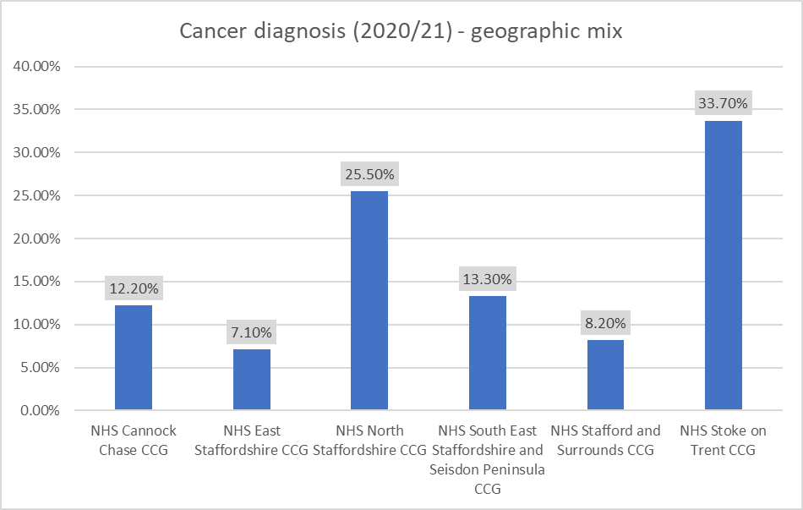

Forward projection of current trends

- By 2035 the population growth estimates for people with a learning disability of 29,000 we may expect to see 550-610 people with a cancer diagnosis if the same prevalence was reported. For Autism (England non-LD prevalence rate is 3.5%) for 14,000 people may result 460-520 people with a cancer diagnosis. Note it is likely that screening, treatment, prevalence and improved survival rates will change but the projection is illustrative of potential scale and uses a 95% statistical confidence range.
- Potentially there are people not currently known to the system requiring reasonable adjustments of mainstream pathways.
- A data improvement plan includes action to join up cancer data with annual health check reporting to check for patterns of diagnosis.

4.7 Key theme 7 – Acute activity demand increasing sharply

Building the Right Support ‘guiding principles’
A good start in life
As a child or young person, I want good opportunities and experiences as I grow up. For me, this means:
- I have a timely autism diagnosis that enables me to access the support I need to live an ordinary life.
- If I have a learning disability, I can access the support I need to live an ordinary life.
Keeping people safe and ensuring high quality health and social care
When I am supported in a hospital or social care setting:
- The care I receive is of the best possible quality; when this care is in a hospital, it helps me get better and is the least restrictive possible.
- I am safe and respected, and I feel safe and respected.

The issue based on available data evidence
- Acute activity in this dataset refers to day cases (outpatients) and admissions to stay in hospital overnight (inpatients). The data tracks all completed appointments for day cases and all episodes of a stay in hospital. Table 11 displays growth data for autism (all ages).
- A study over four years revealed growth rate for autism CYP activity of 51.1% overall. South-East Staffordshire and Stafford had more than 100% growth. South-East Staffordshire seeing 100 more children in 2021/22 compared to 2018/19. See table 12a for activity types
- Leading pathway / point of delivery for autism was emergency admissions with 64.6% of all cases. Elective activity increased marginally but only accounts for 4% of the total activity.
- Day case four-year growth rate was 74.4% (an extra 122 people). Emergency admissions growth rate was 46.2% (an extra 208 people).
- Learning Disabilities growth rate in East Staffordshire 55.1%, whilst Stafford growth was 31 people (24%).
- Leading pathway / point of delivery for LD was emergency admissions with 69.4% of all cases. Elective activity remained relatively unchanged and only accounts for 5% of total activity.
- LD activity levels are below pre-covid rates by 12% (154 people). Before covid annual growth was 7% (83 people per year).
- Lived experience ‘too many accessibility barriers, and that health passports would benefit understanding’.

Table 11 acute activity by type for autism

Table 12a – Autism activity for children over a four-year period (2018/19 – 2021/22) Data from Midlands and Lancashire Commissioning Support Unit using SUS data.

CCG - Acute activity Autism Children | 18/19 | 19/20 | 20/21 | 21/22 | 4 year growth
NHS CANNOCK CHASE CCG | 84 | 75 | 61 | 111 | 32.1%
NHS EAST STAFFORDSHIRE CCG | 61 | 100 | 60 | 109 | 78.7%
NHS NORTH STAFFORDSHIRE CCG | 74 | 93 | 77 | 107 | 44.6%
NHS SOUTH EAST STAFFORDSHIRE AND SEISDON PENINSULA CCG | 92 | 172 | 107 | 192 | 108.7%
NHS STAFFORD AND SURROUNDS CCG | 58 | 72 | 112 | 123 | 112.1%
NHS STOKE ON TRENT CCG | 160 | 161 | 137 | 186 | 16.3%
Virgin Care -- NHS East Staffordshire CCG | 19 | 4
Grand Total | 548 | 677 | 554 | 828 | 51.09%

Table 12b Learning disabilities acute activity over a four-year period (2018/19 – 2021/22). Data from Midlands and Lancashire Commissioning Support Unit using SUS data.

CCG - LD Acute Activity all ages | 18/19 | 19/20 | 20/21 | 21/22 | 4 year growth
NHS CANNOCK CHASE CCG | 112 | 82 | 99 | 124 | 10.7%
NHS EAST STAFFORDSHIRE CCG | 29 | 81 | 42 | 45 | 55.2%
NHS NORTH STAFFORDSHIRE CCG | 231 | 215 | 156 | 212 | -8.2%
NHS SOUTH EAST STAFFORDSHIRE AND SEISDON CCG | 154 | 152 | 147 | 149 | -3.2%
NHS STAFFORD AND SURROUNDS CCG | 128 | 146 | 118 | 159 | 24.2%
NHS STOKE ON TRENT CCG | 519 | 596 | 390 | 435 | -16.2%
Virgin Care -- NHS East Staffordshire CCG | 22 | 6
Grand Total | 1195 | 1278 | 952 | 1124 | -5.9%

Forward projection of current trends
- Projection scenario modelled for acute activity growth rates to continue to 2030 and 2035 (also factoring in expected population growth). The results showed autism CYP growth of 10-12% per year results in an extra 150-180 people (Staffordshire) and 50-60 people (Stoke-on-Trent) aged 0-17 years. The growth rate is unlikely to continue long term due to the size of the overall cohort.
- A 3% growth trajectory could see an extra 50-60 people (Staffordshire) and 15-20 people (Stoke-on-Trent).
- The pre-Covid LD growth rate of 7% added to the baseline figure may result in an extra 200-250 people compared to the current annual total assuming similar growth trajectories. However, Covid disruption to inpatient activity requires caution in our analysis and therefore a more conservative rate of 2% growth could mean an extra 50-70 people.

4.8 Key theme 8 – Housing strategy lack of focus and wider economic issues
Building the Right Support ‘guiding principles’
Living an ordinary life in the community
- I live an ordinary independent life in my community.
- I live in my home, in my community with the people I love and who love me.
- If I have an employer, I know they will make necessary reasonable adjustments to have an inclusive workforce.
The issue based on available data evidence

- Of the 9 city / district/ borough housing strategy documents (checked January 2022) only Lichfield contained a specific section and detailed recognition of meeting the needs of neurodiversity and learning disabilities.
- Stoke-on-Trent has success supporting young people leaving care to get their own home (DfE scheme).
- More traditionally the system has a higher proportion of residential care (our system has 24% with social care support compared to 21% nationally). ‘Out of area’ residential placements total 98 from Staffordshire and 71 from Stoke-on-Trent.
- Supported living proportions for our system are less than 50% compared to 58.6% for the rest of England.
- Personal Health Budgets (PHB) and Direct Payments LD data was collated from health and social care. The CCG had 53 PHB recipients with a learning disability (March 2022). Staffordshire have 715 people in receipt of a direct payment (average age 35) and Stoke-on-Trent 380 recipients. Therefore 35% of social care funded adults receive a direct payment.
- Employment rate for all disabilities in our system is 59.6% in Staffordshire and 53.8% in Stoke-on-Trent compared to 81.7% non-disabled. Regarding benefits there are higher proportions of people claiming benefits in Stoke-on-Trent, Cannock Chase, Tamworth and Newcastle-under-Lyme compared to the national average. See table 13 for government employment data.
- Lived experience feedback ‘Help me live a 24/7 life supporting my housing and employment aspirations’
Table 13 – Employment rate (%) data showing the increasing employment rate but still sizeable gap. Source Statistics.gov.uk

 | Disabled | Non-disabled
2020/21 | employment rate | employment rate | Difference
Staffordshire | 59.6 | 81.9 | 22.3
Stoke-On-Trent | 53.8 | 81.4 | 27.6
2019/20
Staffordshire | 54 | 86.1 | 32.1
Stoke-On-Trent | 50.7 | 80.6 | 29.8
2018/19
Staffordshire | 54.6 | 85 | 30.4
Stoke-On-Trent | 42.7 | 78.7 | 36

Forward projection of current trends
- By 2035 the total cohort (all forms of autism and / or learning disabilities) population could be 3,000 people more than the current total, taking the overall total to 43,000 people.
- Need a stronger visible housing / accommodation type plan across the system that is co-produced.

4.9 Key theme 9 – Police crime incidents data shows emerging autism issues
Building the Right Support ‘guiding principles’
Living an ordinary life in the community
- I live an ordinary independent life in my community. I have good quality care and support in the way I want and need it to live my life the way I want to. I am respected as a citizen and have the freedom and opportunities to live my life the way I choose.
- If I come into contact with the police and criminal justice system, I know that they understand my needs, make reasonable adjustments, and divert me away from prosecution where possible.
- I am treated like a whole person and my needs are met by professionals who work in a joined-up way
- I have the right support if I have a time of crisis in my life, and I have a clear plan on what this looks like.
The issue based on available data evidence

- There were 23.4% more autism incidents recorded in 2020/21 across Staffordshire and Stoke-on-Trent compared to the previous 12 months, whilst the total for all types of incidents reduced by 1.5%. The total count of incidents was 3,517 (equivalent to 26.9% of total autistic population).
- Incidents refer to any recorded Police activity that involve an autistic person as the victim or perpetrator.
- Stoke-on-Trent had 20.3% more incidents than population proportion, Stafford had +10.1% more.
- Leading incident category types were 1. Public safety, led by missing person. 2. Crime, led by violence against the (autistic) person, and 3. Anti-social Behaviour, led by ‘rowdy and inconsiderate’ behaviour.
- The crime category accounted for 711 incidents (20.2%). Of this category, 189 were violence against the autistic person (26.6%).
- Lived experience ‘be better connected with the local Police and their autism initiatives’.
Table 14 - Staffordshire Police incident data for 2021 with a category lead of autism
Area 2021 data | Incidents | Proportion a. | Expectation based on population b. | Difference % proportions (a-b) | Difference -actual impact
Stoke-on-Trent | 993 | 28.23% | 22.51% | 5.72% | 20.25% | 201
Stafford | 473 | 13.45% | 12.09% | 1.36% | 10.07% | 47.7
East Staffordshire | 351 | 9.98% | 10.61% | -0.63% | -6.30% | -22.1
Newcastle | 309 | 8.79% | 11.37% | -2.58% | -29.37% | -90.7
Lichfield | 298 | 8.47% | 9.27% | -0.80% | -9.42% | -28.1
Cannock Chase | 281 | 7.99% | 8.90% | -0.91% | -11.44% | -32.1
Tamworth | 279 | 7.93% | 6.74% | 1.19% | 14.96% | 41.7
South Staffordshire | 270 | 7.68% | 9.86% | -2.18% | -28.37% | -76.6
Staffordshire Moorlands | 217 | 6.17% | 8.64% | -2.47% | -39.96% | -86.7
Not Known | 46 | 1.31%
Note that the data presented has been collated via the Business Information Team and Autism Champions team of Staffordshire Police. For wider data information see the website:-
www.police.uk/pu/your-area/staffordshire-police/performance/performance-staffordshire-police/
Forward projection of current trends
- Growth rate implication based purely on expected population growth (e.g. 800-900 extra autistic people by 2035) using the ratio of 27% equates to 3,600-3800 incidents during a year.
- In one year if there was another 25% increase we could have an extra 750-850 autism incidents, or 12-18 per week, equivalent of 4-5 incidents in Stoke-on-Trent, and 2-3 incidents in Stafford.

4.10 Key theme 10 – the data issues to resolve

Strategic Priorities from 3-year road map

- There is a broad range of data, and willingness to support and share insights from children, adults, parents, and carers. An LDAP data dashboard is already in development.

The issue based on available data evidence

- Stoke-on-Trent and Staffordshire Councils recognise gap in specific autism data recording (tends to be consumed within LD data or there is no option to record autism).
- MPFT to be in position to share their autism tracking data (it is new, and time will provide confidence in the data and trend information).
- NSCHT to share TPC data in granular form as per DPIA.
- NSCHT to address gaps in diagnostic data.
- Police to develop learning disability analysis and data bank as per the autism data set.
- Housing data to be able to drill down to learning disabilities and autism markers (not just case notes).
- Data linking learning disabilities and autism – often distinct cohort data sets exist that in reality contain a portion of the same people.
- Data linking health condition data to identify multiple health conditions for our cohorts.
- Cross reference annual health check data with social care annual reviews to identify common ground where both completed and gaps where neither completed.
- Lived experience ‘system data doesn’t always truly reflect the reality of the challenges faced e.g. waiting times’.
Forward projection of current trends
- Existing issues would grow in scale relative to the growth in population and increased understanding of prevalence. Plans are in place to improve the situation.
- Plans include the using a newly formed data steering group to tackle the issues as a system.
- System wide need for more specific autism recording, improved data sharing, and cross referencing of data sets.
- Investigate the intersection of data (e.g., cross refencing AHC cohorts with obesity cohort and the SEN cohorts).

5.0 Conclusion

Staffordshire and Stoke-on-Trent has a growing population with learning disabilities and /or autism (LDA), with notable higher than average prevalence of the former and gaps in the reporting of the latter. Accessibility issues and lack of reasonable adjustments highlighted by lived experience feedback present a challenge to our system to support achieving the outcomes of our users of health, social care, and education. Meeting needs in the mainstream should create an inclusive environment and reduce health inequalities evident in the data analysed for this JSNA.
There are higher proportions of the LDA population with epilepsy, cancer, and weight management issues. The conditions affect a greater proportion of people at a much younger age profile and diminish life chances and significantly reduce life expectancy. The increase in acute activity highlights the need for action to prevent the future projections of trends materialising and further impacting on life quality.
Challenges exist around appropriate housing, job opportunities and crime. In Staffordshire and Stoke-on-Trent there has been some improvements in employment rates relative to England but there is still a large gap and higher than average benefit claim rate. Criminal activity involving autistic people as both victim and perpetrator has risen sharply and aligns to the data for lower employment rates and higher benefit claims.
Variation exists across different communities with notable multiple issues in East Staffordshire and Stoke-on-Trent. Further work is required to understand the connections between the existing data sets but also to source and share the current known data gaps including autism information and ethnicity profiling.
Studies to date have identified several wider system strengths as we seek to improve the lives of our learning disabilities and autistic population. There is a dedicated workforce despite recognised capacity pressure, as well as a network of locally focused voluntary sector organisations championing the opportunities and supporting the challenges of the people they know well. We have a devoted and ever-growing group of experts by experience and link in with national charities for their wealth of knowledge. The combination of the skilled individuals, data evidence base and an LDA Partnership model provide a platform position to facilitate an improvement plan that can deliver aspirational outcomes and independent lives. The collaborative work of this system has been recognised by NHSE, an acknowledgement that validates the approach to date, and that now requires practical action plans.
To conclude, the Staffordshire and Stoke-on-Trent population of people with a learning disability and / or autism is diverse in its needs and inequality can take many forms which impacts on health and wellbeing, to which organisations from across the system need to respond.

6.0 Appendices
The 10 key themes data details are expanded in this section.

6.1 The autism gap in Stoke-on-Trent

Appendix table 1: SEN Primary need data

Appendix table 2: Age and gender profile for Stoke-on-Trent autism SEN cohort

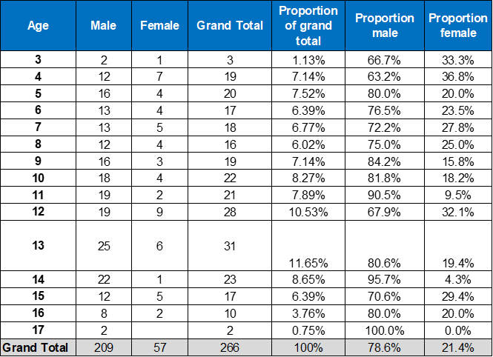

Appendix table 3: Autism assessment waiting times

 |  | Waiting Times (weeks)
 | NSCHT Service | 2019/20 | 2020/21 | 2021/22
Children | School Age ASD | 26 | 40 | 49
Adults | Autism Assessment Service | 19 | 40 | 46
Children | School Age ASD (yr/yr growth) |  | 53.80% | 22.50%
Adults | Autism Assessment Service (yr/yr growth) |  | 110.50% | 15.00%

6.2 The LD/A prevalence in Staffordshire

Appendix table 4: Staffordshire SEN primary need ASD age profile

6.3 Annual health checks variation

Appendix table 5: AHC achievement 2021/22

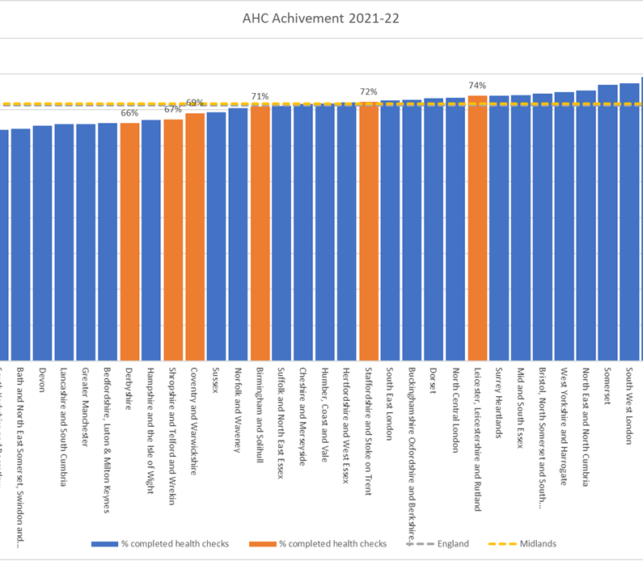

Appendix table 6: LeDeR gender and ethnicity profile data

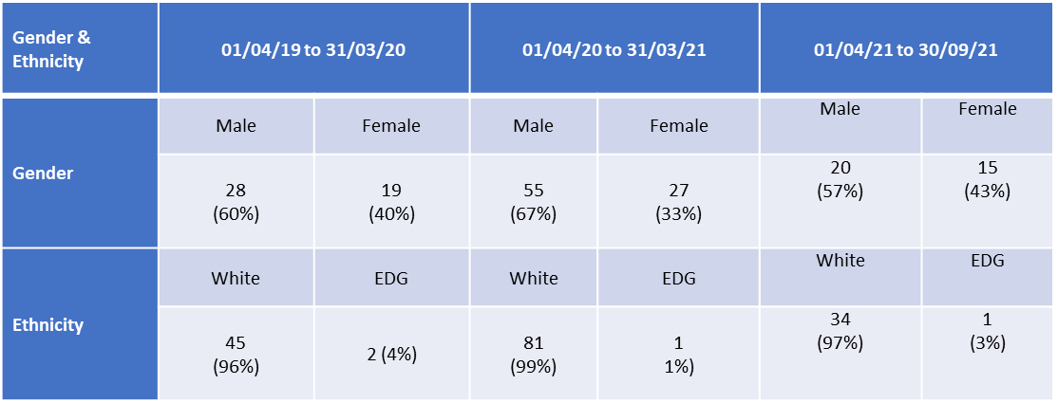

6.4 Weight Management

Appendix table 7: health condition gender ratio mix

Health Conditions | LD Ratio F:M | Control Ratio F:M
Obese | 48:52 | 57:43
Overweight | 38:62 | 52:48
Healthy | 34:66 | 66:34
Underweight | 34:66 | 58:42
Heart failure | 35:65 | 42:58
T1 Diabetes | 37:63 | 43:57
SMI | 41:59 | 51:49
Asthma Active Register | 44:56 | 56:44
Cancer diagnosis | 44:56 | 53:47
COPD | 44:56 | 47:53
Anti Depressants | 44:56 | 65:35
Dementia | 47:53 | 63:37
Breast Screening | - | -
Epilepsy Register | 41-59 | 51-49
Epilepsy Seizure 12m | 40-60 | 51-49

6.5 Epilepsy demand

Appendix table 8: Epilepsy CYP data

Appendix table 9: Epilepsy geographic prevalence

CCG | Epilepsy Register
North Staffordshire | 15.39% LD population V 0.61% total population
Stoke-on-Trent | 19.04% LD V 0.73% total population
Stafford & Surrounds | 19.31% LD V 0.80% total population

CCG | Epilepsy Register
Cannock Chase | 14.93% LD population V 0.65% total population
East Staffordshire | 22.79% LD V 0.49% total population
South East Staffordshire & Seisdon | 16.19% LD v. 0.63% total population

6.6 Cancer analysis

Cancer diagnosis ratio for LD cohort is 44% female and 56% male compared 53% female and 47% male for the non-LD cohort. Peak LD female age range 55-64 years compared to 75+ years for non-LD female. Peak age for LD males 35-64 years compared to 75+ years for non-LD males (QOF register data 2020).

6.7 Acute activity appendices – POD and delivery data

Appendix table 10: POD data for autism

Appendix table 11: Procedure data for autism

Appendix table 12: POD data for Learning Disabilities

Appendix table 13: Procedure data for Learning Disabilities

F819 - Developmental disorder of scholastic skills unspecified
Procedure | 18/19 | 19/20 | 20/21 | 21/22 | 4 year growth
300 - General Internal Medicine Service | 319 | 364 | 340 | 364 | 14.11%
420 - Paediatric Service | 95 | 112 | 69 | 113 | 18.95%
301 - Gastroenterology Service | 75 | 82 | 64 | 84 | 12.00%
101 - Urology Service | 54 | 59 | 54 | 77 | 42.59%
100 - General Surgery Service | 76 | 70 | 80 | 70 | -7.89%
180 - Emergency Medicine Service | 158 | 189 | 62 | 69 | -56.33%
110 - Trauma and Orthopaedic Service | 65 | 44 | 44 | 50 | -23.08%
501 - Obstetrics Service | 38 | 31 | 37 | 32 | -15.79%
340 - Respiratory Medicine Service | 22 | 29 | 29 | 32 | 45.45%
430 - Elderly Medicine Service | 35 | 36 | 32 | 20 | -42.86%
320 - Cardiology Service | 10 | 29 | 13 | 17 | 70.00%
107 - Vascular Surgery Service | 3 | 3 | 3 | 14 | 366.67%
302 - Endocrinology Service | 8 | 9 | 5 | 9 | 12.50%
328 - Stroke Medicine Service | 9 | 11 | 6 | 5 | -44.44%

6.8 Housing strategy including employment and benefits

Appendix table 14: Benefits geographic spread

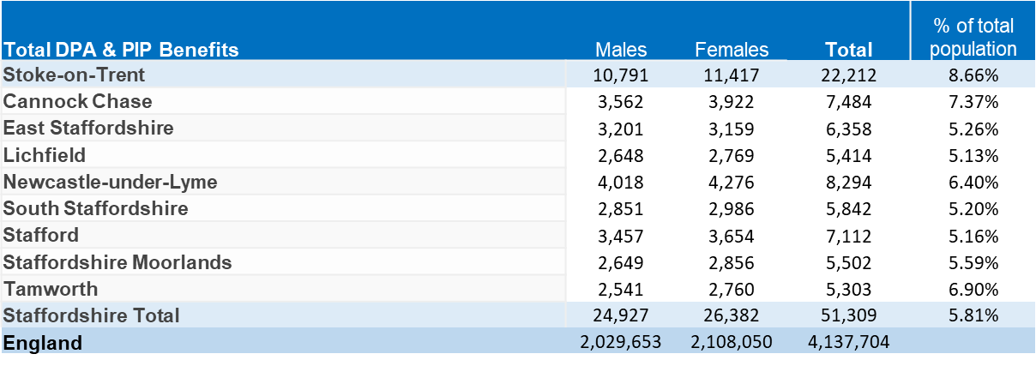

6.9 Police crime incidents relating to autism.

Appendix table 15: Staffordshire autism incident data

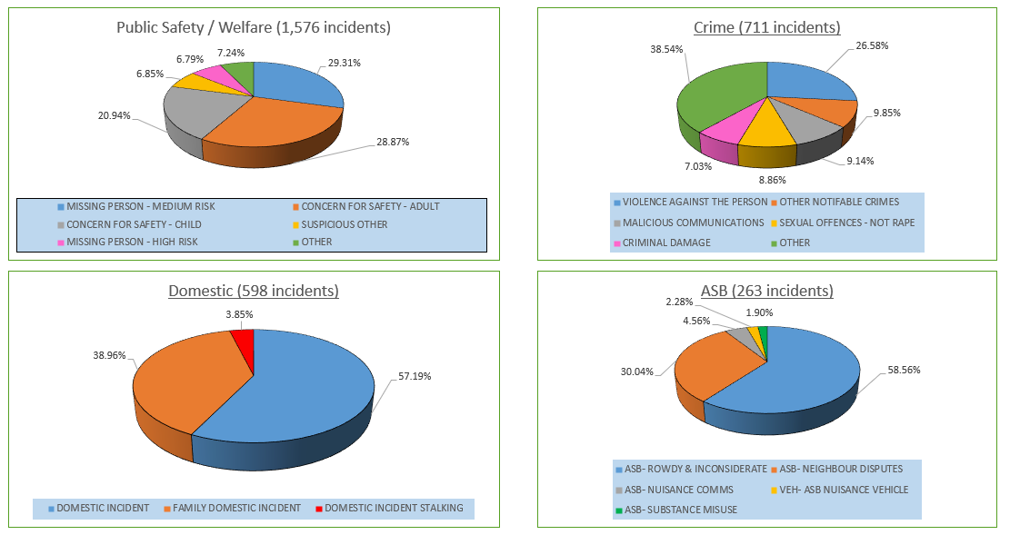

6.10 Lived experience summary themes from workshops December 2021

