Social Channel | Copy | Graphic
Facebook/ LinkedIn/  Twitter | Measles cases are rising in England. Make sure your child is up to date with their MMR vaccinations.  For more information visit nhs.uk/mmr | 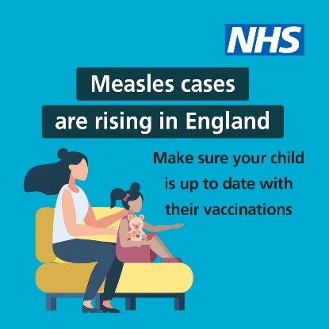
Facebook/ LinkedIn/  Twitter | Two doses of the MMR vaccinations can help stop your child becoming seriously unwell with measles.  For more information on how to check your child’s vaccination record, visit nhs.uk/mmr | 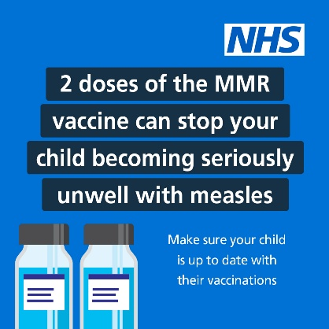
Facebook/ LinkedIn/  Twitter | Measles cases are rising in England.  You can ask your GP practice for the MMR vaccine if your child has missed either of these 2 doses.  For more information visit nhs.uk/mmr | 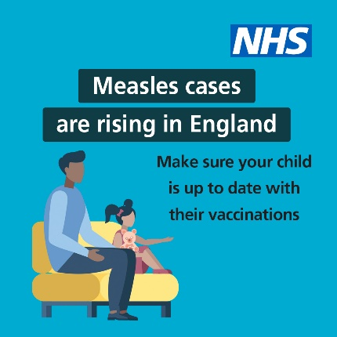
Facebook/ LinkedIn/  Twitter | Measles – are you protected? For lifelong protection, you need 2 doses of the #MMR vaccine.  If not, you could be at risk –contact your GP to get up to date. | 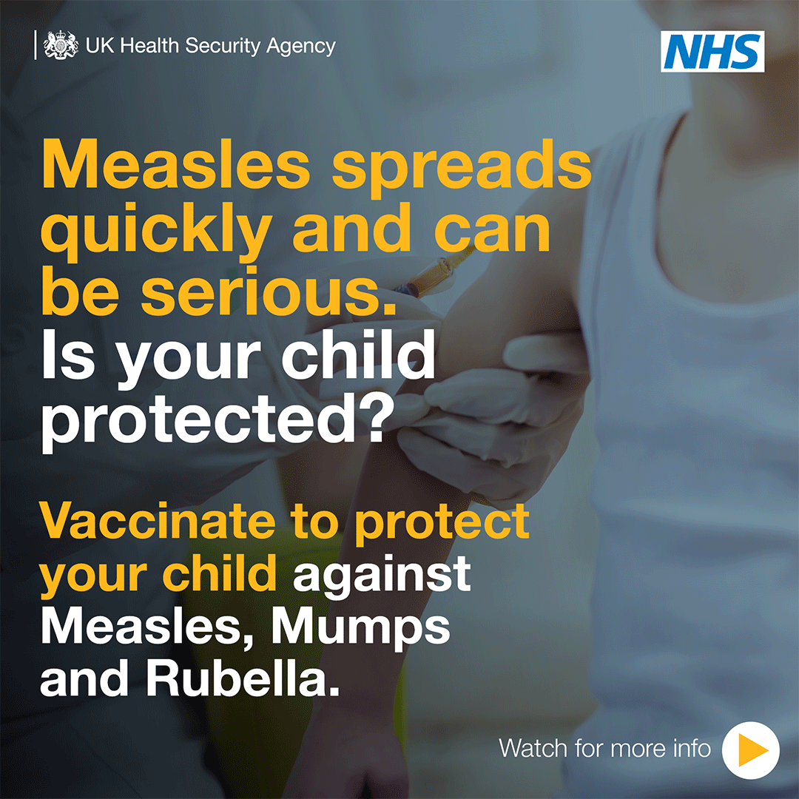
Facebook/ LinkedIn/  Twitter | To get lifelong protection against measles you need to have 2 doses of the #MMR vaccine. If you think you or a loved one isn’t up to date, contact your GP to get up to date. | 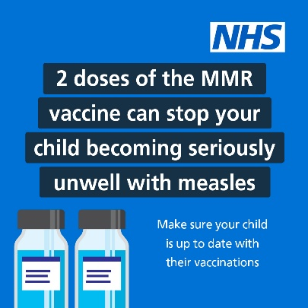
Facebook/ LinkedIn/  Twitter | Did you know? 15 minutes with someone who had measles is enough time for the virus to be passed on.  Make sure you’re up to date with #MMR vaccinations.  For more information visit nhs.uk/mmr | 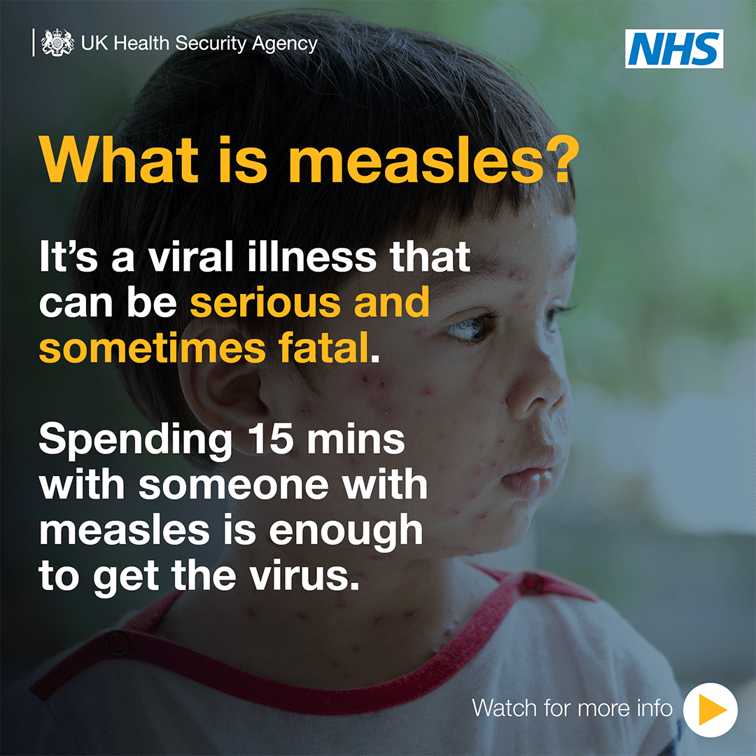
Facebook/ LinkedIn/  Twitter | Measles can have serious or sometimes fatal consequences and is still common in many countries worldwide. Before you travel, make sure you & your loved ones are up to date with #MMR vaccinations.  Measles can have serious or consequences and is still common in many countries worldwide. Before you travel, make sure you are up to date with #MMR vaccinations. | 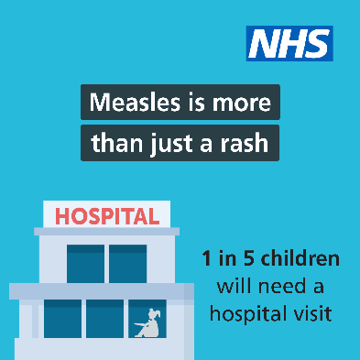
Facebook/ LinkedIn/  Twitter | If you’re planning to travel abroad over summer, make sure to check your child is up to date with their vaccinations, including the #MMR vaccine. Contact your GP to get up to date. | 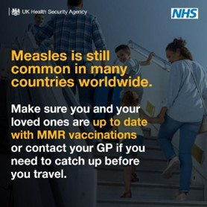
Facebook/ LinkedIn/  Twitter | Planning on going abroad for the school holidays? Before you go, check that your children are up to date with their vaccinations including the #MMR vaccine. | 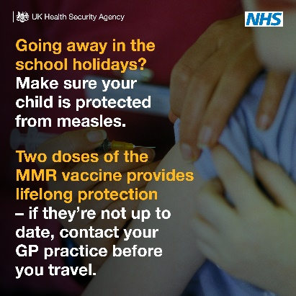

MMR vaccine assets to download
Asset 1- Measles- More than just a rash
Asset 2- Measles Travel
Asset 3- Measles Travel 2
Asset 4- Cases are rising
Asset 5- Cases are rising 2
Asset 6- 1 in 5
Asset 7- Get two doses
GIF 1 Measles symptoms
GIF 2 Measles is your child protected

More resources
Vaccine animation:
This animation was co-created with the British Society for Immunology and explains how vaccines work, to help parents and carers in making informed decisions about consent or when discussing routine vaccinations with their families and children and young people. It should not be marketed directly at Children and Young People.
Do you know how vaccines work? Click to view on YouTube

A leaflet to remind you to get your child immunised at one year of age- translated materials:

https://www.gov.uk/government/publications/immunisations-between-12-and-13-months-of-age

Available to download in the following languages: Afrikaans, Arabic, Bengali, Cantonese, Chinese, French, Italian, German, Hebrew, Hindi, Lithuanian, Polish, Portuguese, Romani, Romanian, Swahili, Spanish, Turkish, Tagalog, Tamil, Ukrainian and Urdu.

Measles information for schools and healthcare centres- translated materials:
https://www.healthpublications.gov.uk/ViewArticle.html?sp=Smeaslesdontletyouchildcatchitflyerforschoolstranslations
Available to download in the following languages: Afrikaans, Arabic, Bengali, Cantonese, Chinese, French, Italian, German, Hebrew, Hindi, Lithuanian, Polish, Portuguese, Romani, Romanian, Swahili, Spanish, Turkish, Tagalog, Tamil, Ukrainian and Urdu.

Useful links

A guide to vaccinations from 2 to 5 years: Details of immunisations for children between 2 and 5 years, before they start school

https://www.gov.uk/government/publications/pre-school-vaccinations-a-guide-to-vaccinations-from-2-to-5-years

Blog: What do I need to know about the MMR vaccine?
What do I need to know about the MMR vaccine? - UK Health Security Agency (blog.gov.uk)

Blog: Ensuring every child gets the best start in life – starting with vaccine protection
https://ukhsa.blog.gov.uk/2021/08/05/ensuring-every-child-gets-the-best-start-in-life-starting-with-vaccine-protection/

