


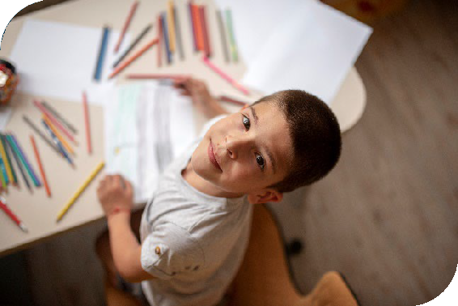

Sensory Processing

Needs
A Graduated Response

Staffordshire County Council Stoke-on-Trent City Council
NHS Staffordshire and Stoke-on-Trent Integrated Care Board
North Staffordshire Combined Healthcare NHS Trust
Midlands Partnership University NHS Foundation Trust

Contents
Acknowledgements 1
Introduction 2
What is sensory processing? 3
When to use the Sensory Processing Needs Toolkit? 6
A Graduated Approach to Sensory Support – Sensory Flow Chart 7
Targeted – Step 1 8
Environmental Audit 9
Observation Chart 15
Checklist for Recognising Sensory Difficulties 16
My Views 25
Targeted – Step 2 31
Set up, Assess, Plan, Do, Review 32
Suggested Classroom Strategies 33
Calming Sensory Activities 43
Calming Movement Activities 44
Wake up activities (alerting activities) 46
References 46
My Sensory Plan - Template 47
My Sensory Plan - Example 48
Appendix A 49

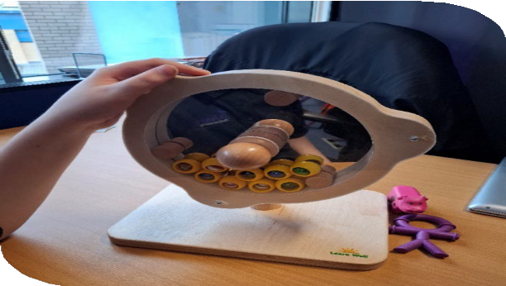
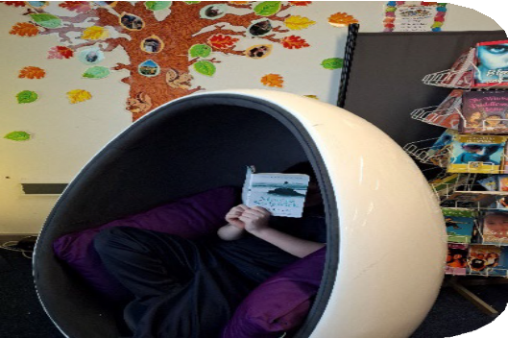

Sensory toy, St Peter’s Academy, Stoke-on-Trent

Reading space, St Peter’s Academy, Stoke-on-Trent

Acknowledgements
The Staffordshire and Stoke-on-Trent Sensory Processing Needs Toolkit is based on the Derbyshire Multi-agency sensory processing needs toolkit1. We would like to thank to the Derbyshire Local Area for allowing us to do this and for their guidance and support in the early stages of its development.
This Toolkit has been developed by a multiagency team of professionals including Children’s Occupational Therapists, SEND advisors, teachers and Educational Psychologists. Without their time, commitment and passion, this system wide Toolkit would not have been possible.

Name | Job title
Sally Bond | Assistant Educational Psychologist, Stoke-on-Trent City Council
Emma Dodd | Senior Educational Psychologist, Staffordshire County Council
Danielle Drakeley | Assistant Educational Psychologist, Stoke-on-Trent City Council
Kuljit Jheeta | SEND Learning and Support Manager, Stoke-on-Trent City Council
Jenna Lee | Trainee Educational Psychologist, Stoke-on-Trent City Council
Katherine Lee | Senior Educational Psychologist, Stoke-on-Trent City Council
Catherine Lewin | Designated Clinical officer SEND, Staffordshire and Stoke-on-Trent Integrated Care Board
Rebecca Loo | Children’s Occupational Therapist, Midlands Partnership University NHS Foundation Trust
Sarah Mountford | Head of Allied Health Professionals, North Staffordshire Combined  Healthcare NHS Trust
Jessica Perkins | Communications and Engagement Manager, Staffordshire and Stoke- on-Trent Integrated Care Board
Ceri Reed | Autism and SEN Advisor, Stoke-on-Trent City Council
Bryony Robinson | CAMHS Occupational Therapist and Advanced Sensory Integration Practitioner, Midlands Partnership University NHS Foundation Trust
Elizabeth Salvage | SEND Improvement Manager, Midlands Partnership University NHS Foundation Trust
Amanda Whitehouse | Children’s Occupational Therapy Team Leader, Midlands Partnership  University NHS Foundation Trust
Denise Dyke | CYP Strategic Manager, Staffordshire and Stoke-on-Trent Integrated Care Board

Special thanks also go to:
- Rose Martin, Children’s Occupational Therapy Assistant (Midlands Partnership University NHS Foundation Trust) for allowing us to use her ‘Sensory Characters’ that are used throughout the Toolkit.
- Gladstone Primary School, Priory CE Primary School, St Peter’s Academy, Stoke Minster School, Summerbank Primary School and Watermill School for allowing us to use their photographs within this Toolkit.
- Abbey Hulton Primary School, Forest Park School, Ormiston Horizon Academy, Barlaston First School and Sir Graham Balfour School for giving feedback on the development of this Toolkit.
Version Control

Version | Date published
V1 | 24 February 2025

1 DCC SPN Toolkit v13 Interactive

Introduction
The two Local Authorities2, healthcare providers3, and healthcare commissioners4 across the Staffordshire and Stoke-on-Trent Integrated Care System have come together to produce the Sensory Processing Needs Toolkit and Position Statement. These documents have been developed in partnership in response to an increasing number of requests from school settings for additional support with sensory processing difficulties and the acknowledgement that locally there was a limited support for sensory processing difficulties. It is also important that there continues to be a joint approach in how partner address this area of need.
This Sensory Processing Needs Toolkit is a school facing resource and provides a Graduated Approach to sensory processing support to children and young people within an educational setting. It is intended to be used by teachers to support children and young people and offers information on supportive strategies to consider, how to conduct an environmental audit and suggestions for regulating activities, so that children can take part in daily activities in school.
It can used with all children and young people, including those with autism and social and emotional mental needs, as it uses a general lens to look at sensory processing needs rather than through condition specific lens. It is not an assessments or diagnostic tool.
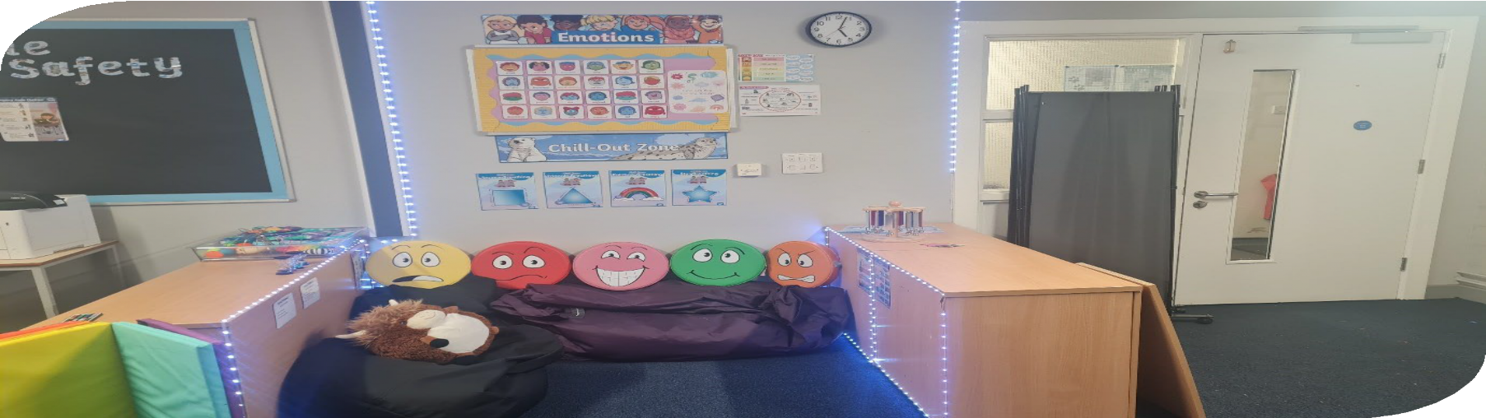
Sensory area, St Peter’s Academy, Stoke-on-Trent

2 Staﬀordshire County Council and Stoke-on-Trent City Council
3 Midlands Partnership University NHS Foundation Trust and North Staﬀordshire Combined Healthcare NHS Trust
4 Staﬀordshire and Stoke-on-Trent Integrated Care Board

What is sensory processing?
Sensory process is the cycle that we receive, process and respond to sensory input all of the time. This sensory information helps us explore and understand our surroundings.
Information from your senses is received by your brain which filters out all that is necessary and formulates a response to the information it receives. Some sensory information we choose to ignore, some we prioritise and respond to. This all happens subconsciously, and we can regulate our levels of alertness, for example when feeling sleepy you may fidget with pen or have a drink of water to ‘wake ourselves up’.


Sensory input


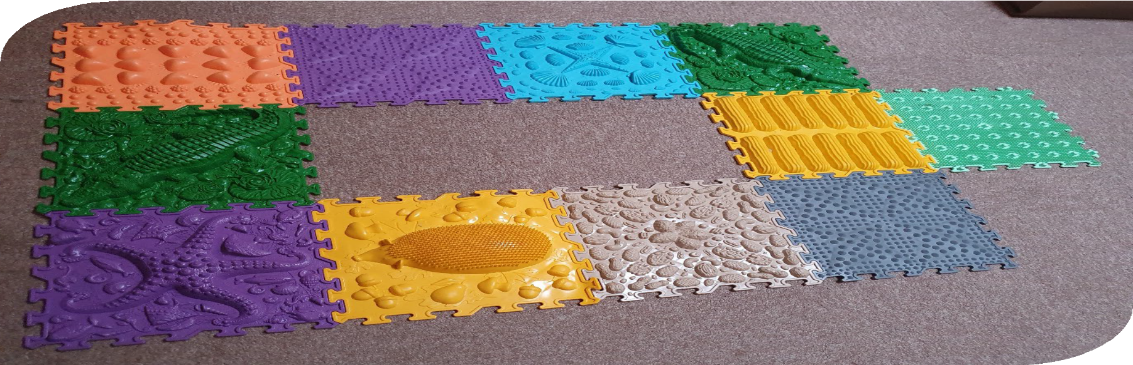
Response
Processing

Sensory mats, Priory CE Primary School, Stoke-on-Trent

We have eight sensory systems:
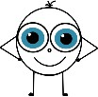
Sight (Vision) – the visual system is responsible for the information we receive through our eyes. This system provides information about people and objects around us and it helps us define boundaries so we can move around. This system is closely linked with proprioception so we would use vision and proprioception to help us walk through a busy classroom and negotiate objects.
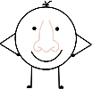
Smell (Olfactory) – the olfactory system is responsible for our processing of different smells we receive through our nose. We can detect whether a smell is flowery, sweet, strong and we can use it to help detect when food has gone off.
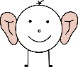
Hearing (Auditory) – the auditory system is responsible for the sensory information we receive through our ears. We can work out whether a sound is nearby, far away as well as the pitch or loudness of a sound.

Taste (Gustatory) – the gustatory and oral motor sensory system is responsible for the sensory information we receive through our taste buds in our mouth. We are able to detect salty, savoury, sweet, sour and bitter tastes. This system is linked very closely with smell and also with proprioception as the process of chewing/sucking plays an important part in sensory regulation.
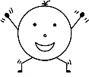
Movement (Proprioception) – the proprioceptive system senses the position, location, orientation and movement of our body muscles and joints. It lets us know where our limbs are in space, and how they are moving. It also influences how much force we may need to use.
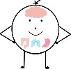
Internal (Interoception) – this system receives our internal sensory information from our internal organs, muscles and skin. It’s the internal information about our body state and emotion happening mostly at an unconscious level until we need it, such as the sensation of hunger or thirst, or feeling too hot or cold. It can also reflect the sense of excitement, tiredness and anxiety.

Touch (Tactile) – this system is responsible for the sensory experience that we receive through our skin. Light touch and deep pressure sensors help us work out whether items are soft, hard, hot or cold; detect vibration and sense pain. This system also works closely with our proprioceptors.
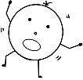
Balance (Vestibular) – the vestibular system is responsible for the sensory information we receive through the nerve endings in our inner ear. It contributes to our balance and orientation in space as well as helping to control our eye movements and keeping us steady. This system helps to co-ordinate both sides of our bodies.
Any information our body receives from our senses is sent to our brain via nerves, this is called sensory registration. Our brain will then process the information from all of the sensory systems and choose an appropriate response (sensory integration).
Sensory processing needs are the differences in the way people notice, process and respond to sensory information and can have an impact on how they are able to interact within their environment. Challenges can come at any stage of the sensory process. Sensory needs can be placed under any area of need, whilst often associated with other conditions such as Autism and Attention Deficit Hyperactivity Disorder (ADHD), there is evidence of sensory differences with people who have experienced trauma and learning disabilities it is not limited to these conditions.

This Toolkit does not focus on Ayre’s Sensory Integration Therapy or sensory processing disorder (SPD).
SPD is currently not a recognised disorder and is not included in the DSM V5 (Diagnostic and Statistical Manual of Mental Disorders).
A child or young person may have sensory processing needs when there is a difference in the way that their brain receives and processes any sensory information. Children and young people may have low registration to a particular sensory input (under responsive), which means they experience low levels or even a complete absence of the sensory input, for example, they may seek loud noises. On the other hand, some may have hypersensitivity (over responsive), in which they have heightened awareness of sensory input, for example they may be physically sensitive to sounds. It is important to note here that sensory processing needs does not include hearing or visual impairment.
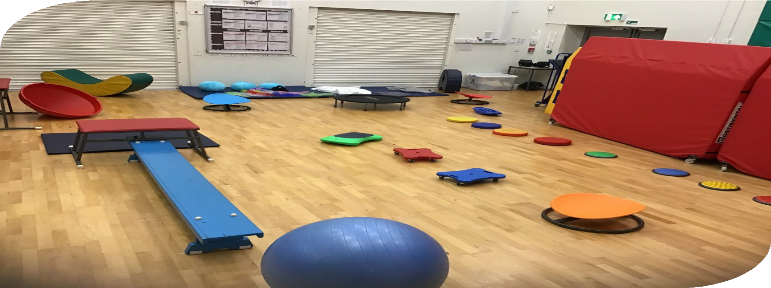
Sensory space, Watermill School, Stoke-on-Trent

When to use the Sensory Processing Needs Toolkit?
Before using the Toolkit, there is an expectation that the universal element of the tiered approach is completed. This includes ensuring the child or young person is accessing quality first teaching. There are additional resources that can be used at this stage.
Sensory needs can impact upon children and young people at school – for example those with sensory processing needs may find that it takes them longer to learn new skills and routines. Similarly, their sensory processing needs may make them sensitive to bright lights, loud noises or the feel of their clothes. As a result, concentration could prove challenging.
This could lead to high levels of anxiety which can impact behaviour, confidence and social skills. The Sensory Processing Needs Toolkit aims to identify and address sensory processing needs.
As mentioned earlier, sensory modulation needs in children and young people will occur as under-responsivity (hyposensitivity - experiencing little or no response to stimulus) and over- responsivity (hyper-sensitivity - having increased sensitivity to stimulus). Typically, a child will present with both under and over-responsivity in different sensory systems.
Consequently, a child or young person may then compensate through sensory seeking activities or sensory avoidance. Although these terms are not diagnostic, they are useful to help us describe a child or young person’s presentation and their responses to what we observe in them. We must keep in mind that children and young people’s behaviours and their responses can change dependent on their stress levels, the environment they are in, their developmental levels and changes within their sensory systems.
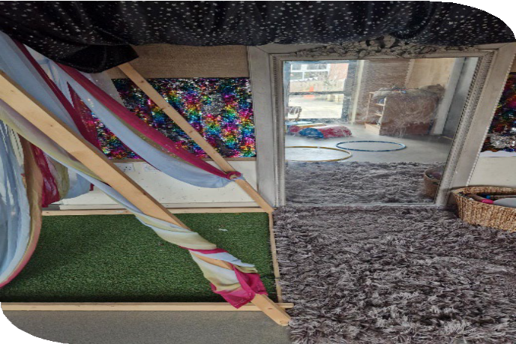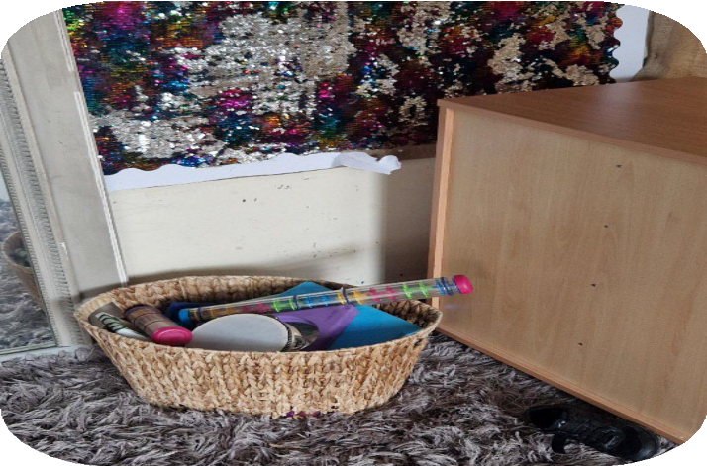
Sensory areas, Summerbank Primary School, Stoke-on-Trent

A Graduated Approach to Sensory Support – Sensory Flow Chart

Targeted – Step 2
- My Sensory Plan
- Specific Support for Needs
- Access to Sensory Champion

Targeted – Step 1
- Environmental Audit
- Observation Chart (ABCC)
- Checklists for Recognising Sensory Difficulties
- My Views/My Day/Waking Day Diaries
- Attend Sensory Needs Training

Universal
This is the first stage of helping children with sensory needs. This stage includes quality first teaching, along with accessing website, resources, and training offered by the council.

Targeted – Step 1
Environmental Audit
This will help in identifying the environmental factors that are having an impact upon the child or young person’s ability to function. An environmental audit should be completed for each child or young person experiencing sensory processing needs as their individual response to their environment will differ. You should complete each section in the appropriate setting.
Observation Chart (ABCC)
This will help in identifying what is happening and when. It can seem that some behaviours occur for no reason, but by completing the observation charts, it will facilitate in developing a clearer understanding of what the challenges are and why they might be happening.
Checklist for Recognising Sensory Difficulties
Using the eight sensory systems table and checklist at the start of this Toolkit will help to identify which particular area the child or young person might be having difficulties in.
My Views: Day with School or Weekends/Holidays; My Sensory Environment
These documents help to collect the child or young person’s own views about what their challenges are, how they feel in response to their sensory environment and what currently helps them.
If initial strategies have not made adequate impact, the ‘team around the child or young person’ might decide to alter the plan and review in another 6-8 weeks.
Alternatively, they might decide that there is enough evidence that further intervention is required and move on to Step 2.

Environmental Audit
Those with sensory processing needs can find certain environments challenging. This environmental audit is to help practitioners to evaluate and assess an environment so that if required, the environment can be adapted to engage and support children or young people with sensory processing needs.
An environment can be described as anything from a space, room or a whole building. This Toolkit is not a definitive guide, but it does provide ideas and suggestions on how the environment can be adapted if children or young people are experiencing anxieties and/or sensory reactions which in turn can make it difficult for them to engage, learn in, and tolerate the environment that they are in.
This audit will help in making the environments in your setting “friendlier” for children and young people with sensory processing needs.
The checklist is split into two parts. Part A is applicable for all settings to complete. Part B is for more specialist providers.
Each sensory area will have questions that require a yes/no response. If you believe that the environment fully addresses the question raised, tick ‘yes’. If not, tick ‘no’.
Next to each question, there is a section titled solutions/actions. This is there to prompt ideas in changing the current environment if needed. Please note that even if you have ticked ‘yes’, it might still be useful to note down how you have achieved this.
**This audit has been adapted from Stephen Simpson’s Autism Friendly Environment Checklist (2016) and the Derbyshire Sensory Processing Needs Toolkit Environmental Audit**
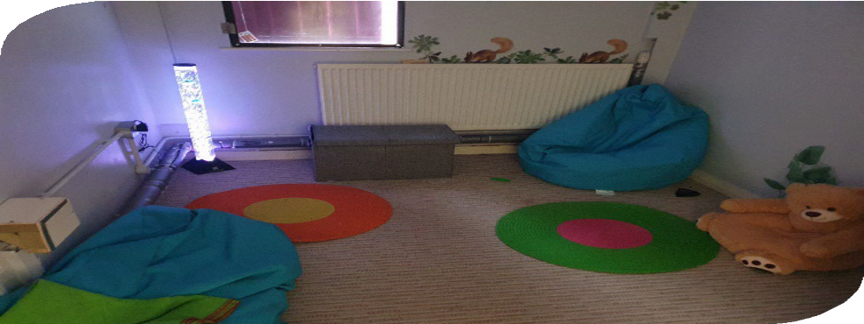
Sensory Space, Priory CE Primary School, Stoke-on-Trent

Date: Environment: Assessor:
Environmental Audit: Sight/Visual

 | Things to consider and evidence to look for: | Yes/No | Solutions/Actions
1 | Consider the impact of wall displays. Are they visually distracting (e.g., bright colours, lots of information etc.)? Also consider other surfaces e.g., table tops, blinds, curtains, pictures etc.
2 | The environment is clutter free and information/activities/objects can be found easily.
3 | The environment is well organised with all information/activities/objects clearly labelled/in designated zones for easy accessibility.
4 | If the child or young person has a workstation, this is in an appropriate place to allow them to focus and be free from distractions.
5 | Lights are turned off if not required and any broken/flickering lights are replaced promptly.
6 | An awareness of light coming into the room (e.g., from the sun) and if this creates patterns, reflects off surfaces etc.

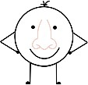
Date: Environment: Assessor:
Environmental Audit: Smell/ Olfactory

 | Things to consider and evidence to look for: | Yes/No | Solutions/Actions
1 | An awareness of everyday smells (e.g., cleaning products, ink from pens, glue, paint, highlighters, play dough etc.).
2 | An awareness of individual/personal smells (e.g., perfumes, deodorants, aftershaves, body odour etc.).
3 | An awareness of smells entering the environment from elsewhere (e.g., smells from the toilets, kitchen, food technology room, gardens, outdoors etc.).
4 | Could the child or young person have alternative toileting arrangements to avoid bathroom smells.

Date: Environment: Assessor:
Environmental Audit: Hearing/ Auditory

 | Things to consider and evidence to look for: | Yes/No | Solutions/Actions
1 | There is a system in place for the child or young person to have access to a quiet/loud room if the noise level is causing discomfort or distress.
2 | The child or young person has a system (e.g., flash cards) to notify staff when the noise level is causing discomfort or distress.
3 | There are strategies in place to reduce noise in rooms and corridors (e.g., carpets/wall coverings to reduce movement noise).
4 | The child or young person has access to ear defenders/headphones when needed (e.g., particularly during transitional times of the day when noise levels may be higher).
5 | All unused electrical equipment is switched off and specific noises that may irritate have been considered (e.g., clock ticking, humming from lights, noise from outside etc.)
6 | The child or young person is given advance notice of any loud, sudden noises (e.g., fire alarm, end of lesson bell).


Date: Environment: Assessor:
Environmental Audit: Touch/ Tactile

 | Things to consider and evidence to look for: | Yes/No | Solutions/Actions
1 | There is flexibility in the uniform policy for the child or young person to find appropriate alternative clothing if needed (e.g., clothing that is soft, no seams, no labels, comfortable etc.).
2 | Sensory materials are available for the child or young person to explore/use to self-regulate if needed (e.g., sand, water, different textiles etc.).
3 | There is flexibility in the writing policy to allow for the child or young person to use alternative forms of writing (e.g., iPad, laptop etc.).
4 | Movement breaks are available for the child or young person should they require them (e.g., those that find sitting on the floor/a chair for too long difficult).
5 | For safety and if applicable, all hot surfaces are clearly identified and labelled as such.

Date: Environment: Assessor:
Environmental Audit: General

 | Things to consider and evidence to look for: | Yes/No | Solutions/Actions
1 | The child or young person has a designated person that they can talk to if feeling discomfort or distress (communication tools are available if needed e.g., flash cards).
2 | Seating plans within the classroom considering sensory needs (e.g., a child or young person with sensitivity to light to not be seated by the window etc.).
3 | Consider adapting the timetable for the child or young person to transition around the school during quieter times (e.g., slightly before/after the start/end of a lesson, early access to the dinner hall for lunch time to avoid queues and noise etc.).
4 | Ensure that systems are in place to effectively communicate changes to routine (this can include the use of symbols, pictures, photos and objects to support).
5 | With regards to taste/gustatory sensitivities, ensure systems are in place for if a child or young person is mouthing/eating inedible food.

Date: Environment: Assessor:

Observation Chart

Date | Time | What happened just before the incident? | What does the behaviour look like? | What sensory experience is the child or young person gaining from the behaviour? | How long did it last? | What helps? | Initials
01.01.24 | 09:00 | The children were about to walk into the hall for the whole school assembly. | Bob covered his ears and started to hum. He was very reluctant to go into the hall. | It is reducing the amount of sound that Bob can hear. The humming minimises the amount of external sound. | 5  minutes | We gave Bob some ear defenders – he was then happy to go and sit in the  hall. | AB

Checklist for Recognising Sensory Difficulties
Please use the checklist below to highlight and consider the sensory needs of the child or young person. Think about how disabling/limiting the sensory difficulties are to that child or young person’s ability to learn, focus or interact with others. When considering the impact, please use the following scale:
- – Not observed
- – Observed but no impact
- – Minor impact on functioning
- – Moderate impact on functioning
- – Significant impact on functioning
Any scores of 3 and above may require interventions.
Needs may not always be present or observable in one assessment. Therefore, please consider what may be typical for the child or young person.
Please note that these lists are not exhaustive. If you see anything in addition to what is listed, please place in the additional notes box and score accordingly.

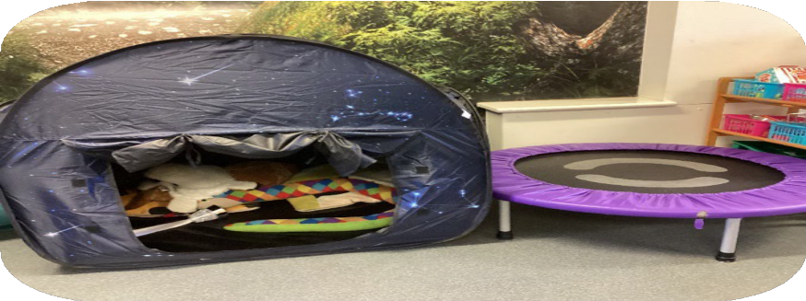

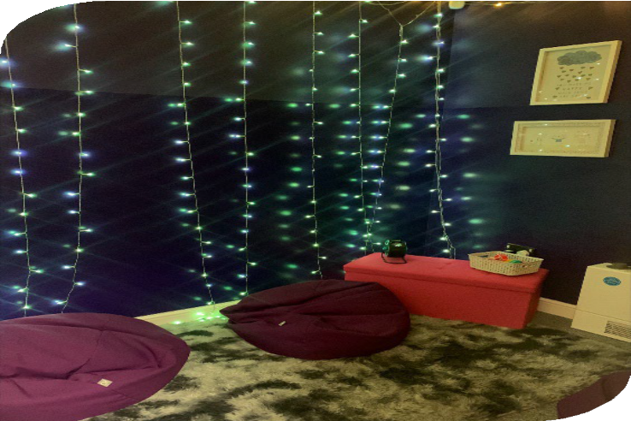
Sensory area, Gladstone Primary School, Stoke-on-Trent
Sensory area, Stoke Minster School, Stoke-on-Trent

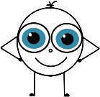
Vision
Sensory information received through our eyes and made sense of using our visual memories, visual perception skills, and visual cognition

Over Responsive | Impact Score | Under Responsive | Impact Score
- Be distracted by ‘everything they see’ and cannot focus attention on the pertinent thing  - Be disturbed by bright light  - Squint their eyes or complain of glare from sun or screens  - Struggle being outdoors in bright conditions  - Give excessive attention to things in their peripheral vision |  | - Miss visual details  - Struggle to recall things they have seen  - Struggle to spot the differences between similar objects or shapes (such as the letters a and o)  - Take longer to develop reading skills  - Learn better with varied or novel visual input and in differing environments.  - Bump into doorways, other children and fall over obstacles  - Enjoy flashing lights / discos
Additional Notes

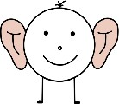
Auditory
Sounds detected through our ears and transmitted to the brain where they are interpreted.

Over Responsive | Impact Score | Under Responsive | Impact Score
- Find noisy environments distressing or even painful  - Cover their ears  - Experience fright / fight / flight response to sudden noises, or loud noises  - Make noises themselves. Noise they control themselves is much easier to tolerate and can sometimes be used as a coping strategy when noise from others is difficult for them |  | - Miss instructions given verbally  - Need more repetition than others to understand instructions  - Wait to see what others are doing before they begin  - Engage in noise-making, which can irritate others  - Enjoy loud music and noisy situations like concerts and carnivals
Additional Notes

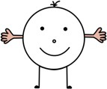
Tactile
Sensations we receive through our skin relating to texture, shape, and location of a stimulus on our bodies.

Over Responsive | Impact Score | Under Responsive | Impact Score
- Struggle with being touched, bumped or brushed past  - Experience pain much more severely than other children  - Show distress from every-day routines such as moving along corridors, using the bus, lining up outside the classroom or queuing for lunch.  - Struggle to tolerate clothing and footwear - making it hard for them to follow uniform requirements (or meaning the child is dysregulated in uniform)  - Not be able to tolerate underwear - creating issues around dignity for children and young people who wear skirts for uniform  - Can become distressed from wind, rain and snow on their face  - Struggle with swimming due to the sensation of the water on their skin and changes in temperature  - Avoid or get distressed by messy play or activities  - Get distressed if their hands or face are messy  - Tell you they don’t want to write because of the feel of the paper  - Avoid wiping their bottom due to the feel of the toilet paper  - Reject socks or only tolerate them for short periods |  | - Not detect pain responses as strongly or as quickly as peers (injuries can go undetected or untreated)  - Not notice when their face or hands are dirty  - Not notice when clothing has become dishevelled  - Be heavy handed  - Seek out hugs  - Prefer a heavy coat  - Enjoy being squashed during play or squeezing their bodies into tight spaces  - Pick away at skin around their nails, making them sore.
Additional Notes

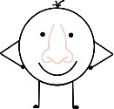Olfactory
Our sense of smell. This is closely associated with memory. Children and young people can become distressed if they detect a smell associated with a past or ongoing trauma.
Bear in mind that we all find some smells calming and others offensive / overwhelming. A smell that a child or young person finds calming is useful to have in your toolkit to use when they are feeling overwhelmed or stressed. Examples include handkerchief covered in a loved one’s perfume / aftershave; a few of their favourite smelling sweets in small tin; a soft toy that smells of home.

Over Responsive | Impact Score | Under Responsive | Impact Score
- Smell things that go unnoticed by others, and this can cause distraction or concern  - Heave, gag or feel repulsion to certain smells  - Struggle more (become dysregulated) after or during exposure to ‘smellier’ parts of the school building (e.g. dining room, cooking spaces, PE hall, toilets) |  | - Fail to detect smells that others can easily smell  - Not notice when food has “gone off”  - Not notice the smell of smoke as quickly as others
Additional Notes

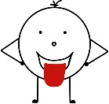Gustatory
Our sense of taste. Heavily influenced by our sense of smell.

Over Responsive | Impact Score | Under Responsive | Impact Score
- Finds some flavours and textures repulsive  - Struggle with eating a balanced diet  - Be quick to gag on certain food textures or tastes  - Only eat foods if they are within a certain temperature range |  | - Say all food tastes bland  - Add a great deal of spice, sauces or condiments to their food
Additional Notes

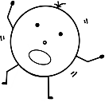
Vestibular and Movement
Sensations caused by the interaction between gravity and our body position or movements

Over Responsive | Impact Score | Under Responsive | Impact Score
- Be ‘travel sick’  - Avoid using a swing, roundabout or other playground equipment  - Avoid fairground rides and rollercoasters  - Turn pale or report feeling faint or dizzy more easily than others  - Resist tipping their head back for hair washing  - Resist performing rolls in gym class, or appear distressed after  - Have taken longer to learn to use a swing than others  - Be fearful of “outward bound” activities such as boating, rafting, high ropes etc where movements happen that affect balance  - Appear distressed or uncomfortable when up on a bridge looking down  - Refuse to use escalators |  | - Fidget and move a lot  - Tap or rock  - Struggle to maintain a steady position at the desk  - Rock the chair forwards, backwards or sideways, creating risk or injury to themselves or others  - Take movement risks such as climbing too high  - Have had a lot of injuries, bumps or have scars  - Shift their weight from one foot to the other or rock when sitting or standing  - Enjoy sports (but can sometimes appear clumsy or poorly coordinated)
Additional Notes

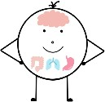
Interoception
Sensations relating to the physiological condition of the body (e.g. hunger, thirst, heart-rate, needing to use the toilet) and emotional state. It is possible for a child to have typical processing for some internal senses or emotions, but struggle to process others.

Over Responsive | Impact Score | Under Responsive | Impact Score
- Experience excessive hunger and overeat if not supported  - Feel discomfort from internal processes more acutely than peers which may distract their focus (e.g. menstrual pain)  - Seem “fussy” or “oversensitive” to sensations or activities that peers don’t complain about  - Experience feelings/emotions very intensely and need support to cope |  | - Struggle to detect physiological changes  - Struggle to detect and label their feelings  - Not notice when they are experiencing early signs of anxiety or anger (increased heart rate, sweaty palms, increased breathing rate)  - Not notice they need the toilet until it is late or even when it is too late  - Forget to eat  - Forget to drink  - Not notice signs of feeling sleepy or needing to rest  - Not detect changes in temperature so may dress in ways that do not fit the conditions (too many or too few clothes)  - Not realise when they are becoming agitated/upset - may therefore change very quickly from a “ready to learn” state to a state of low arousal or dysregulation
Additional Notes

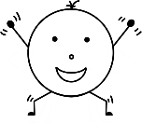Proprioception
Sensations that come from body movement and the position of our joints in space. It can also present as poor gross and/or fine motor skills. It is unlikely that a child or young person will show over responsive behaviours.

Under Responsive | Impact Score
- Poor body awareness (e.g., bump into furniture, door frames etc.)
- Unaware when touched or bumps into things
- Might find motor coordination tasks difficult
- Does not use enough (or sometimes uses too much) pressure/force to complete a task
- Often plays rough or accidentally breaks items
- Struggles to (or unable to) copy the movements of others
- Seeks pressure by leaning into others, furniture etc
- Seeks out close physical contact
- Seeks and/or squeezes into small, cramped spaces
- Enjoys carrying/pushing/pulling heavy items around
- Enjoys rough play (but may take it too far)
- High toe/tip toe walking and/or stamps feet when walking
- Often cracks their knuckles and/or stretches their limbs
Additional Notes

My Views
- Day with School
- Weekends/Holidays
- My Sensory Environment

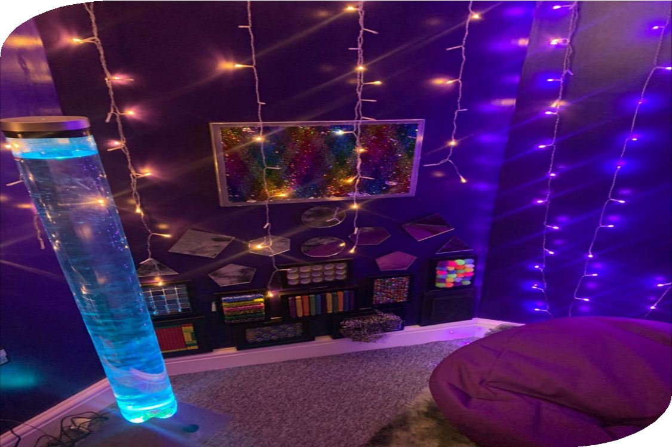
Sensory space, Gladstone Primary School, Stoke-on-Trent

My Views – Day with School
Name: Class: Date:

Activity |     What do I feel? |   Which sense is most affected? | What would help me?
Wake up
Get washed and dressed
Have breakfast
Brush teeth
Travel to school
Enter school
Lesson 1
Playtime
Lesson 2
Lunchtime

Activity | What do I feel? | Which sense is most affected? | What would help me?
Lesson 3
Lesson 4
Exit school
Travel from school
Homework
Watching television/iPad
Before dinner
Play
Change to pyjamas
Brush teeth
Story time
Bedtime

My Views – Weekends/Holidays
Name: Class: Date:

Activity |   What do I feel? |   Which sense is most affected? | What would help me?
Wake up
Get washed and dressed
Have breakfast
Brush teeth
Play
Watching television/iPad
Have lunch
Have dinner
Bath time
Story time
Bedtime

My Views – My Sensory Environment – [insert location]

How do I feel here?

Insert image of location here

Which sense does not like it here?
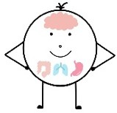
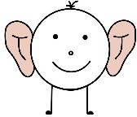
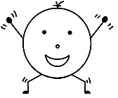
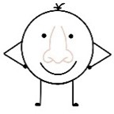
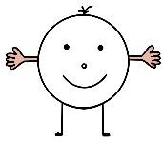
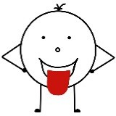
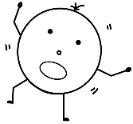
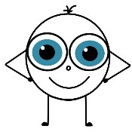

Strategies and support for this area:

You can download the sensory characters by visiting the resource section on the ICS website: Sensory Processing Needs Toolkit - Staffordshire and Stoke-on-Trent, ICS

Interoception | 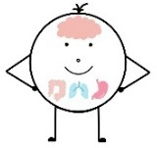
Auditory | 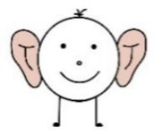
Proprioception | 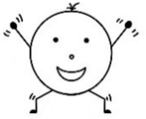
Smell | 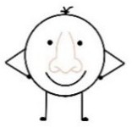
Tactile
Taste | 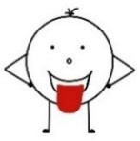
Vestibular | 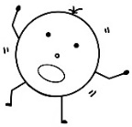
Vision | 

Targeted – Step 2
- Set up, Assess, Plan, Do, Review Cycle

- Suggested Classroom Strategies
These strategies can be used to help put a sensory plan in place with suitable targets.

- My Sensory Plan
This will outline who will do what and when, in order to address the child or young person’s individual sensory processing needs.

Set up, Assess, Plan, Do, Review
School to follow a child-centred assess, plan, do, review cycle.

Assess
  - Environment checklist
  - Sensory checklist
  - Pupil voice

Review
  - Set review date on plan
  - Sensory review plan
Plan
  - Goals and strategies
  - Sensory plan

Do
  - Implement strategies
  - Observations

Suggested Classroom Strategies
For a child to focus on their learning activities they must modulate their sensory input effectively. Modulation involves filtering out irrelevant sensations and noticing and responding to those which are relevant. In doing so the child can maintain the appropriate level of arousal (alertness) and attention, so they can be in a “ready to learn” state. You can help children or young people who struggle to modulate their sensations by providing them with strategies. Examples are given below. Every child is different. You will need to experiment. Talking to the child or young person and their caregivers about the ideas below will help you understand what is worth trying.
REMEMBER: when addressing sensory needs be sure to consider other areas of need: cognition & learning, speech and language, motor skills, hyperactivity, autism etc. Consider how to support these needs and whether specialist services may be indicated.
The activities and strategies below should be done WITH the child not done TO the child. They should be with the child’s agreement and not forced. It is helpful to talk to the child and their family (when things are calm) about what strategies may be suitable and helpful and any they may find upsetting or uncomfortable, so they can be avoided.
In this Toolkit you will find:

Strategies for each sensory system | Self-regulation Strategies
- Visual  - Auditory  - Tactile  - Olfactory (smell)  - Gustatory (taste)  - Vestibular and Movement  - Interoception  - Proprioception | - Calming Sensory Activities  - Deep pressure activities  - Movement Activities  - Fidgets  - Sensory Boxes  - Alerting Activities

Visual
Sensory information received through our eyes and made sense of using our visual memories, visual perception skills, and visual cognition.

Over Responsive | Under Responsive
You could try:  - Ensure a sight test is carried out  - Reduce visual distraction (consider displays within the classroom)  - Create a designated area for frequently occurring information  - Consider seating position in class  - Use auditory cues to support instructions/tasks  - Label drawers, coat peg etc  - Use colour coding on items  - Screen off written information so the child can hone in on the relevant part (cut a slot in cardboard to make a screen, use a “line tracker” or teach the child to use a piece of paper under the line of text)  - Use a marker (such as a blob of blue tack, or post it note arrow) to indicate the place the child should look  - Some children benefit from a desk screen. These should be used sensitively and with discussion. A younger child may enjoy decorating the OUTSIDE of it to make it more fun and acceptable. A desk screen should not be used continuously, but instead for short periods of concentrated work on a specific task.  - Consider making a zone in the class which is free from wall displays and has neutral, plain dividers  - Consider the need for break away from bright lights (dark tent or darker room) | You could try:  - Ensure a sight test is carried out  - Screen for dyslexia  - Consider the need for brighter lighting or more contrast on screens  - Provide distinguishing/contrasting visual cues within the classroom  - Label drawers and cupboards clearly  - Provide notes to enable child to process learning materials  - Use a mirror to check appearance (such as after eating to detect and clear up spills on face or clothing)  - Experiment to see if the child or young person does better when sitting in  different locations within the room  - Give additional verbal cues around hazards or obstacles  - Provide additional supervision and cues when there are changes to the environment (e.g. wet floor, debris,  maintenance work)  - Be aware that road sense may be lower than expected for age, so consider this for outdoor activities and school trips

Auditory
Sounds detected through our ears and transmitted to the brain where they are interpreted.

Over Responsive | Under Responsive
You could try:  - Consider noise levels (e.g. allow the use of ear defenders, headphones, audio devices to eliminate excess noise or to provide noise cancelling or white noise if enjoyed)  - Consider whether white noise, or chosen music, through headphones may assist their state of regulation  - Ask others to speak in a calm, quiet and well-paced voice  - Keep instructions concise and consistent  - Give a visual cue to gain attention  - Allow them to sit close to the source of information  - Limit auditory distractions where possible  - Consider small group work  - Consider special arrangements for tests to provide an environment where noise is controlled  - Consider noise exposure for breaks and lunch times. The child or young person may not be able to face eating in busy dining halls and may need a quiet space to eat, digest and decompress from the noise in classroom  - If the toilets have hand dryers the child may need to use a different space as the noise can be intolerable for children who are sensitive to noise  Consider moving around in school. If corridors are noisy the child may need to move around at different times to the crowds | You could try:  - Ensure hearing assessment is completed  - Give a visual cue to gain attention (e.g. teacher puts hand up and pupils follow, or use a change of screen on the whiteboard)  - Allow them to sit close to the source of information  - Use visual cues to support auditory instructions  - Allow them to receive auditory input that does not distract other children  - Have the child act as a classroom messenger to rehearse their listening skills  - Repeat the instructions for the child or young person directly after setting the class off  - Check the child or young person’s understanding of the instruction given by asking “what do you need to first?”, “then what is next”  - Keep instructions to the simplest length so the child and young person can manage. You may need to give only one instruction then come back to give the next  Keep instructions on the board whilst task is progressing

Tactile
Sensations we receive through our skin relating to texture, shape, and location of a stimulus on our bodies.

Over Responsive | Under Responsive
You could try:  - Avoid approaching the child or young person from behind  - Consider position in class – if possible, allow them to choose where to sit (quiet areas)  - Allow standing at the start/end of the line  - Provide a quiet space (within the classroom if possible)  - Help them to communicate their need for personal space  - Identify any trigger fabrics, tools or materials  - Allow adaptations to uniform to eliminate sensations that cause discomfort  - Introduce any new tactile sensations gradually  - The child may need the ‘protected feeling’ of a coat with a hood up, even in warm weather. Discuss with the child or young person and family about how they may use tolerated clothing without get- ting into trouble re. uniform  - Lessons such as dance, performing arts can involve close proxim- ity and touch from others. Discreetly ask the child first what they can tolerate. This may vary depending on other exposures during the day.  - Consider time and space away, so the child can get a break from the uncomfortable sensations of being buffeted by other people.  e.g. having lunch break in a small room with very few children in it  - For children who cannot tolerate constricting feel of underwear, they may need to have significant uniform allowances, such as being able to wear long skirts, culottes, bloomers or ‘harem pants’ to protect their dignity  - Dispensations may be needed for PE kit adaptation  - Offer gloves / apron for activities that involve getting messy | You could try:  - Ensure hearing assessment is completed  - Give a visual cue to gain attention (e.g. teacher puts hand up and pupils follow, or use a change of screen on the whiteboard)  - Allow them to sit close to the source of information  - Use visual cues to support auditory instructions  - Allow them to receive auditory input that does not distract other children  - Have the child act as a classroom messenger to rehearse their listening skills  - Repeat the instructions for the child or young person directly after setting the class off  - Check the child or young person’s understanding of the instruction given by asking “what do you need to first?”, “then what is next”  - Keep instructions to the simplest length so the child and young person can manage. You may need to give only one instruction then come back to give the next  - Keep instructions on the board whilst task is progressing

Over Responsive | Under Responsive
- Have washing facilities close at hand for messy tasks i.e. bowl and towel or provide wet wipes or wet flannel in the child’s bag or tray so they can self-clean face and hands
- Offer flushable wet wipes for bottom wiping
- Allow the child to write using alternative tools and materials (white board and marker, use a piece of plastic notebook cover under their writing hand, write on a laptop or make letters on a tablet)
- Let them use a favourite pen or pencil that slides over the paper in a way that they can better tolerate
- Consider adding a squashy gripper to the pen where they hold it
- Offer disposable gloves for use in the toilet

Olfactory
Our sense of smell. This is closely associated with memory. Children and young people can become distressed if they detect a smell associated with a past or ongoing trauma.
Bear in mind that we all find some smells calming and others offensive / overwhelming. A smell that someone finds calming is useful to have in your toolkit to use when they are feeling overwhelmed or stressed. Examples include: handkerchief covered in a loved one’s perfume / aftershave; a few of their favourite smelling sweets in small tin; a soft toy that smells of home. Natural scents are often softer than man made
i.e. fruit or herb fragrances.

Over Responsive | Under Responsive
You could try:  - Ensure any incoming smells are: moderate, non-distinct and associated with pleasant experiences  - Do not wear strong fragrances  - Introduce smells gradually (e.g., with small objects of reference that can be removed quickly if needed)  - Do not complete cookery activities with strong smells  - Remember that smell can provoke a very strong emotional reaction, so any smells introduced need to be planned for in an appropriate way  - Consider personal odours i.e. “coffee breath”  - Consider toilet smells – some children and young people with high levels of sensitivity to smells can find the smells of cleaning products and toilet smells intolerable. They may need a different toilet space away from others to be able to use the facilities. Check fluid intake, as these children may  avoid drinking to avoid needing the toilet and dehydration will impact learning and behaviour. | You could try:  - Remember they may want to eat/taste items, some of which may be unusual or surprising, so be aware of this when presenting any items to smell or play with  - Complete cookery activities choosing stronger flavours/smells to capture interest and alert sensory system  - Ensure the child can select condiments, spicy foods, sour/ tangy foods and those with strong flavours (as plainer food can taste bland)  - Additional cues may be needed (e.g. when detecting fire) – ensure smoke detectors are in place if the child or young person spends time alone at home

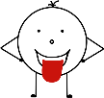 Gustatory
Our sense of taste. Heavily influenced by our sense of smell. Every person experience tastes differently. Understanding sensory preferences is important.

Over Responsive | Under Responsive
You could try:  - Maintain the temperature of food  - Choose food with a similar smoother texture/consistency  - Ensure foods are mild in flavour (e.g., choose bland, familiar food)  - Avoid pressurising the child or young person to try new foods. When presenting new foods, do so on days when the child is otherwise happy, calm and regulated. Encourage and don’t pressurise. Give praise for small wins such as smelling a new food or touching it, or for one lick or small bite being taken  - Try not to make food an issue with the child.  - If there are concerns about restricted diet, consult school nurse or GP about the possible need for blood tests for deficiencies and whether nutritional supplements are needed | You could try:  - Using taste testing as an activity to establish preferences  - Include foods with a variety of textures such as crunchy/smooth etc  - Include strong tastes (e.g., sweet/sour)  - Utilise sensory based cookery tasks in the classroom where possible  - Be aware and vigilant that individuals may attempt to seek out and eat non-food items and items that could be harmful i.e. paint crayons, coffee granules, soil, cigarette ends

Vestibular and Movement
Sensations caused by the interaction between gravity and our body position or movements.

Over Responsive | Under Responsive
You could try:  - Avoid/limit fast movements  - Offer alternatives to activities which are too distressing  - Consider appropriate awards i.e. a “reward trip” to a theme park may not be particularly motivating and may seem more like a punishment to some children – discussion may be needed.  - If the child or young person is able and wants to join in with vestibular activities for a short while, then discuss with them what they need after to recover  - Discuss with caregiver and the child or young person the strategies needed to prevent / deal with travel-sickness (and carry bucket and change of clothes) | You could try:  - Encourage them to participate in sensory motor and perceptual games/programmes  - Incorporate movement breaks into the school day  - A “wobble cushion” (see further guidance on this in  Appendix A)  - A foot fidget  - Reduce the length of time a child is expected to sit in one position  - Have the child pass out materials as a way to allow movement  - Start with bigger movements in PE before expecting them to master more precise actions  - Add visual cues to hazards such as steps, doorways or obstacles  - Non-slip soles on shoes  - Keep walkways clear of clutter

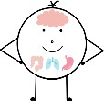
Interoception
Sensations relating to the physiological condition of the body (e.g. hunger, thirst, heart-rate, needing to use toilet) and emotional state. It is possible for a child to have typical processing for some internal senses or emotions, but struggle to process others.

Over Responsive | Under Responsive
You could try:  - A medical cause for pain and physical symptoms should be explored before assuming the child is highly sensitive to internal sensations  - Adults can help the child or young person understand how they are feeling by providing knowledge such as that found in the Zones of Regulation Program or the Alert program  - Children who over-responsive to interoception and are experiencing pain may need more adjustments to support their attendance and learning – such as access to heat pad, support with accessing pain relief, sympathetic staff (be aware of menstrual pain in particular)  - Adults to avoid dismissing the child or young person’s sensory discomforts, as the child or young person genuinely perceives them strongly. Instead acknowledge and ask them what will help. | You could try:  - Adults can help the child or young person to understand how they are feeling by providing knowledge such as that found in the Zones of Regulation Program or the Alert program. Be aware though that children and young people who are under-responsive to interoception may struggle to apply their learning in the moment.  - Adults should take any injuries more seriously than the child’s level of distress may first suggest. Pain response may be reduced or delayed.  - A toileting routine may be needed with adult reminders to avoid bowel/bladder accidents and where possible monitoring of bowel movements to avoid constipation  - Review fluid intake and establish a routine if needed  - Allow drinks bottle on the desk and encourage regular fluid intake  - Consider need for support around sleep routines at home  - Watch for signs of the child or young person becoming too hot or too cold and support them to respond with action to assist their temperature management  - Offering a supportive approach to illness i.e. flatulence, burping, vomiting, as the usual prior notice may not occur or be recognised.  - Use of body maps and vigilance around bruising and injury as individuals may not notice these  - Regular checks of teeth and ears as common pain causes may be overlooked and may be the reason for distress or behaviours that may challenge  - Monitor changes in any self-stimulatory or self-injurious behaviour

Proprioception
Sensations that come from body movement and the position of our joints in space. When we engage in activities that give proprioceptive sensations, it helps regulate and calm us.
Our proprioceptive sense is activated when we do:
- Whole body actions such as pushing, pulling, lifting, playing, and moving
- Oral actions such as chewing, sucking, and blowing
- ‘Heavy work’ which creates resistance (meaning input to muscles, tendons and joints)
- Place all the chairs under desks at the end of the day
- Erase whiteboard
- Help to tidy/rearrange desks
- Help to move gym mats, equipment etc
- Eat chewy or crunchy food at break/lunch times (e.g., fruit bars or vegetables/cereal)
- Sharpen pencils
- Hand out books
- Climb on playground equipment
- Colour rainbow over a large sheet of paper, whilst kneeling
- Stack/put away chairs/benches after an assembly
- Regular movement breaks
- Squeezing, squashing or stretching a ball or fidget toy.
- Use a trampoline or trampette to bounce
- Hang from play equipment like monkey bars
- Digging in the garden
- Tug of war
- Pushing and holding open heavy doors


Some ways to use the proprioceptive sense to improve attention, alertness level, body awareness and muscle tone, as well as decreasing defensiveness.

Calming Sensory Activities
Some activities produce sensations that are calming and regulating. In addition to the suggestions listed under ‘proprioception’, the activities below can help children and young people to maintain a “ready to learn” state rather than agitation. Ideally these activities should be used proactively to prevent dysregulation, rather than reactively after a child has lost control of their state of arousal and have become overwhelmed or agitated.
Deep Pressure
Applied to the body (especially over the places where there are joints). Examples include:
The Burrito Roll
- Explain to the child what you are going to do and ask their permission
- Ask whether the child wants their arms inside or whether they want to straighten their arms up beside their ears to stay outside the roll
- Slowly roll the child along the floor in a blanket until the blanket ends and the child is rolled inside it
- Ask if they would like to be rolled along a bit more
- Ask if they would like “sauce” and if so apply slow, steady pressure to their back, hips and shoulders in turn
- Observe the effect on the child and have them tell you how they feel
- Some children may enjoy some learning when inside their burrito roll – they might want to recite times tables, or practice their spellings or listen to a book or hear some of their lesson in this position
- Always ensure the child know they can say when they have had enough and that you will help them out immediately
The Bug in a Rug
As above but have the child wriggle along the floor in the blanket like a caterpillar or inch worm.
Hug myself
Cross your arms over your chest, hands on opposite shoulders and give yourself a squeeze like you are hugging yourself.
Chair lifts
Sitting on a chair, put your hands (with palms flat on the seat) under your bottom. Push yourself up so you are slightly lifted for a few seconds. Repeat a few times.
Push the wall down
Challenge the child to stand a little away from a wall and push into it hard as if they are trying to make it fall.
Head squash
Place both hands on your head and press down towards the floor. Hold for a few seconds. Repeat a few times
Praying hands
Fold your hands together like you would if you were praying. Keep your elbows out. Press your hands together, keeping your position the same. Count for a few seconds. Rest for a moment then repeat a few times. You might like to breathe out as you press too.

Calming Movement Activities
Calming movements are back and forth, side to side and up and down. Spinning, twisting, turning, and upside-down movements can make a child more excitable and agitated. Here are some calming activity ideas
- Wheelbarrow walking (crawling along using your hands, whilst someone holds up your straight legs)
- Jumping on a trampette or trampoline (remaining upright, not somersaults)
- Space hopper play
- Digging in the sandpit or garden
- Drawing on walls or paths with big chalks
- Skip with a rope
- Building a den
- Doing an exercise session (yoga, Pilates, gym ball activities)
- Activities with swing motion i.e. a swing hammock
Getting outside into nature is helpful to all of us who need help to calm and regulate ourselves. A child may need to run off some energy or simply walk outdoors.
Fidgets
A foot fidget can help some children to wiggle and move whilst listening without disturbing others. There are a range on the market and instructions should be followed carefully to ensure age/size limits are followed and that it is suitable for the child or young person. Such items should be trialled with careful observation of their effects and with monitoring as to whether the child or young person can safely use the item and that it does not present risk to others. If introducing other sensory aids, each aid should be introduced one at a time so their impact can be clearly seen.

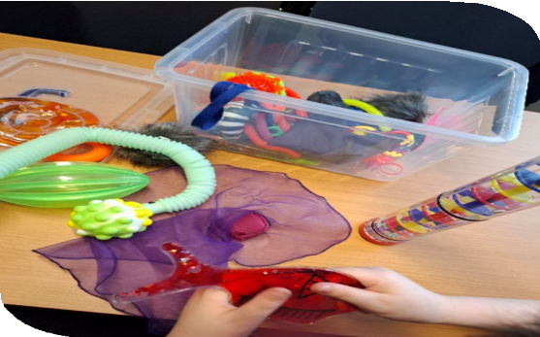
Sensory toys, St Peter’s Academy, Stoke-on-Trent
Hand fidgets can be important educational aids for some children who cannot listen and learn if their bodies are kept still. Some children can look busy with their hands and adults assume they are not listening, when they can actually be listening better. When some children are told to sit quietly and look forward, it takes all their attention to do that, and so it reduces their ability to learn. You can easily tell if a fidget is helpful or not. Have several separate trials of the fidget and compare the child’s ability to tell you what has been taught when they had it versus when they had to sit still. A child needs to be able to use the fidget sensibly and at the right time. A fidget rule card or similar can help with this. Some children need to squeeze something, others need to flick something or stretch something.
Having a range of different fidgets to try can be helpful. For older children, age-appropriate fidgets can be given in the form of stationery items (e.g., a binder clip to flick, a spinner on the end of pen, a pencil case zipper, a squashy rubber to pick apart). Some children can discreetly manage their need to use their hands to fidget by holding something sewn into their pocket or by messing with a tag on a pencil case for example

Sensory Boxes
Sensory box, St Peter’s Academy, Stoke-on-Trent
Some children and young people benefit from a sensory box or bag. This contains a range of sensory activities that the child finds soothing and settling. It may contain things like:
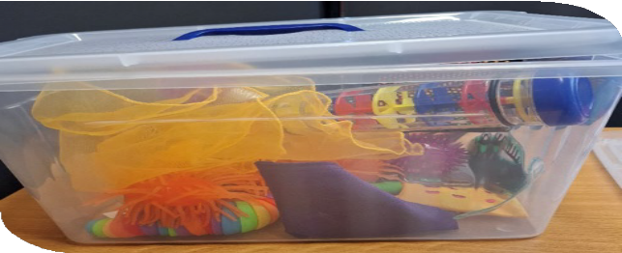
- Something to squeeze (rubber ball, fidget ball, playdough, bubble wrap or squishy)
- Something to feel (favourite fabric, feather, or a textured toy)
- Something to smell (handkerchief with caregiver’s perfume)
- Something to listen to (like a wind-up chime toy), or block out sound (ear defenders, flare audio noise reduction aids)
- Something to look at (family photo, pictures of

preferred video characters)
- Pictures of the ‘deep pressure’ and regulating activities the child prefers and responds to
- A blanket if the child responds well to being wrapped as a burrito
- A small, weighted item such as a weighted soft toy.
- Small manipulatives to fidget with – fidget toy or for older children stationery items that can be fiddled with such paper clips to unravel, binder clips to flick open and closed, pen with a topper that moves
- Items from nature such as shells, feathers, leaves etc.
- Something which smells like home i.e. an item washed in the family’s usual washing powder
Sensory box, St Peter’s Academy, Stoke-on-Trent
.

The items should be carefully chosen with the child or young person and family, and safety rules and expectations established.

Wake up activities (alerting activities)
Some children will enter a sluggish, sleepy state and need help to push up their alertness level so they can listen and learn. Ideally these activities should be used proactively at the first signs of the child losing alertness (or as part of a regular routine to maintain alertness) rather than reactively after a child has lost control of their state of arousal and have become overwhelmed or agitated.
You could try:
- Don’t let the child or young person sit for too long
- Alternate desk-based activities with short movement-based activities
- Star jumps
- Hopscotch
- Ball play activities
- Running
- Younger children could follow the activities in Kim Griffin’s YouTube series https://www.youtube.com/watch?v=jmCytSK_Zlo&list=PLRNxO7qxEvMQulqxtRlH42 XiRhPMqW5GG
- Crunchy snacks
- A strong “wake up” smell if the child enjoys and tolerates it.

References
These are the primary sources of information which supported production of this section:
- Sensory Integration: Theory and Practice. 3rd Edition. Anita C Bundy and Shelly J Lane (2019)
- Adolescent/Adult Sensory Profile. Catana Brown and Winnie Dunn (2002)
Further reading and resources on sensory strategies
https://www.nhsggc.org.uk/media/255431/making-sense-of-your-sensory- behaviour.pdf
https://www.griffinot.com/category/sensory/sensory-supports/

My Sensory Plan - Template

Insert picture of child or young person
My Sensory Plan
Name: D.O.B:
Date of Plan:
Review Date:

My targets:
I want to be able to …….
My sensory needs:
•
•
•

I will help myself by:
•
•
•

School can help me by:
•
•
•

My Sensory Plan - Example

Insert picture of child or young person
My Sensory Plan Name: J. Bloggs D.O.B: 01.01.24
Date of Plan: Spring Term 2024
Review Date: End of Summer Term 2024

My targets:
I want to be able to stay in my art lesson for 30 minutes.
My sensory needs:
- Sensitive to loud sounds
- Unable to concentrate on a conversation if another is taking place
- Avoidance of noisy situations

I will help myself by:
- Independently use my ear defenders if I need them
- Access a safe, quiet space when I need to
- Let adults know when I’m feeling distressed

School can help me by:
- Encourage others to speak in a quiet and calm voice
- Let me sit close to the front of the class
- Limit auditory



Appendix A
OT guidance for use of a wobble cushions
What are wobble cushions or air-filled cushions designed for?
A wobble cushion is an inflatable air cushion which is designed for a child to sit on. The idea is that this movement will help to keep the child more alert.
A wobble cushion may help a child who is constantly moving, fidgeting and maybe rocking on their chair to help them stay alert.

Types of cushions
Move ‘n’ sit
- To be used on a chair.
- Can be suitable for children with ADHD, autism and children who are considered to be sensory seekers.
- This comes in 2 sizes junior and adult.
Wobble cushion
- It can be used on a chair or the ground.
- Can be suitable for children with ADHD, autism and children who are considered to be sensory seekers.
Safe use of cushions
- Ensure the cushion is the correct size for the child/young person.
- Check for correct seat height, feet should be able to touch the floor.
- Ensure the child/young people’s bottom is fully on the cushion and not on the edge.
- Ensure correct amount of air is used to inflate the cushion, over or under inflation re- sults in the cushion not being used properly. The cushion must have enough air in it, so it is unstable when the child sits on it. If it is too deflated the child’s bottom will touch the chair underneath. If it is over inflated the child will rock to side to side like a seesaw. Heavier children will need more air in it.
- Ensure the pin at the back is secure, this maintains the level of air in the cushion.
- Regularly clean the cushion with disinfectant wipe and soapy water.
- The cushion can be changed sides if the child/young person is sensitive to the dim- ples.
- Put the cushion aside and use at regular intervals throughout the day. It should be used no longer than intervals of 30 minutes.
- Monitor the cushion and the child’s response to using it. You need to be sure that it is addressing the purpose it is intended for such as increase participation in writing task.
- Do not use at the same time as a lap pad.

When not to use a wobble cushion or air inflated cushion
- If the child has hypermobility.
- If the child is using other weighted products such as weighted lap mat.


Children’s Occupational Therapy

 |  | 
 |  | 

