Reading Exercise
Michelle Mellor

Nurse Practitioner

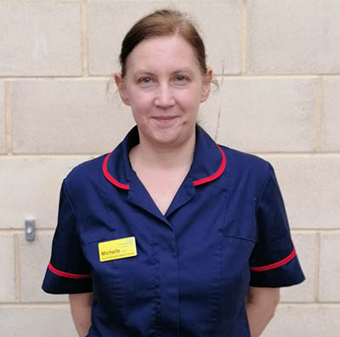
Michelle worked as a care assistant in a care home before she had her family. Once her three children were all at school she decided she was ready to go back to work and keen to be challenged a bit more. She completed her nurse training at Staffordshire University and qualified in 2008.
She initially worked on the female acute ward at what was then Shelton Hospital. Although she gained a lot of useful experience this wasn’t where she wanted to be so she moved to Whitchurch Cottage Hospital to work with people with dementia. She took the opportunity to gain some community experience and when the cottage hospital closed took up a permanent post with the community mental health team which went on to become the Memory Service. By this time she realised her passion lay with the assessment and diagnosis of people with dementia and this has been the focus of her subsequent career. Along the way she has also gained qualifications in physical health and in prescribing as well as becoming a student mentor.
Michelle has held a management position with the memory service but has now returned to a more clinical role as a Nurse Practitioner which she prefers. The role involves the assessment and diagnosis she is passionate about, as well as a medication prescribing role.
Michelle says “No one wants to hear that their loved one has dementia, but if the assessment and diagnosis is done well it can make a difficult situation so much easier. You need compassion, patience and knowledge to carry out the role but it offers me real job satisfaction.
“The Coronavirus pandemic has presented some interesting challenges. I was redeployed onto a ward which was a bit of a learning curve as things had changed. We also went virtual and had to work out how to carry out assessments via video calls. I was skeptical at first but it has proved successful and will certainly make us more flexible and resilient in the future – coping with bad weather for example.
“I never thought when I started caring for people aged 18 that I would be where I am now, but I have been given lots of opportunities and supported to gain the confidence to make the most of them. I feel MPFT is a very forward-thinking trust which recognises the value of a nurse-led service.”

