Supporting Information: SWITCH (Staffordshire & Stoke-on-Trent’s Weight-related Interventions Tailored in Care for Health) connector role.
Obesity care and weight loss are not the same.
Obesity care delivered by qualified clinicians consists of evidence-based options that address comorbidities of obesity (diabetes, hypertension, hyperlipidaemia, etc.) and improve well-being. Obesity care is about health, not weight. Weight loss is just one outcome of obesity care.
Obesity is a serious, relapsing chronic disease that requires long term care, just like any other chronic disease. Safe and effective evidence-based obesity treatments that improve patient health are available.
Evidenced-based methods for obesity and severe obesity may include: nutrition and behaviour modification, physical activity, medications, approved devices, and metabolic/bariatric surgery. In decisions shared with patients, clinicians utilize one or more of these modalities to treat obesity.
Evidenced-based methods for obesity and severe obesity may include: nutrition and behaviour modification, physical activity, medications, approved devices, and metabolic/bariatric surgery. I decisions shared with patients, clinicians utilize one or more of these modalities to treat obesity.
People with obesity deserve care, free from stigma and shame. (The European Association for the Study of Obesity)
Our Staffordshire and Stoke on Trent SWITCH approach will consider people within the context they live in – their social influences and networks, cultural and societal norms, as well as the physical environment and physiological factors.
The SWITCH connector will be a key component of a person’s care, connecting people to activities, groups, and services in their community to meet the practical, social and emotional needs that have contributed to obesity development and affects their health and wellbeing.
SWITCH connectors will be in a unique position to give people time, to focus on ‘what matters to me?’ to coproduce a personalised care and support plan, and support people to take control of their health, wellbeing and navigate their journey within the SWITCH service and through their treatment options.
Needs identified may relate to:
- Low level mental health issues
- Use of food to manage emotions
- Loneliness and isolation
- Complex social needs which affect wellbeing
- Food choice and insecurity
- Physical activity and sedentary behaviour
- Social and financial challenges
- Families and relationships
- Managing sleep and stress
- Adverse experiences, abuse and trauma
- Health and wellbeing behaviours
- Confidence and self-esteem

Biopsychosocial Model of Obesity:
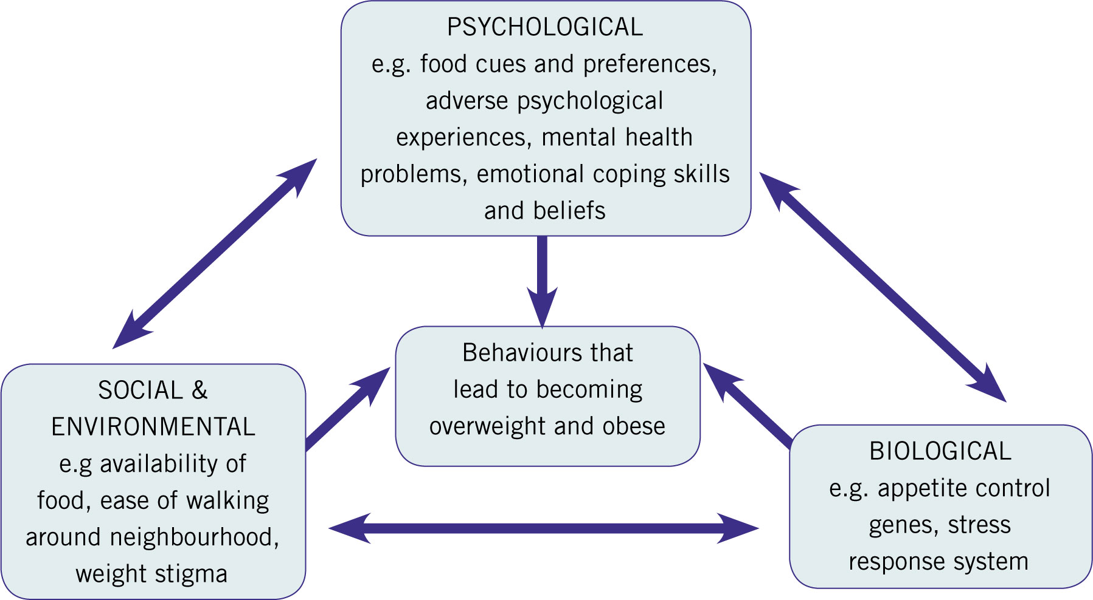

British Psychological Society, 2020 Psychological perspectives on obesity: Addressing policy, practice and research priorities | BPS - British Psychological Society

The SWITCH connector will form part of and be supported by the SWITCH MDT, comprising of:
- Psychologist | - Dietitian | - GP with interest
- Bariatric Surgeon | - Bariatric Specialist Nurse | - Pharmacy / NMP
- Endocrinologist |  | - Physiotherapist
Expectations in practice:
It will be expected that SWITCH connectors will uphold the Association for the Study of Obesity society’s values through all forms of professional work:
- Use person-first language: avoid using terms such as ‘obesity’ or ‘overweight’ as adjectives. Use phrasing such as ‘adults with overweight and obesity’ or ‘adults with obesity’ rather than ‘overweight adults’. People first language is the accepted way to address people with physical or mental disabilities or chronic illnesses.
- Use non-stigmatising images: avoid using stigmatising or derogatory images of individuals who are overweight or with obesity.
- Provide accurate information: avoid using weight-based stereotypes through inappropriate language or imagery; fat jokes/humour; or suggestions that a person’s body weight implies negative assumptions about their character, intelligence, abilities, etc.
- Recognise the complexity of obesity: the UK Government’s Foresight Report (2007) informs that there are over 100 factors that cause obesity, many of which are outside of a person’s control. It is imperative that members recognise the array of causes and thus, avoid implicitly or explicitly blaming individuals, families and groups, or implying that a particular population group does not wish to manage their weight.
- Recognise that people have different views and opinions: avoid implying that all people with overweight and obesity have a desire to lose weight. Recognise that there is an array or weight loss methods that people might choose, and where weight loss is desired, that no one form of treatment is appropriate for all.
- Avoid combative language when referring to efforts to reduce the prevalence of overweight and obesity. For instance, 'the war on obesity' and 'fight against obesity'.
- Where appropriate, take the opportunity to condemn weight stigma attitudes and discriminatory behaviour: weight stigma and discrimination is widespread and in many areas of society is perceived to be acceptable. Speak out against weight stigma attitudes and discriminatory behaviours or practices.
The ASO statement on weight stigma and discrimination has been developed by Stuart W. Flint, Leeds Beckett University.
Further Supporting Guidance:
ASO-weight-stigma-and-discrimination-position-statement.pdf
https://www.obesityaction.org/wp-content/uploads/People-First.pdf
Language Matters: Obesity MAC01941_NN_UK_HCP_Obesity_Guidelines_lo1b (squarespace.com)

Training and Education Opportunities:
There will be a number of opportunities for training and development which will align with the healthier weight competency frame work below.
https://www.e-lfh.org.uk/programmes/healthier-weight-competency-framework/
https://www.scope-elearning.org/

