Urgent Dental Appointments
Partner toolkit
September 2025

Social media

Post copy | Graphic
In pain or facing an urgent dental issue?  Extra NHS urgent dental appointments are now available in Staffordshire and Stoke-on-Trent.  Call the Dental Advice Line for help.  More info: https://tinyurl.com/4z84pzxz | 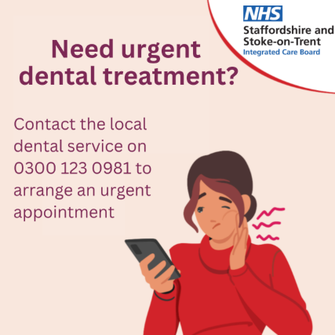
Need urgent dental help?  Over 16,000 extra NHS appointments are now available across Staffordshire and Stoke-on-Trent.  Call NHS 111 or the Dental Advice Line to get seen.  More info: https://tinyurl.com/4z84pzxz | 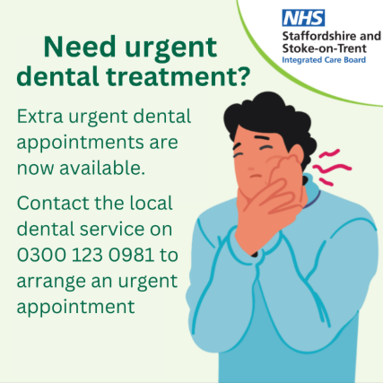
Urgent dental issue?  Call the Dental Advice Line to access urgent NHS dental care in Staffordshire and Stoke-on-Trent.  New appointments now available!  More info: https://tinyurl.com/4z84pzxz | 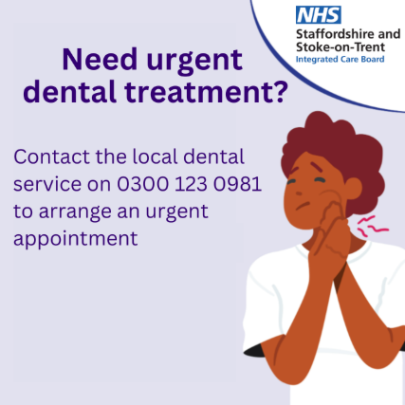

Newsletter/bulletin copy (for internal and external use)
Need Urgent Dental Care? Help Is Now Easier to Access

If you're in pain or experiencing an urgent dental issue, NHS urgent dental appointments are now available across Staffordshire and Stoke-on-Trent.

As part of the Government’s national commitment to deliver 700,000 additional urgent dental appointments, the Staffordshire and Stoke-on-Trent Integrated Care Board (ICB) is expanding access to urgent dental care in your local area. This is part of the ICB’s Local Dental Plan to improve dental access, address workforce challenges, and support better oral health for all communities. This means that:
- Over 16,000 new urgent dental appointments will be made available each year across Staffordshire and Stoke-on-Trent.
- The new appointments will be provided in addition to existing NHS urgent dental care services.

These urgent slots are reserved for patients in need of immediate care, such as:

- Severe dental pain or swelling
- Infections or dental trauma
- Bleeding or urgent post-treatment issues

You’ll be signposted to available urgent appointments by contacting the Staffordshire and Stoke-on-Trent Dental Advice Line (via Community Dental Services).

Appointments are offered based on clinical need and availability at local dental practices who have signed up to provide additional urgent care slots.

The ICB has launched a local public information campaign to raise awareness about how to access urgent dental services, and the support available to patients. Find out more information about the campaign here.

Web copy
Urgent Dental Care in Staffordshire and Stoke-on-Trent

If you’re experiencing an urgent dental issue, help is now easier to access.
As part of a national plan to improve access to urgent NHS dental care, the Staffordshire and Stoke-on-Trent Integrated Care Board (ICB) is expanding urgent dental services across the region. Over 16,000 additional urgent appointments will be available every year to support people in pain or in need of emergency treatment.

What Is Urgent Dental Care?

Urgent dental care is for issues that cannot wait, such as:
- Severe or persistent toothache
- Dental infections or abscesses
- Swelling in the mouth, jaw, or face
- Bleeding following dental treatment
- Accidents involving teeth or gums

If you're unsure whether your condition is urgent, it’s best to seek advice.

How to Get an Urgent Dental Appointment

Urgent appointments are available by referral only by calling the Staffordshire and Stoke-on-Trent Dental Advice Line, run by the Community Dental Advice line on 0300 123 0981.

You will be assessed and signposted to the nearest available dental practice offering urgent NHS care.

Please note: These appointments are only for urgent dental needs. For routine care, contact your usual NHS dentist or check availability using the NHS Find a Dentist tool.

Why Are More Appointments Being Offered?

In February 2025, the government announced an additional 700,000 urgent dental appointments across England. Staffordshire and Stoke-on-Trent will deliver over 16,000 of these every year, helping more people get timely, essential care.

Supporting Better Oral Health for Everyone

This expansion is part of the ICB’s Local Dental Plan, which focuses on:
- Improving access to dental care
- Addressing workforce pressures
- Supporting better oral health outcomes across all communities

Need Help or More Information?

Call the Dental Advice Line to speak to someone today.

We’re committed to ensuring you get the care you need, when you need it most.

Press Release
Over 16,000 Additional Urgent NHS Dental Appointments for Staffordshire and Stoke-on-Trent

Patients across Staffordshire and Stoke-on-Trent will soon find it easier to access urgent NHS dental care, thanks to a major expansion of services across the area.

As part of the government’s national plan to improve access to urgent dental treatment, the Staffordshire and Stoke-on-Trent Integrated Care Board (ICB) is introducing more than 16,000 additional urgent dental appointments every year. These appointments will support people experiencing pain, infection, or other urgent dental issues.

What counts as urgent dental care?

Urgent dental care is for conditions that cannot wait, such as:

- Severe or persistent toothache
- Dental infections or abscesses
- Swelling in the mouth, jaw, or face
- Bleeding following dental treatment
- Accidents involving teeth or gums

Appointments can only be accessed through referral by calling the Staffordshire and Stoke-on-Trent Dental Advice Line on 0300 123 0981, where patients will be assessed and directed to the nearest dental practice offering urgent NHS care.

Dr Rachel Gallyot, Interim Chief Medical Officer at the Staffordshire and Stoke-on-Trent ICB, said:

“Too many people have struggled to access urgent dental care when they need it most. By introducing thousands of additional appointments every year, we are making sure that patients in pain or distress can receive timely treatment close to home. This is a vital step in our commitment to improving oral health and ensuring fair access to NHS services across Staffordshire and Stoke-on-Trent.”

The announcement follows the government’s February 2025 pledge to deliver an extra 700,000 urgent dental appointments nationwide.

For urgent dental advice or to access an appointment, call the Dental Advice Line on 0300 123 0981.

